**Regular salary/wage distribution of school teachers**

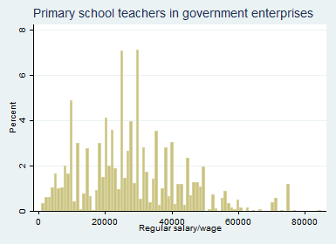

N= 8777906

minimum=900

max=85000

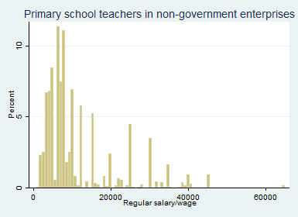

N=8194230

minimum= 2000

max= 112000

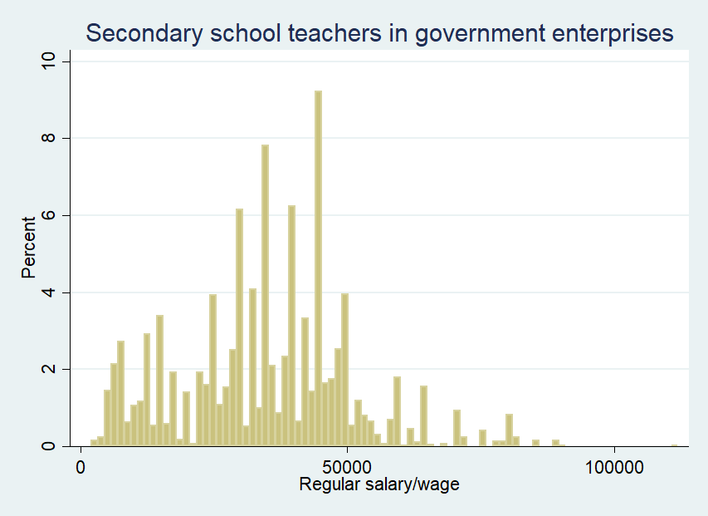

N= 4675699

minimum=700

max= 65000

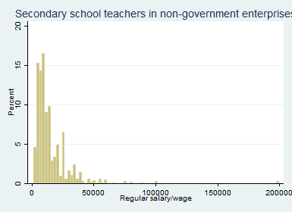

N= 5798356

minimum=1500

max= 200000

=================================================================

New alternatives- 1

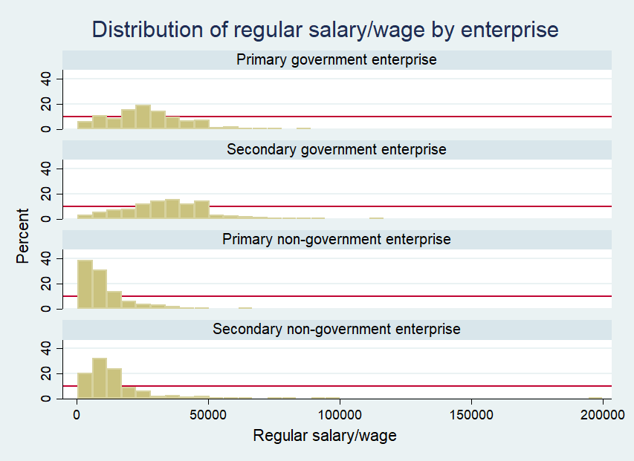

New alternative- 2

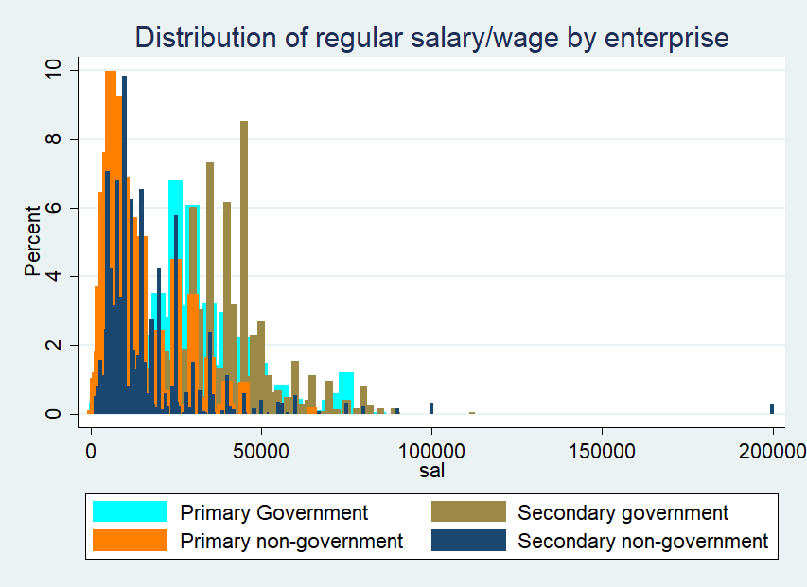

Final Graph

