DAY 9

CONCEPT: Observation & Classroom Management

Guidelines for the trainers: The following section contains details about skill sets and teaching aids required to conduct the training session along with references for further reading.

Required trainer skill set:  - Understanding of NESP  - Understanding of present school processes of Afghanistan  - Knowledge of school time table and academic calendar | Expected Outcome:  - Guide and support school administrators and teachers on development of strategy to achieve NESP III Goals.  - Create and enable a learning culture with measures and processes that support development of school staff.

Day | Sub-topic | Concepts | Pedagogy | Time
9 | Communicate & Interact Effectively, Developing Self and Others, Critical Thinking, Collaboration with Others,
 | Classroom Management | Communication, Strategic thinking, Classroom Observation | Activity 1: What “Management” is required for Managing a classroom? | 90 Mins
 |  |  | Break | 10 Mins
 |  |  | Activity 2: To understand the practices/actions we consciously or unconsciously have been engaging in managing the classroom. | 90 Mins
 |  |  | Lunch Break | 60 Mins
 |  |  | Activity 3: To demonstrate critical thinking for managing the classroom effectively. | 90 Mins
 |  |  | Break | 10 Mins
 |  |  | Activity 4: Structured reflection of the day | 60 Mins

Activity 1

Objective: to understand What “Management” is required for Managing a classroom.
Output: Participants will be able to understand the strong correlation of academic and non academic aspects of managing a classroom.
Resource required: computer, PPT, Notebook and Pen
Lecture Notes:

- Now let's ask ourselves what different processes and systems we need to manage to enable teachers and students in a learning environment? You may say Human Resources, Resources, Time, Process, Pedagogical tool, control.
- Now during your observation of a classroom. Let's break the classroom (40 Mins) into as many tangents as possible. We try to understand the seen and the unseen part of a classroom of 40 Mins. The trainer will instruct participants to think about what goes behind in running a successful classroom where teachers are facilitating constructive and participative learning experiences for students.
- Here is the Mindmap: Where we try to understand when we say classroom Management, What is likely to be a classroom Management (for a teachers or a head teachers)
- In the below mindmap, you may observe that How academic and non academic tasks are interacting with each other to make a class possible.

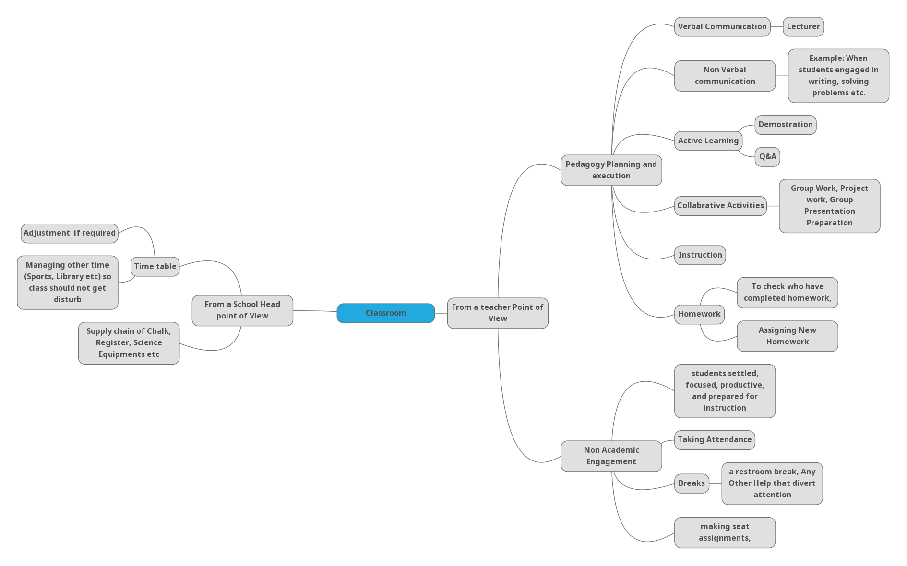
Small Small Group Activity: What do you understand by the term “classroom management” as a supervisor?

Instruction to Participants:
- Show the mindmap during this activity (slide on projector)
- Ask them to discuss in their respective small group for 15 Mins,
- Ask them to draw a mindmap on a chart paper (Take any one specific subject, Grade and then design a mindmap)
- After 15 Mins ask them to put their chat paper on the training room wall
- Ask other groups to have a look at this chat paper during breaks.

Concluding discussion:

- classroom Management is evolving in nature. There may not be a single definition of what classroom management is going to look like? Both academic and non-academic processes evolve over time, Teacher’s perception, attitude, and knowledge changes over time which changes the practices of classroom management.
- Teacher’s attention is a limited resource. Therefore it is important to create a space where we need to understand how teachers' time is divided in the classroom and how we can support teachers' time and efforts in creating constructive learning experiences.
- Points to reflect on while thinking about classroom Management as an academic supervisors:
- Learner Agency, Teacher Agency
- Pedagogy, Transaction, Active Learning
- Interaction (use of Language, eye contact, gestures, attention, or misbehaving)
- Content (Subject, Topic,Concepts, Examples, Assessments)
- Time

Homework: How would students like to manage their own classroom Process? ( discuss with a school going child to understand his/her perspective)

Activity:2
Objective: To understand the practices/actions we consciously or unconsciously have been engaging in managing the classroom.
Output: Participants will be able to reflect certain actions to manage a classroom.
Resource Required: Whiteboard, Computers, PPT, Notebooks, Chartpaper, Sketchpens
Trainer’s Instruction to participants:
- In the first column is the list of learner behaviour that participants are likely to encounter during the classroom. Ask the group to Devise strategies or actions to address each disruptive behaviour and record them in the second column.
- Participants will discuss in their small group and come up with solutions. (10 Mins for internal Discussion + 5 Mins for large group Sharing)
Activity
The purpose of implementing classroom management strategies is to enhance school and teachers efforts to create, use and maintain constructive learning space for student learning.
 | Some areas of improvement found in classroom Observation | Strategies to support teacher after observation
Caselet 1 | - Maximum students engages in the side conversation during classroom session and teachers did not pay attention to it apart from instructing them to keep quiet
Caselet 2 | - In one classroom, only two to three students continuously answer teachers' questions, answers it perfectly. Teachers are very content to listen to only these students and move forward in their lesson facilitation without addressing the rest of the students whether they have understood or they need further support.
Caselet 3 | - The classroom has 5 female students and 20 male students. The female students are learning all the concepts taught in the classroom, but in multiple observations it is found that they do not participate and express themselves in the classroom. The teacher identified this problem himself but could not find a solution for encouraging participation and therefore seeking your help.
Caselet 4 | - The teacher has prepared the lesson well and students are learning and participating. While the class is running smoothly, the teacher is habituated to make inappropriate remarks (related to gender, class and their background) to students while addressing them.
Caselet 5 | - In your classroom observations in a school, you have observed all the teachers over a period of time. They understand your feedback and work on it and show improvement. In staff meetings, they share that though they are happy to get some feedback from you and in school, there is no acknowledgement of their best practices. The headmaster of the school is totally detached with classroom learning processes and does not support teachers in any initiative.
Traine Note:
The trainer will give participants these caselets in small groups to identify the strategies or action plan to resolve these areas. The trainer will display one caselet after another to a larger group and receive different group action plans and strategies on each caselets with their rationale to back their solution. The trainer then facilitates the discussion by establishing that these observation pointers may be same or similar in their experiences, but the solution for classroom and school management will be different depending on the seen and unseen aspect of that particular school.
Concluding discussion:
The castle discussed so far are derived from he gerental observation of classroom Management while observation we generally focus on subject facilitation and student learning. It is our responsibility to observe classroom learning experiences holistically and therefore having observation based discussion with respective stakeholders to improve overall classroom Management in a school. For example:
- How to ensure gender inclusiveness?
- How to ensure students participation and knowledge construction in the classroom instead of teachers directive teaching?
- How to ensure that teachers and other school staff discuss their problem on a monthly basis and identify solutions collaboratively for ensuring student learning?

Activity 3
Objective: To demonstrate critical thinking for managing the classroom effectively. .
Output: Participants will have the opportunity to intervene for better classroom Management.
Resource required: Computer, PPT, Projector, Notebook, Pens, chart paper, Sketch Pens
Instruction to Participants:
- Read the Activity sheet.
- Discuss in small groups: Do you believe that mentioned strategies will work? If you are observing the class & you observe learner’s behaviour then what suggestions/Feedback you will provide to Teachers.
- In the first column is the list of learner behaviour that participants are likely to encounter during the classroom.
- Ask the group to advise/choose the best strategy option to address each disruptive behaviour
- Participants will discuss in their small group and come up with solutions. (5 Mins for internal Discussion + 5 Mins for large group Sharing)
- Trigger Questions during discussion
- Trigger Question 1: If the kids are from grade 1-5, Grade 6-10 , do you intervene differently? If yes then ask why?
- Trigger Question 2: Do you change your strategies if all the students are girls? If yes then ask why?
- Trigger Question 3: if you are teaching any specific subjects like religious subjects, maths, Science, Language….Do you think you will change or modify your answers?

 | Learner’s Behaviour in a class | Teacher’s intervention (Suggested Strategies)  Participant may add other Strategies
1 | Student Engages in the side conversation | - Behave as if you know the side conversation in class related and ask the participants to add their thoughts  - If you are lecturing or leading a discussion, slowly move into the parts of the room where the disruptors are; continue to lecture or discuss and don't look at them as you continue.  - Change the pace of the activity, do something dynamic and playful.  - Re-form the groups, separate the disruptors.  - At the start of the session, Revisit the classroom rules.
2 | A student talks too much even after the teacher requests her/him to quit several times. | - If the learner is on the subject, begin talking with him or her and summarize the learner’s point. Then turn to others and invite their participants: “What does everyone else think?”  - Avoid making eye contact for a while.  - If he or she if off target, say, “Great point, but it’s beyond the scope of our class….Let's talk about this outside class”  - Change the pace of the activity and ask students to lead the class for a short time.
3 | One kid Complains Against Another during the middle of a classroom session. | - Ask if others feel the same way, if they don't then offer to assist or listen to the disruptor during break.  - If others do feel the same way, facilitate a ‘productive tangents’  - Acknowledge the complaints, then turn the group discussion to strategizing how to overcome it.  - Writing the issues on the flipchart, and discussing the possible solutions.  - If the complaint is valid, incorporate it into the action planning to have the learner address the issue.
4 | Student Daydreams; Is not really in the class. | - Change the current activity to make it more dynamic.  - If more than one student, then acknowledge it. Allow a short discussion with students. Ask how the class could be better?
5 | Student Heckles teachers | - Give the learner your attention in a learning orientated way rather than encouraging the heckling.  - Change the activity so that the participants are interacting with each other rather than with you.  - If heckling continues, talk privately to the person.
6 | Challenges: If the students came prepared to the class and answered all teacher questions. Not giving opportunities to other students. | - In this case, ask the student to be the collaborator in your teaching.  - Create opportunities for the learners to participate in pairs or in small groups. You Remember, Zonal Proximal Development, Peer Learning….It works.  - What would you will Suggest ?
7 | Tell jokes around at inappropriate times in the middle of a session. | - When the joke is funny and told at the right time, Laugh!  - Give the learner attention by reengaging him or her in the content without acknowledging the joking behaviour.  - What would you will Suggest ?

concluding Discussion:
- From the above discussion, we found that there is no one solution to manage a classroom. It evolves with teachers experiences, Pedagogical innovations, Teacher-student engagement & Relationships. There are many other factors that affect a classroom.
- Whatever we do, act, speak and react inside a classroom, students imitate that. So discussion around that act with teachers gives an opportunity to reflect and make meaning out of it. It helps to rectify, improve, and sometimes unlearn.
- Before concluding the discussion let's reflect the following when you visit the school next.
- What are the rules teachers communicate to students in a classroom and why?
- How are our outcomes established due to our response?
- What learning environment are we creating for our students?
In the next activity we will go through classroom observation forms.

Activity 4: Structured reflection of the day

Objective: To provide feedback and input to stakeholders for effective education delivery and other educational services.
Output: Participants will able fill the observation form ( collect Data, provide meaningful feedback to peers and share data with Authority)
Resource required: Copies of Classroom observation forms, Computer, PPT, Notebook, Whiteboard, Sketchpens
Structured reflection (25 mins + 35 mins)
Notes for Trainer:

- Trainer will distribute the classroom observation forms to all participants and ask the participants to read the observation template.
- The participants will end the day with the structured reflection around classroom observation forms (Both General and Academic).
- Trainer will ask them to list out two ideas/ skills/ strategies that were most useful for them in today’s training, and one idea/ skill/ strategy that they need clarification on.
- To conclude the structured reflection session, participants and trainers will engage in an interactive diary session throughout the 10 days of training.
- Interactive dairy is a strategy to include the supervisors’ voice in the training. In an interactive diary, the trainees get to give live feedback on the design of the training that they are undertaking by engaging in a dialogue with the trainer. Other than this, there are two reasons to include interactive diaries in this training.
- First, it will include supervisors’ voice in the training process.
- Second, it builds a transferable skill in the supervisors that they can use when they are working in the field with their supervisors.

Trigger Questions
1. What did you learn about in today’s training?
2. How today’s activities help you in filling classroom observation forms? (Refer classroom Observation)

List down various observation indicators

- academic and non academic indicators that affect classroom Teaching. .
- Indicators related to Room Setup
- Indicators related to Availability and usage of Media, Artifacts, Teaching learning Materials, Toys
- Teacher Physical presence (Voice, Non Verbal behaviour , Body Language, Posture, Dress, Appearance)
- Teacher’s Articulation of an Example (Demonstrations, Examples, Facts, Exhibits, Analogies, Testimonials, Statistics)
- Are textbooks being used? For what purpose and when?
- Is a time table being followed? Is there a structure for the day/time? What is this?
- How does the teacher interact with children? What is the language used? What type of pedagogical interactions and support is she providing? Does she sit in one place or does she move around?
- How are the children sitting? Groups or Rows—describe the type of groups that have been formed.
- How do the children interact with each other? Are they giving each other academic support?
- Do children approach the teacher? For what purposes
4. Teachers use multiple Active learning teaching methods to engage students. Some of the active learning methods we learnt in this training (Day 3,4,5,6,7). (Example: Suppose we are observing a science teacher using Hands-on Science and case study methods together), then where we capture that process in the given observation form.
Supervisors will write their notes for the Trainers in the diaries and then these will be collected. The trainers will respond to the diary entries by writing back, thus beginning a dialogue between the Trainers and the trainee supervisors. as references for further reading.

---------------------------------------------------------------------------------------Day End---------------------------------------------------------------------------------

