Day 2: Introduction To Learning Theories

CONCEPT: Learning Theories

Guidelines for the trainers: The following section contains details about skill sets and teaching aids required to conduct the training session along with references for further reading.

Required trainer skill set:  - Understanding of Afghanistan Textbook and school curriculum  - Understanding of Learning theories and Applications | Expected Outcome:  - Understand the learning theories to approach active learning.  - Understand the importance of active learning in classroom Processes.

Day | Sub-topic | Concepts | Pedagogy | Time
Day 2 | Competency Developed: Knowledge of pedagogy, Know Learning Theory, Applying Multiple Teaching Style and instructional strategies to engage student in learning process
 | Introduction to Learning Theories |  | Recap: Day 1: Agency, Classroom rules, Active Learning | 15 Mins
 |  |  | Activity 1: Learner’s Agency | 90 Mins
 |  |  | Short Break | 10 Mins
 |  |  | Activity 2: How children learn from more knowledgeable learners. | 90 Mins
 |  |  | Lunch Break | 60 Mins
 |  |  | Activity 3: Support children to discover their world and knowledge. | 90 Mins
 |  |  | Short Break | 10 Mins
 |  |  | Activity 4: Structured Reflection of the day | 35 Mins

Notes for Trainer: To carry forward the momentum of the training, Trainer will go through the recap of the previous day. It also helps the trainer to set the tone of the day.
RECAP:
The previous day, We learnt about classroom, Learning and School processes. Also we tried to understand why we need to be sensitive towards active learning methods to make the learning spaces more vibrant and joyful. While creating learning spaces we may consider processes, available time, TLM resources and activities. It will help us to engage more meaningfully with students as well as with the content.
Today's first session, we will try to understand how the Learner's Agency plays a crucial role in the process of teaching learning. Also We will check a few child development Theories that provide a basis to understand how a child learns? This is one way to explain, describe, analyze and predict learning. A theory helps us make more informed decisions about the curriculum design, lesson plan development and delivery of classroom teaching-learning. we will not devote time to behavioural learning. The selected theories are aimed at understanding active learning.

Small Group Activity 1: Learner’s Agency
Objective: To engage participants on what factors contribute to an active learning environment where the student as well as Teachers voice is reflected in all aspects in the learning space.
Expected Output: Participants are expected to critically examine what enables students participation in an authentic way to contribute to their own learning. (learning space, active learning pedagogy, Subject, Available time, process, inclusiveness, interactions, networking).
Activity: Trainer will circulate classroom rules (One page) to all groups. With reference to this document, small groups will discuss and bring factors to ensure active learning where the student voice is reflected in all aspects in learning space.
Tinkering Remark (Trainer to Participants): Ask participants to take any example, concepts like (Social Justice, Free Speech, Cultural Relativism, Sensitivity to Old People, etc to reflect the above activity.
Resource Required: chart papers, Sketch Pens, notebooks, Pens
Trainer Lecturer Notes : Learner’s Agency:
- Education is the process through which learners become capable of thinking independently that leads to autonomous action. A learner agency is when learners have “the power to act”. In a classroom context, Agency is when learning involves the activity and the initiative of the learner rather than responding to just inputs (instructions leads to passive learning) given by others.
- Students need to exercise agency, in their own education and throughout life. Agency implies a sense of responsibility to participate in the world and, in so doing, to influence people, events and circumstances for the better. Agency requires the ability to frame a guiding purpose and identify actions to achieve a goal.
- To help enable agency, educators must not only recognise learners’ individuality, but also acknowledge the wider set of relationships – with their teachers, peers, families and communities – that influence their learning.
- A concept underlying the learning framework is “co-agency” – the interactive, mutually supportive relationships that help learners to progress towards their valued goals. In this context, everyone should be considered a learner, not only students but also teachers, school managers, parents and communities.
Two factors, in particular, help learners enable agency.
- Learning environment that supports and motivates each student to nurture his or her passions, make connections between different learning experiences and opportunities, and design their own learning projects and processes in collaboration with others.
- The second is building a solid foundation of content knowledge.
There are three things that are core features of understanding of learner agency.
- Agency involves the initiative or self-regulation of the learner. Before a learner can exercise agency in their particular learning context they must have a belief that their behaviour and their approach to learning is actually going to make a difference for them in the learning in that setting .
- Second, agency is interdependent. It’s not just about a learner in isolation doing their own thing and what suits them. Learners must develop an awareness that there are cause-effects relationships for the decisions they make and actions they take.
- Thirdly, agency includes an awareness of the responsibility of one's own actions on the environment and on others. So there’s a social connectedness kind of dimension to that.
As we think about how our schools are going to be places that will prepare kids for life ; skills and knowledge and innovative approaches,we need to be encouraging them to be agentic in their learning, because that’s what they are going to need to be able to do beyond school of course - in work, and as citizens.
Small group Presentation: Small groups will present their summary discussion to the whole class. (Presentation 5 Mins + Q&A 5 Mins)
- After Presentation of groups, Trainer will facilitate Question Answer Session. Other groups are welcome to ask Questions to the presenter. If Q & A exceeds the time, the Trainer may ask the Participants to discuss during breaks.
Concluding Discussion (Trainer to the whole class): We need to consider how that is reflected in the day to day decisions that are made around school - not simply in order to satisfy ourselves that we’ve heard what students have to say, but in more engaged and authentic ways that are about their learning. It is critical to consider the pedagogical approaches that are adopted by teachers and schools, and to question and challenge those that are not student centric, with an emphasis on delivery and curriculum coverage. Learner agency will develop when learners are involved in the whole learning process - including decisions about the curriculum itself, involving learners a lot more in the choices about the what as well as the how and the why of what is being learned.
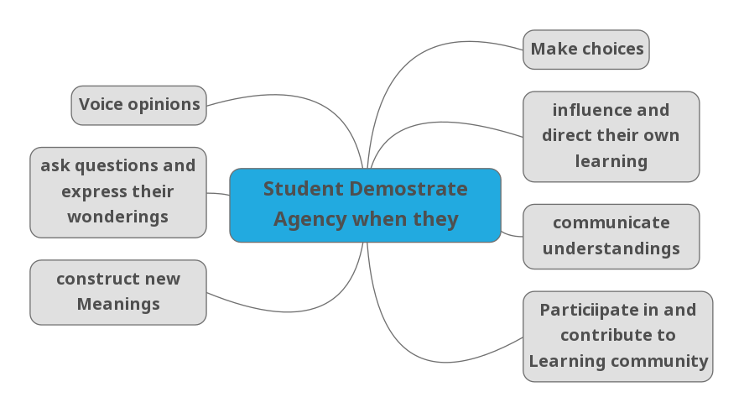
Additional Reading for Trainer:
https://plato.stanford.edu/entries/agency/
https://www.oecd.org/education/2030/E2030%20Position%20Paper%20(05.04.2018).pdf

************************Short Break*********************
In the next session we will learn Learning theory;.the works of Piaget and Vygotsky. They suggested that learners were not simply empty vessels into which a teacher "poured" knowledge. Their work suggested that even young children were capable of constructing their own knowledge of how the world works around them. Learning theory must be able to explain and predict observations.
Education is a discipline in which a theory can be used to explain observations as there are so many factors outside of the classroom that can affect a student’s learning. Having a theory of how learning occurs is crucial for a teacher and for formulating their approach to teaching, So one does expect to (a) Design Learning for students; (b) measure the effectiveness of Teaching approach and procedures.
There are many learning theories to read and understand, But in the next two sessions we will try to understand Piaget and Vygotsky’s work.

Small Group Activity 2:
Objective of the Activity: To Explain process of learning through social interaction as being in the Zone of Proximal Development (ZPD) in Classroom.
Resource Required: Laptop, chart papers, Sketch Pens

Readings: Woolfolk, Anita. (2004). Educational Psychology. (9th ed). Boston: Allyn and Bacon.

How to conduct the Activity:
- Trainer will ask the participants to read the a shot notes (material cited above)
- Explain the Theory and its usages to the participants.
- After explanation of the video shown will pose these following questions for having further discussion
- Activity (Small group): Suppose, we have observed that few students are able to perform simple addition independently, few could do it with the support of the teacher. Some of the students were not able to perform the same task at home while working alone. If this scenario is prevalent in our classroom , what strategies would you suggest to teachers while observing the class and its student as a supervisor?
- After the group discussion, Trainer will ask one person from each group to summarize their small group discussion.
Concluding discussion: (Trainer explaining to Participants)
- Children learn and create knowledge through social interaction.
- A student has a capacity to learn any task but provided appropriate assistance, the student can learn a certain skill in a particular period of time.
- Zone of proximal development is the difference between what a learner can do without help and what he or she can achieve with guidance and encouragement from a skilled partner or adult.
The zone of proximal development had a huge implication in teaching and pedagogy where he also defined the concept of scaffolding to describe the teacher's role in engaging with students in providing them support through demonstration or instruction.
The principles underpinning scaffolding are:
- Build interest in the subject and engage with people.
- Break the given task into smaller sub-tasks,
- Keep the individual or group focused on completing the sub-tasks but don't allow them to lose sight of the main task.
- Model possible ways of completing the task, which individuals can imitate and then eventually internalise.
ZPD is one aspect of scaffolding that can be achieved by:
- Test learners' prior knowledge of the subject. (what kids know about addition, is there any misconception: identify)
- Identify the kid who understood the concept and those who are still struggling.
- Form Small groups and facilitate group discussion around addition. Ensure that kids get proper assistance from other learners who know it.

Small Group Activity 3: Objective of the Activity: To Explain process of learning through stage of development, So participants can analyze classroom learning.
Resource Required: Laptop, Audio System, chart papers, Sketch Pens.
Readings: Woolfolk, Anita. (2004). Educational Psychology. (9th ed). Boston: Allyn and Bacon.

How to conduct the Activity:
- Trainer will ask the participants to refer to the above reading material.
- Explain the Theory and its usages to the participants.
- The explanation of the video shown will pose these questions for having further discussion towards developmental Stage Theory. .
Small Group Activity: (15 Mins)
Suppose, You are observing the following science classroom (Blackboard teaching/Grade 9/concrete operational stage). After the teacher teaches the concept of Heat,
T: Is metal colder than Plastic/Wood? Imagine, a metal spoon, a wooden spoon and a plastic spoon are placed in hot water for half a day. The water is maintained the same temperature throughout. At the end of the experiment all spoons are taken out and temperature is measured. In a 40-50 minutes class, It is not possible to engage with a half day long experiment. What are the strategies and questions teachers should ask in a classroom?
Notes for Trainer:
- Trainer will ask the Questions to the participants.
- Ask them to discuss in their small groups.
- After discussion one person from each group will summarize the small group discussion.
Concluding Discussion: (Trainer explain to participants)
In classrooms, construction of knowledge is based on the individual's experiences.
- People react differently to learning according to their stage of cognitive development.
- Teachers should take an active, mentoring role towards their learners.
- Learners should be encouraged to learn from their mistakes.
- The focus should be on the process of learning as well as the outcome.
- Teachers should respect each learner's interests, abilities, and limits.
Here are some tips on how to apply Piaget's theory:
- People may react differently to learning, not as a result of their age, but according to the stage they are at in their cognitive development.
- Some learners will flourish in group work whereas others may need more one-on-one support.
- Try to balance your time so that you can cater for all of your learners' needs.
- Encourage your learners to learn from each other and emphasise that everyone will have something to offer in this respect.
Convince them that failing at something doesn't mean they are a failure; simply that they have failed a task. The important thing is to get learners to learn from their mistakes. Congratulate your learners on their efforts as well as their achievements. In the Classroom: Try to get an understanding of what stage in their cognitive development your learners are at. Acknowledge effort as well as achievement. Trigger Questions Like
- How would you test if your response is correct?
- Just think, If we keep a steel spoon, Which spoon will be the hottest?
- If I keep the spoon on ice, Would your answer change? Which one is the coldest?

Activity 4: Structured reflection of the day

Structured reflection (25 mins + 10 mins)

- The participants will end the day with the structured reflection session. Trainer will ask them to list out two ideas/ skills/ strategies that were most useful for them in today’s training, and one idea/ skill/ strategy that they need clarification on. ensuring that everyone gets time to share in their groups.

- All the structured reflection sessions can also be used for further contextualization of the learning. Participants can reflect about the skills and strategies they learned, challenges they see with the existing supervision system, and how best they can be used to improve on them.

- To conclude the structured reflection session, participants and trainers will engage in an interactive diary session throughout the 10 days of training. Interactive dairy is a strategy to include the supervisors’ voice in the training. In an interactive diary, the trainees get to give live feedback on the design of the training that they are undertaking by engaging in a dialogue with the trainer. Other than this, there are two reasons to include interactive diaries in this training. First, it will include supervisors’ voice in the training process. Second, it builds a transferable skill in the supervisors that they can use when they are working in the field with their supervisors. The Trainers will see trainees as valuable contributors in their development as supervisors, and for trainees get to actually comment on their training to make it their own. Interactive diaries

- Material required: Any notebook and a pen. The diaries will be distributed to the supervisors along with the prompts for feedback on the training, such as,
What did you learn about in today’s training?
How learning theories will help them in their observation skills?
- Participants will write their notes for the Trainers in the diaries and then these will be collected. The trainers will respond to the diary entries by writing back.

******* Day 2 Ends Here***********

