**A. Overall Teacher Education Sector in the state**

**1. What is the teacher education scenario in the state?**

Teacher Education Scenario of the State

Number of government and private teacher education (M.Ed., B.Ed. & D.Ed.)Institutions in the state

M.Ed- 06

B.Ed- 39

D.El.Ed- 32 (9 Govt. + 23 Pvt.)

ECCE (NTT)-29

**2. How is the teacher education organised in the state?**

To enhance the quality of teacher education and quality of educational institutions, to update educational methodology and to offer publicity to educational innovations by conducting various types of educational research, the state has established 9 GOVT D.EL.ED institutes, two IASE and one state university (GGSIPU) .These two IASE and one state university –GGSIPU runs various teacher education courses such as M.Ed, B.Ed, D.El.Ed, ECCE etc.

Since 2003-04, the B.Ed. in service training course is being conducted by SCERT with an intake of 100 seats, reserved for assisstant teachers deputed by the Department of Education. The B.Ed. course is affiliated to Guru Gobind Singh Indrapraprastha University, New Delhi. From the academic session 2015-17, the duration of this full time B.Ed programme has been of two academic years, as per NCTE Notification dated 28th Nov. 2014. Details of the seats approved by the NCTE and affiliated to GGSIP University for the B.Ed. admission in the ratio of 70:30 i.e. 30 seats for government school teachers and 70 seats through GGSIP University on basis of merit of centralized entrance test conducted by the university.

SCERT is working as the nodal agency for affiliation of Early Childhood Care Education (ECCE) run by DIETs and private recognized institutions.

At present 9 DIETs, 23 Private (self financing) recognized Institutions offering Diploma in Elementary Education (D.El.Ed) course and 29 private institutions offering Early Childhood Care Education (ECCE) course are running under SCERT. The admission procedure, course design and evaluation process, are conducted centrally by SCERT.

**3. What is the state’s vision for teacher education?**

The following are the visions of state in the field of teacher education

* + To work towards universal elementary education of equitable quality for all children in Delhi.
  + To work towards quality improvement at all spheres and all levels of education.
  + To work towards universal elementary education and universal adult literacy.
  + To act as resource support agency for policy, planning, research, training & material development for the school system in Delhi.
  + To act as affiliating agency for elementary and pre-school teacher education courses and teacher education institutions working in the GNCT of Delhi.
  + To design Courses for professional development of teachers.
  + To frame curricula, syllabi, textbooks, materials and evaluation framework for educational administrators, teachers and children.

**4.How has the state’s vision evolved in the light of the NCFTE 2009 And RTE 2009?**

The state has laid down the following objectives in the light ofNCFTE 2009 And RTE 2009 for achieving the vision for teacher education

* To work towards quality improvement at all spheres and all levels of school and teacher education.
* To work towards universal elementary education of equitable quality for all children in Delhi.
* To act or resource support agency for policy planning research, training and national development for the school system in Delhi.
* To act or affiliating agency for elementary and early childhood/ pre-school teacher education courses and teacher education institutions in the NCT of Delhi.
* To frame curricula, syllabi, textbooks, supplementary reading materials evaluation framework etc. for students teachers, educational administrators and others.
* To Design courses and resources materials for professional development of teachers;
* Heads of schools and others in the field of school non-formal education.
* To bring innovation in the process of teaching learning and other activities.

**5. What are the key achievements of the state in the field of teacher education?**

The major achievements (2016-17) of the state in the in the field of teacher education is enclosed at annexure 1.

**6.What according to you are the challenges of teacher education sector in the state?**

|  |
| --- |
| * More than 50% vacancies |
| * Capacity building programmes for teacher educators |
| * No linkages between IASEs, SSA, RMSA, SCERT and DIETs |
| * No MIS for Teacher Education * No Teacher Education Cadre * Delay in release of funds from MHRD * Grant of IASEs may be released in single instalment |

* No National Awards for Teacher Educators
* Lack of monitoring of teacher training programmes
* Shortage of good and experienced resource persons/trainers for in-service training programmes
* English Subject teachers are not recruited as per their subject of specialization at the Post Graduate Level
* Lack of Professional Development among teacher educators
* Up gradation of study materials for teacher educators
* No welfare schemes for teacher educators

**7. How has the state been able to identify and deal with the challenges?**

The challenges of teacher education sector has been identify by following ways in the state

* By conducting researches in the different areas.
* Through discussions in seminars, conferences, symposium etc. in concerned areas
* By conducting need based workshops.
* By reviewing reports of various committees, NGOs, organizations like MHRD,NUEPA,NCERT .

The following are the specific action Steps/ mechanisms for dealing with the challenges

* Proper feedback and monitoring of In-service Teacher Education Programmes conducted.
* Visits by faculty member for feedback and on-site support on continuous basis
* To engage/identify persons with strong experience/ background and innovative approaches as good Resource Persons for In-service Teacher Training Programmes and other academic support.
* The trainers should be the best trainers who are well versed with the school curriculum and evaluation system and the latest changes in the syllabus
* Develop a resource pool of good Resource Persons in each subject from national and state level institutes and outstanding school teachers and teacher educators.
  + Trainers can be from the organizations like NCERT, CBSE, NUEPA and also from Colleges and Universities
  + Addressing capacity building on a long-term, strategic level and by creating a focal point for leadership training/education, professional development, awareness raising, research and information etc.
* Teachers who have studied in the English medium and also taken English Literature as a subject of specialization at the graduate or the post graduate level to be recruited/promoted as TGTs and PGTs in English in Government Schools
* In-service education support and assist the professional development and provide avenues for teachers to refresh their knowledge, to improve their competencies and to bring about paradigm shift in their outlook towards educational issues.
* Conduct workshops for Teacher Educators on using Reflective and Experiential Learning methods, and on adult learning theories (Experts will be invited for this) – so that they experience this for themselves and gain the skills to use this methods
* Real assessment of the needs of the language teachers ,based on which should be the teacher training programmes which would create meaning experiences for the teacher.
* improving the the proficiency level of the teachers through ongoing short term training programmes.
* providing multiple opportunities for teachers to demonstrate their competencies
* Attitudinal changes, Creating interest to explore the vast knowledge by the use of ICT Orient teachers on the skills and knowledge in content and pedagogy related to their subject of specialization in ICT.
* Training modules should be enriched with use of ICTs, videos of activity-based lessons and other innovative materials
* Use of modern techniques and technology during training
* Develop a software to identify the training needs of individual teachers and prepare the INSET programme accordingly (e.g. teacher id , subject , theme based , skill based training)
* Plan a strategy for feedback and monitoring of In-service Teacher Education Programmes conducted
* Develop a resource pool of good Resource Persons in each subject from national and state level institute and outstanding school teachers and teacher educators.
* Create a system of feedback from teachers regarding innovative approaches by resource persons during teacher training programmes
* Develop quality modules and teacher support materials for teacher education
* Publish newsletters for dissemination of education related, matters.
* Develop manuals for teacher training including current issues like CCE, RTE, Inclusive Education, Girls education, Life Skills, Hard spots and innovations
* Develop manuals for teachers, administrators and special teachers
* Digitization of manuals and then to upload them on the SCERT website
* Schools need to adopt /be more responsive to quality standards and results.
* Devise methods of monitoring of Quality teaching in schools
* Encourage Self – Assessment and Reflection among teachers on a regular day to day basis
  + Teachers need to take up innovative practices in curriculum/classroom transactions
* Develop quality modules and teacher support materials for teacher education

**8. What are the roles and contributions of the central government, state government, private actors, NGOs in teacher education? How do these stakeholders interact with each other?**

For pre-service training, the government and government-aided teacher education institutions are financially supported by the respective State Governments. Further, under the Centrally Sponsored Scheme on Teacher Education, the Central Government also supports institutions, including the DIETs, CTEs and the IASEs.

For in-service training, financial support is largely provided by the Central Government under the Sarva Shiksha Abhiyan (SSA), which is the main vehicle for implementation of the RTE Act. Under the SSA, 20 days in-service training is provided to school teachers, 60 days refresher course for untrained teachers and 30 days orientation for freshly trained recruits. Central assistance for in-service training is also provided to District Institutes of Education and Training (DIETs), Colleges of Teacher Education (CTEs) and Institutes of Advanced Studies In Education (IASEs) under the Centrally Sponsored Scheme on Teacher Education. State Governments also financially support in-service programmes. Several NGOs, including multi-lateral organizations, support various interventions, including in-service training activities.

**9. What are the measures for enhancing quality of teacher education in the state?**

The following measures are helpful for improving quality of teacher education:

* To provide professional development for practicing in-service teachers by updating their knowledge and skills
* Effectiveness of the new initiatives curricular reforms
* Intensive use of ICT for school education and also involvement of the community
* To adopt innovative Teaching strategies in teacher education and Improving educational administration practices
* To evolve strategies to enhance professional competency in teacher education
* To provide expert advice to local schools upon request
* To analyse the future of teacher education institutions
* To provide Infrastructure facility in teacher education
* Teacher education and professional competence of teacher educators
* Spreading sense of ethical values in teacher education
* Modern and latest communication and knowledge management for quality teacher education.

**10. How often does SCERT meet DIETs and CTEs? What is the purpose and function of these meetings?**

SCERT conducts regular meeting with DIETs as per the need and requirements of respective DIETS or other bodies like MHRD, DoE, SSA,RMSA etc.

**11. What are the challenges faced with in the SCERT?**

|  |
| --- |
| * More than 50% vacancies at SCERT and DIETs |
| * Capacity building programmes for teacher educators |
| * No linkages between IASEs, SSA, RMSA, SCERT and DIETs |
| * No MIS for Teacher Education * No Teacher Education Cadre * Delay in release of funds from MHRD * Grant of IASEs may be released in single instalment |

* No National Awards for Teacher Educators
* Lack of monitoring of teacher training programmes
* Shortage of good and experienced resource persons/trainers for in-service training programmes
* English Subject teachers are not recruited as per their subject of specialization at the Post Graduate Level
* Lack of Professional Development among teacher educators
* Up gradation of study materials for teacher educators
* No welfare schemes for teacher educators

**B.CSSTE IN THE STATE**

**12. How has the state approach towards teacher education changed post 2012?**

**13. Has the state prepared a perspective plan for teacher education under the CSSTE? Could you mention some of the silent features of this plan?**

Yes, state has developed perspective plan 2012-17 for teacher education under the CSSTE.

Under the perspective plan following action plan for teachers and teacher educators were prepared

**Action Plan for School Education in Delhi State for 2012-17**

|  |  |  |  |  |
| --- | --- | --- | --- | --- |
| **S. No** | **Areas needing change** | **Issues** | **Goals** | **Specific Action Steps/ mechanisms for doing this** |
| **1.** | Transition rate from upper primary to secondary | Decline of enrolment from  upper primary to secondary and reasons for high dropout rate in class VIII | To increase enrolment of students in class IX | -Improving its effectiveness in terms of increased enrolment, improved quality and increased retention  -Create awareness among parents about the need and importance of Education for their children  -Encourage women/mothers to participate in literacy programmes as mothers play an important role in encouraging children to participate in education |
| **2.** | Dropout rate in schools | Zeroing of dropout rate in schools | Find out /solve/ rectify the problems faced by students, which lead to dropping out from schools | Making teaching learning -Awareness/ Counseling of parents and community on the importance of Education |
| **3.** | Teacher-student ratio | High pupil-teacher ratio in schools | Reduce the pupil-teacher ratio to 30:1, as envisioned in the RTE Act-2009 | -More schools/ classrooms  -Recruitment of teachers or engagement of additional teachers at different levels on contract basis to maintain PTR as per the RTE Act-2009  -Attracting better quality persons to the teaching profession |
| **4**. | Gender, spatial disparities | -Eliminating gender, spatial (rural and urban), social and other disparities | Education for all categories of children | Bringing girls, SC&ST, OBCs, Minorities, the Disabled and other disadvantaged groups at par with the rest, thereby eliminating gender, spatial (rural and urban), social and other disparities  -Provision of extra support for education of girls, rural children and students belonging to SC/ST, minority and other weaker sections of the society. |
| **5**. | Enrolment of SC children in schools | Non-enrolment of children of SC community. Reports from Planning Commission HRD Division show- **Central Delhi has 23% and North West Delhi has 19.3% SC children with only 10% and 10.8%, enrolment** | Education for all the SC children in schools, eliminating all gender disparities | -Make efforts for a barrier free enrolment of SC children in schools in all the districts under NCR of Delhi.  -Counseling of parents to educate children especially daughters and make them self-reliant  - Provide access to education for SC children in the formal school system |
| **6**. | Transition Rate from Primary to Upper Primary | Decline in enrolment from primary to upper primary and reasons for high dropout rate in class V. Reports from Planning Commission HRD Division show**- transition rate in Central Delhi as 67.85% and North Delhi as 63.6% and dropout rate in class V, being over 30%** | To increase the enrolment of students in class VI | --Improving its effectiveness in terms of increased enrolment, improved quality and increased retention  -Create awareness among parents about the need and importance of Education for their children |
| **7**. | Out of school children | Zeroing of out of school children in schools. As per PAB 2010-11 reports, **there are still about** **32,063 out of school children.** | To find out the number of children who have never ever enrolled themselves in any school and make efforts to provide education to them | -Provide special training for age appropriate admission of out of school children  -Mainstreaming of out of school children/ providing access to education in the formal school system, through bridge course, back to school camps etc.  -Establishment of more camps and learning centers in schools and also call in selected NGO’s to enroll and provide special training to all children who either have never been enrolled or could not complete their elementary or secondary education |

**Action Plan for Teacher Education in Delhi State for 2012-17**

|  |  |  |  |  |
| --- | --- | --- | --- | --- |
| **S. No** | **Areas needing change** | **Issues** | **Goals** | **Specific Action Steps/ mechanisms for doing this** |
| **1.** | Monitoring of teacher education programmes | Lack of monitoring of teacher training programmes | To assess the quality of teacher training programmes conducted by SCERT | -Proper feedback and monitoring of In-service Teacher Education Programmes conducted.  *-* Visits by faculty member for feedback and on-site support on continuous basis |
| **2.** | Good Resource persons | Shortage of good and experienced resource persons/trainers for in-service training programmes | Improvement in the teacher training programmes conducted by SCERT at the State level | - To engage/identify persons with strong experience/ background and innovative approaches as good Resource Persons for In-service Teacher Training Programmes and other academic support.  -The trainers should be the best trainers who are well versed with the school curriculum and evaluation system and the latest changes in the syllabus  -Develop a resource pool of good Resource Persons in each subject from national and state level institutes and outstanding school teachers and teacher educators.  - Trainers can be from the organizations like NCERT, CBSE, NUEPA and also from Colleges and Universities |
| **3.** | Institutional capacity development | Lack of adequate leadership qualities | To encourage institutional capacity development at all levels. | Addressing capacity building on a long-term, strategic level and by creating a focal point for leadership training/education, professional development, awareness raising, research and information etc. |
| **4.** | Subject specific teachers for all levels of school education | English Subject teachers are not recruited as per their subject of specialization at the Post Graduate Level | Quality teaching learning in the subject **English** in Government Schools | Teachers who have studied in the English medium and also taken English Literature as a subject of specialization at the graduate or the post graduate level to be recruited/promoted as TGTs and PGTs in English in Government Schools |
| **5.** | Professional Development of teacher educators and teachers | Lack of Professional Development among teacher educators and teachers | -To provide avenues for professional development  -Decide the modalities for education and continued professional development of teacher educators | -In-service education support and assist the professional development and provide avenues for teachers to refresh their knowledge, to improve their competencies and to bring about paradigm shift in their outlook towards educational issues.  -Conduct workshops for Teacher Educators on using Reflective and Experiential Learning methods, and on adult learning theories (Experts will be invited for this) – so that they experience this for themselves and gain the skills to use this methods |
| **6.** | Emphasis on English language teaching and communication skills | Poor English Communication Skills among teachers | Emphasizing English language teaching and communication skills since Class – 1 (as per the **recommendations of National Knowledge Commission**) to be integrated in the overall teaching. |  |
| **7.** | ICT in Education | Inadequate proficiency in ICT skills | -To integrate ICT in TE  - To orient teachers to use ICT resources | Attitudinal changes, Creating interest to explore the vast knowledge by the use of ICT |
| **8.** | ICT for Professional Development | Use of ICT in teaching – learning in their own subject areas | - To orient teachers in the use of ICT for professional and academic enrichment | -Orient teachers on the skills and knowledge in content and pedagogy related to their subject of specialization in ICT.  -Training modules should be enriched with use of ICTs, videos of activity-based lessons and other innovative materials |
| **9.** | Quality teacher training | Lack of quality in the teaching arena | To provide quality teacher training (In-Service and Pre – Service) | -Use of modern techniques and technology during training  -Develop a software to identify the training needs of individual teachers and prepare the INSET programme accordingly (e.g. teacher id , subject , theme based , skill based training)  - Plan a strategy for feedback and monitoring of In-service Teacher Education Programmes conducted |
| **10.** | Database of Resource Persons according to the subjects | Non availability of RPs details prior to the commencement of training programmes | Availability of database of outstanding experts for teacher training programmes | -Develop a resource pool of good Resource Persons in each subject from national and state level institute and outstanding school teachers and teacher educators.  -Create a system of feedback from teachers regarding innovative approaches by resource persons during teacher training programmes |
| **11.** | Quality resource materials | Improvement in the quality of materials produced by SCERT for training of teachers | To develop quality resource materials | -Develop quality modules and teacher support materials for teacher education  -Publish newsletters for dissemination of education related, matters.  -Develop manuals for teacher training including current issues like CCE, RTE, Inclusive Education, Girls education, Life Skills, Hard spots and innovations  -Develop manuals for teachers, administrators and special teachers  -Digitization of manuals and then to upload them on the SCERT website |
| **12.** | Quality teaching in Schools | Lack of Quality teaching in the Government schools of Delhi | To provide quality teaching in schools | -Schools need to adopt /be more responsive to quality standards and results.  -Devise methods of monitoring of Quality teaching in schools  -Encourage Self – Assessment and Reflection among teachers on a regular day to day basis  - Teachers need to take up innovative practices in curriculum/classroom transactions  -Develop quality modules and teacher support materials for teacher education |

**14. To what extent does this plan address the aims and objectives of NCFTE 2009 and RTE2009?**

While preparing this plan, every aspect of NCFTE 2009 and RTE2009 was analyze and considered for formulating objectives. The action plan for achieving these objectives were also prepared.

**15. What has been the extent to which the CSSTE has been able to strengthen the institutions of teacher education in the state?**

CSSTE provides the major concerned areas of teacher education which affect the quality of same. It also provides the guidelines for improvement in the concerned areas. The following areas cover under CSSTE which contributes the strengthening of the teacher education in the state

* Teacher vacancies
* Requirement of Additional Teachers
* Teacher Qualifications
* Teacher Education capacity and teacher shortages:
* Teacher Recruitment
* Recruitment policies need to be improved,
* Training of untrained teachers
* Pre-service Teacher Education
* In-Service Training of teachers
* Restructuring BRCS and CRCs
* Reforming existing Teacher Education Institutions
* Reforming School Curricula, pedagogy, assessment and examination
* Linkage among various institutes

**Annexure 1**

**Major Achievements of SCERT**

**(2016-17)**

SCERT, Delhi has been performing pioneering roles in the area of Pre-Service and In-Service Education of teachers and also providing academic support to the Department of Education, GNCT of Delhi in formulation of policies and planning procedures. The other functions of SCERT are to develop Curriculum Material, Teacher Training Modules, Question Bank, Multimedia Packages etc. and disseminate to schools and teachers to provide resource support for teachers and students. A number of research projects are conducted by faculty members to study and analyse the present situation and bring improvement in quality education in the Government schools of Delhi.

Given below are the major achievements of SCERT, Delhi during 2016-17

1. **In-Service Training Programme**
2. **Details of INSET**

|  |  |  |
| --- | --- | --- |
| **S. No.** | **Name of the Programme** | **Total No. of Participants Attended** |
| **1** | **HoS** | **4910** |
| **2** | **PGT (Newly Promoted PGT)** | **443** |
| **3** | **TGT (RMSA)** | **4266** |
| **TGT (SSA)** | **18000** |
| **4** | **Assistant Teachers (SSA)** | **5546** |
| **5** | **PET Misc.** | **900** |
| **6** | **IEDSS** | **2632** |
| **7** | **Ensuring Values Through Education** | **24188** |
| **8** | **DDE (Middle Level Management)** | **81** |
| **10** | **EVGC** | **352** |
| **11** | **LAB ASSISTANT** | **1630** |
| **Total** | | **62948** |

**Online TGTs (Mathematics) Trained = 57**

**SMCs trained = 15000**

**Total Participants Trained =78005**

1. **National and International Exposure Visits**

With the objective to provide training and exposure to our Principals, Vice - Principals and teachers to the best national and global practices through professional and world class organizations the Directorate of Education received a proposal from the Judge Business School Executive Education Limited, University of Cambridge, UK, for conducting a programme for school Principals on – **Inspiring Leadership Improving Performance**. **The main objective was to introduce and manage change within the school system.**

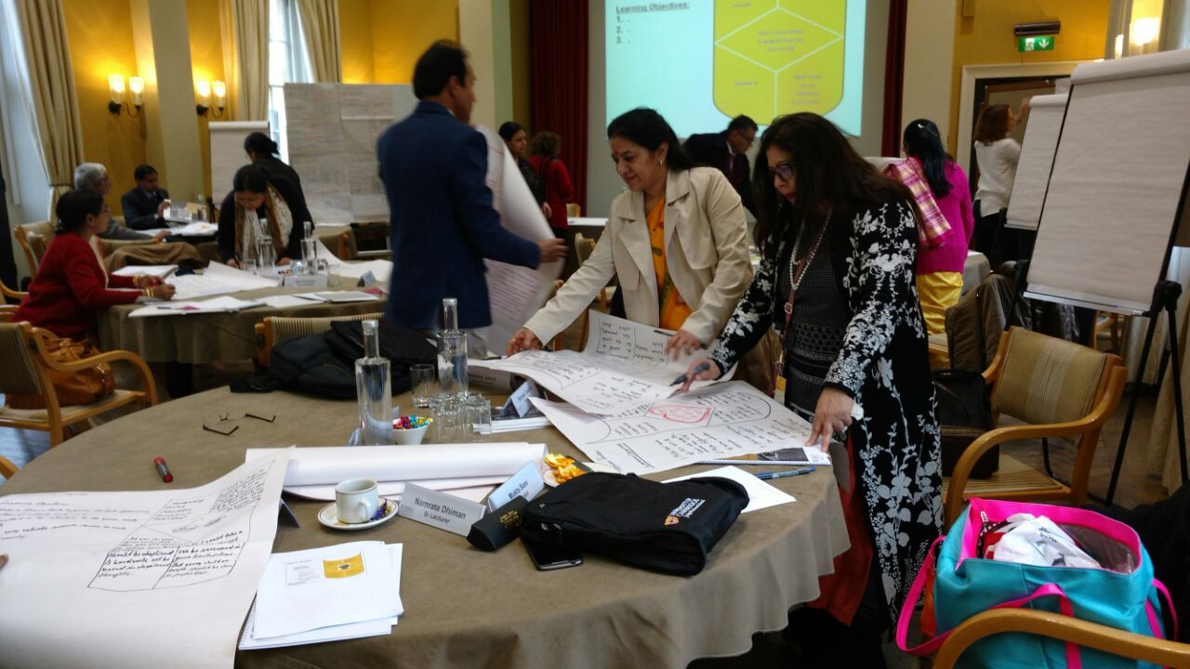In this regard, **the Planning & Administration Department of SCERT has successfully organized the above training programme for 89 Heads of Schools at Cambridge University, UK in 3 cohorts of 30 participants each.** The key focus areas were-leadership, communication and team management, resource management, innovative teaching learning pedagogy, evaluation and feedback, mentoring, counselling, managing and sustaining change.

**Glimpse of a training session in progress at Cambridge, UK**

Additionally**, the Department has also organized a similar Leadership training programme for 57 Heads of Schools at IIM Lucknow.**

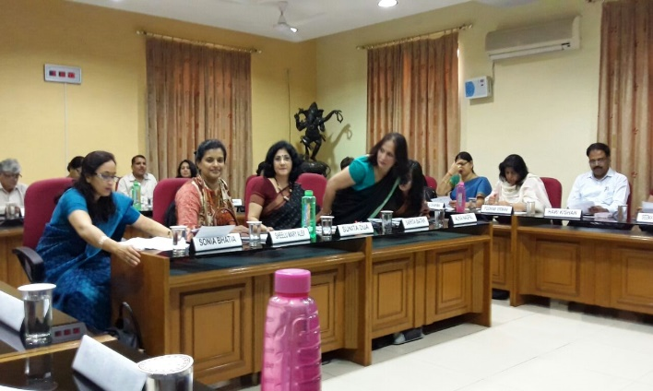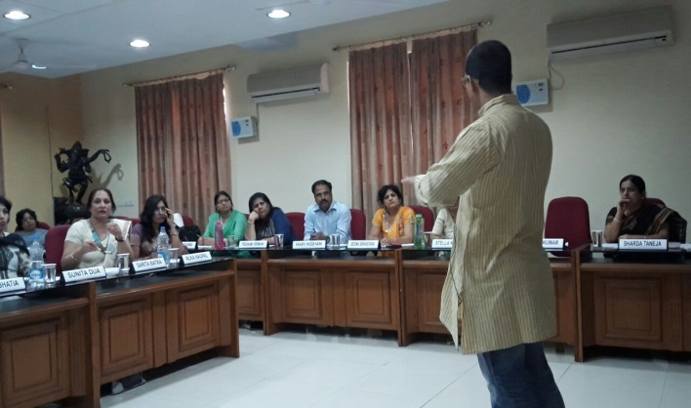

**Glimpses of a training session in progress at IIM Lucknow**

1. **Capacity Building for the Heads of Schools**

The objective of Capacity Building for the Heads of Schools is focused on developing leadership and collaboration, personal responsibility, through shared vision and peer group learning. The HoS in turn would be bringing the same back as practice within their own schools with teachers and SMCs, integrating different learning goals in a cohesive School Learning Plan that they want to take ownership of and have developed themselves.

* **Capacity Building Programmes – in collaboration with NEUPA**
* **School Leadership Development Programme (SLDP**)- It was a 16 (5+5+2+2+2) days programme designed by NUEPA –NCSL for **200 Heads of Schools of DoE** (N/W-A and B) have undergone training under RMSA .
* **Cluster development Programme** for **800+ schools** of DoE through Principal Development Integrated Programme by SCERT in collaboration with CE inaugurated and initiated in August, 2016. 30 Facilitators have been identified from DoE /SCERT/CE which worked with 10-15 HoS’s (along with CRC’s and MT’s in the designated cluster) covering the 800+schools within 85groups.
* **Facilitator Development for In –house Capacity Building**
* 5 days Offsite Intensive CB for 39 facilitators 20-25 June, 2016.
* 2 days residential workshop for induction of new and left out 15 facilitators on 5-6 Sept. 2016 at -Anand Gram, Ghitorni.
* 3 days workshop for integration of available Frameworks for awareness and capacity development - NCSL-NUEPA ; CE and Jeevan Vidya - for developing School Leadership in Pl’s of DoE schools.
* **Capacity Building Programmes - in collaboration with CREATNET Education**
* **Core Programme** for 30 facilitators development in the first week of every month to orient them with content of Principal Leadership Development, all cycles completed.
* **Cluster Development Programme** 30-Facilitators have been identified from DoE /SCERT/CE who worked with 10-15 HoS’s (in a cluster) covering 800+schools under 85groups, all cycles completed.
* **Performance management Proforma** has been developed with experts from NUEPA, Azim Prem Ji Foundation , Central Square Foundation , other educational consultants , for HOS’s who have attended **Delhi School Principal Programme** at **Cambridge, UK** to track and ensure **Managing & Leading Schools and Learning Improvement’.**
* **SRG creation for Outreach of 800 MCD Schools –** A 10 days Capacity Building workshop was organisedfrom 03rd – 13th January, 2017 under SSA, as per NCSL-NUEPA programme design to train 60 SRG members, handpicked from the 3 zones of MCD(20 Each) who will help in covering the earmarked 800 schools of MCD.
* 2 Day  Orientation and capacity Building  Programme on **Strengthening Strategic Leadership ,  was organised on 10th  & 11th January, 2017 at Thyagraj Stadium**for **all School Heads** (DoE ) with the objective to  build their  Leadership Capacities in terms of providing and updating knowledge.

1. **Dilli Shaala Siddhi Delhi State Programme for School Standards and Evaluation (DSPSSE)**

The Dilli Shaala Siddhi is a whole school assessment tool for the govt. schools of Directorate of Education. This has been developed by SCERT Delhi on the premise of the national level document NPSSE developed by NUEPA as per guidelines of MHRD. The National Program on School Standard and Evaluation (NPSSE) was launched by Honorable Minister of MHRD.

SCERT and DoE have developed this document after adopting and adapting the NUEPA module. SCERT being the state academic authority, constituted a core committee consisting of members from Govt. schools, private schools, NGOs and SCERT.

The document was formally launched by Chief Guest, Secretary Education, Madam Punya Srivastava, Guest of Honour, Director Education, Saumya Gupta. Other officers of the Directorate were present at the launch along with 1024 Heads of Schools & 150 mentor teachers of the Directorate of Education. Director SCERT, Ms. Anita Satia delivered the inaugural address & apprised everyone about the development of the Dilli Shaala Siddhi.

This document is to be used in all govt. schools for self-evaluation and improvement in quality of education. The document is based on 7 domains of the school functioning and 46 standards for all the domains. The domains include Teaching Learning Process, Leadership and Management, Inclusive Education, Community Participation etc.

The tool is envisaged to bring about incremental improvement in the Delhi govt. schools.

|  |  |
| --- | --- |
| **S No.** | **Domain** |
| 1. | Enabling Resources of School |
| 2. | Teaching-Learning and Assessment |
| 3. | Managing Teacher Performance and Development |
| 4. | School Leadership and Management |
| 5. | Learners’ Progress, Attainment and Development |
| 6. | Inclusion, Health and Safety |
| 7. | Productive Community Participation |

The salient features of this document “Dilli Shaala Siddhi” are:-

* It is a self evaluation document to be filled after inputs from the principal and all staff and students.
* The data filled can be authenticated with evidence indicated in each domain.
* It is a guide for the school to set objectives after prioritising the domains where they want to reach.
* The document is supportive and non threatening, non judgemental and non labelling.
* It has 3 levels of descriptors by which the school can decide where it is presently placed and where it wants to go in each domain.
* There is scope and place for special innovations, mission and vision statement of the school.

The HOS along with teachers will assess the school as per the description in each standard & make a plan to move forward in chosen domains and standards.

Large group Orientation programmes have been conducted for all the officers and HoS, SIs, DURCCs of DoE, MCD, NDMC, DCB facilitated by NUEPA. SCERT is collaborating with SSA for implementation of this programme in all Govt. schools. The Core Group keeps updated through National Consultative meets organized by NUEPA from time to time.

All schools are in the process of self-assessment as per the Dilli Shaala Siddhi document and filling information on the Dash Board and also on the web portal of MHRD. Till date, 587 schools of DoE have completed self-assessment on the Web Portal.

1. **Mentor-Teachers’ Programme**

At the beginning of the academic session 2016-17, Mentor Teachers Group (MTG) was proposed to be constituted to leverage the creative expertise of about 200 teachers in further strengthening the academic and pedagogic capacities of other teachers of DoE schools. These teachers of DoE have proven experience and expertise of teaching.

Subsequent to their induction, they would get additional opportunity, exposure and support to sharpen their own knowledge and skills. In return, they would be expected to help the other teachers in the system through facilitating capacity enhancement sessions and onsite support.

**Selection Process**

Mentor Teachers were shortlisted from amongst those who voluntarily applied for the role. There were about 1100 applicants. Each applicant was invited to a 1-day workshop where they participated in three activities:

* Psychometric assessment
* Group discussion
* Speech on a given topic

Accordingly, in the first round 191 TGTs (Trained Graduate Teachers- those qualified to teach specific subjects to children of Class 6-10 were shortlisted as MTs. The selected Mentor teachers have undergone and conducted intensive and extensive capacity building programmes with teachers of DoE schools. The focus in the current year has been the Foundational skills at the Elementary level and content at the secondary and Senior Secondary levels. NGOs such as Creatnet Education, Jodo Gyan, Saajha, Kaivalya Foundation have collaborated with SCERT for these programmes.

**Key Tasks of Mentor Teachers**

* To conduct the workshop for Assistant Teachers and other TGTs on teaching methodologies to achieve specific learning goals for children.
* Each Mentor teacher is assigned about 5 schools. He/she is required to visit their assigned schools once a week, observe the class process, talk to the teachers about the activities conducted by them, and get the teachers feedback on any specific support/input that they need, arrange to provide that support with the help of their peers and others.
* To facilitate the experience sharing sessions of the teachers where the teachers can reflect upon their own learning and find solutions through each other’s experience as a group.
* To review different types of teaching learning material (including audio-visual) and shortlist those that can be used by the teachers in furthering the learning of children.
* To help their schools in tracking the learning progress of its child and communicating the same to the parents/guardians of children.

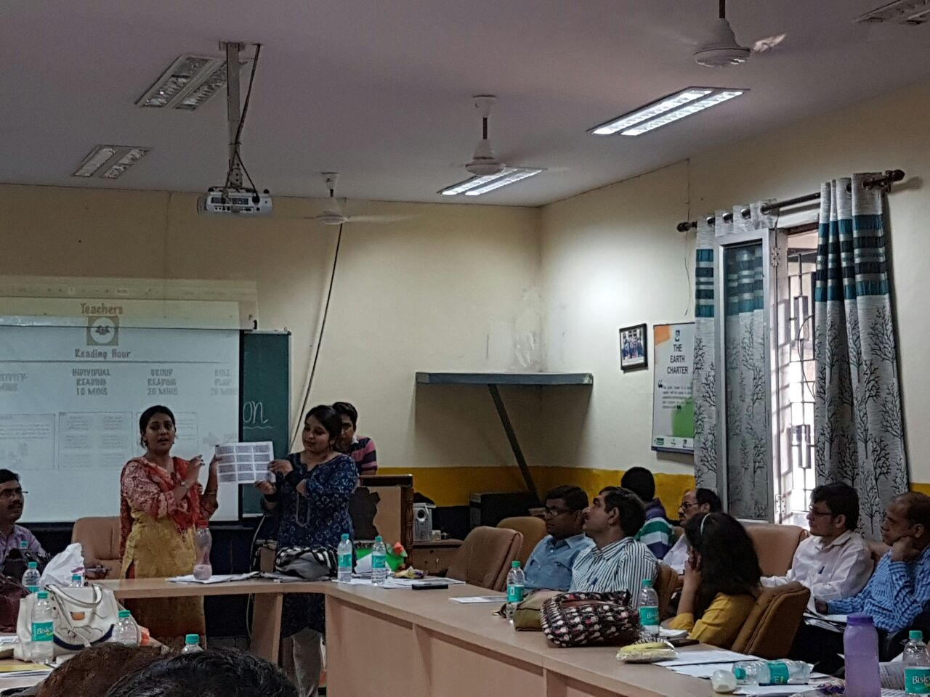

**Major Achievements**

* The Mentor teachers have played an important and positive role in the Summer Camps, Mega PTMs, Reading Campaigns in schools under the “Chunauti” initiative of the DoE.

Till now they have focused on building the baseline skills among the children and improving their basic reading and numeracy skills.

* The Mentor teachers have developed Supplementary material in foundational skills for the students and teachers titled Pragati. Two sets of material namely Pragati 1 before SA1 in Sept, 2016 and Pragati 2 for the next term (SA 2) have already been developed and are being used for students in Govt. schools.
* The Mentor teachers developed Cue Cards in Hindi to help and enable children of classes 6 to 8 to read. These were shared with teachers of their respective schools to be used with the children during the reading campaign. The 2nd baseline assessment data has shown a remarkable improvement among the students of the Nishtha Group.
* Each mentor teacher has conducted workshops in their respective allotted schools with the teachers associated with the “Chunauti” initiative for enhancing learning outcomes among the children. This has helped the teachers to improve their pedagogy skills and share innovative practices.
* The Mentor teachers have themselves undergone a series of specific workshops based on pedagogy and learning strategies with subject experts from DoE, DIETs, SCERT and NGOs from within and outside to enhance their own skills.
* Mentor Teachers have provided support in schools to enhance performance of the students in the SA2 exams.
* Each Mentor Teacher has contributed in development of Pragati 3 supplementary material in foundational skills for classes 6-8 in five subjects namely English, Hindi, Mathematics, Science and Social Science.
* Cue Cards were developed in all subjects for teachers to use in class for improving learning outcomes.
* Mentor Teachers extended their supported in self-assessment of schools for quality improvement.
* Cluster level resource pools were formed in the 5 subjects for teachers teaching in DoE schools.

1. **Mental Maths Project**

Mental Maths is an ongoing project of the Directorate of Education initiated in the year 2004 in District South as a pilot project for class V only. The Mental Maths Project is one such ongoing initiative which has managed to fulfill this objective for the last decade or so and has more importantly helped to reduce the phobia. Over the years the project has been extended from, class I to X in all the Government schools. This fosters a love for mathematics that is beneficial throughout a child’s education, it makes learning joyful and interesting. Mental math improves one’s concentration, and the benefits of this are seen across all subjects! Further, it improves one’s problem solving and reasoning ability and sharpens their calculation skills.

***Activities***

* Mental Maths question bank for classes V to X is prepared every year in Hindi & English medium and have incorporated a variety of activities , puzzles , hands on activity in colourful and attractive manner to facilitate the students in developing Mathematical concepts in 2016-17 and distributed to all the students of government schools.
* Every year the books are edited and reviewed as per the need of students.
* Mental Maths Quiz has been an important part of the project and is carried out for classes 5th to 10th of all schools every year as a component of joyful, meaningful and interesting learning.
* Quiz competitions are organized at 3 levels (Level 1: Class 5 and 6, Level 2: Class 7 and 8 and Level 3: Class 9 and 10) in all Govt. schools of Delhi.
* State Level quiz competition conducted with the help of centralized question bank.

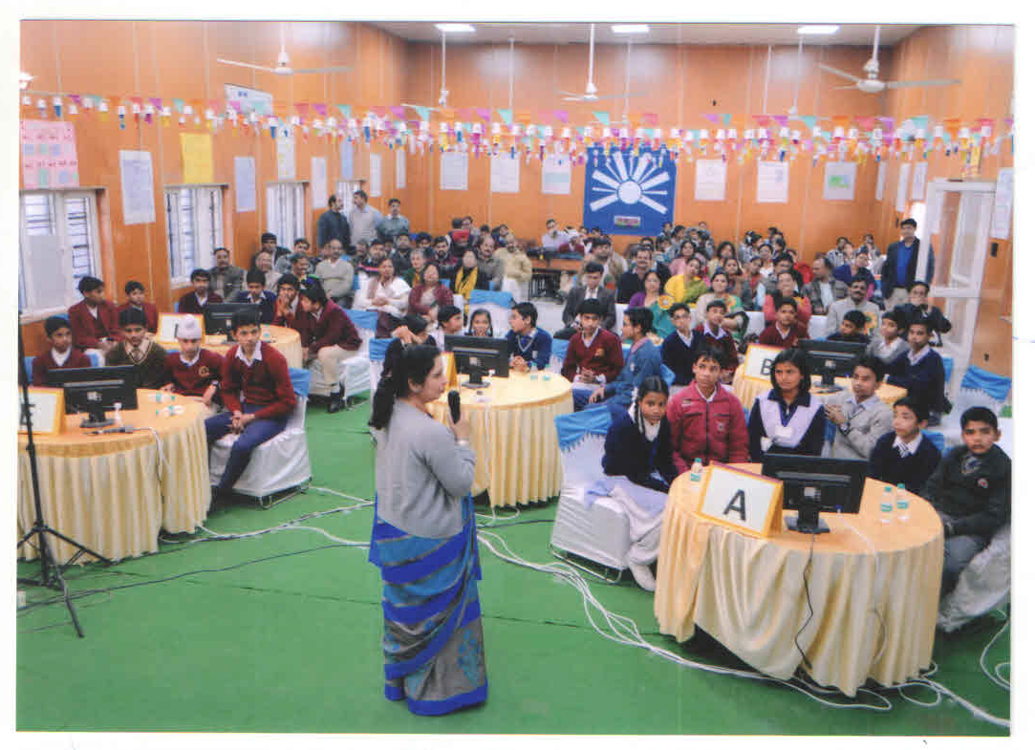

**Glimpse of a training session in Mental Math**

1. **DDEs Professional Development Programme (DPDP) 2016-18**

In its endeavor for capacity building of 41 Deputy Directors of Education (DDEs), SCERT has launched a Professional Development Programme (2016-18) with the following objectives:-

* Perspective shift in the approach of DDEs to efficiently tackle daily challenges.
* To strengthen the DDEs in areas including: Leadership Skills, Team Management, coordination and cooperation amongst stakeholders.

The main areas of interventions under this DPDP are Offsite Perspective Building workshop(PBW) for 12 days per year, DDEs Collective Forums (DCFs) and follow-up/ Onsite Support for above Interventions.

* **Workshop 1-** A need analysis workshop for 02 days was organized in June, 2016 at SIDH Campus in Mussorie. The purpose of the workshop was to understand the needs and areas of concerns for all DDEs. 35 DDEs participated in the said workshop.
* **Workshop 2** –04 days offsite Perspective Building Workshop was organized at PSL, Jhunjhunu, and Rajasthan from 9th -12th December 2017. Total 30 DDEs participated.

1. **Online Capacity Building Programme**

SCERT, Delhi has taken a step ahead towards the ICT enabled Capacity Building Programme for teachers and launched online Capacity Building Programme for 50 Mathematics Teachers & 7 Mentor teachers of DoE as pilot on 5th Dec , 2016 with the following objectives :

* This capacity building programme can be accessed from Smartphone through mobile application called “chalk lit” and from the website [www.chalklit.in](http://www.chalklit.in/)
* SCERT is also planning to extend the online capacity Building program to other subjects across all teachers.

1. **Collaboration with American India Foundation for Digital Equalizer Programme**

AIF has been in partnership with the SCERT for the last 3 years.

Innovative pedagogical practices have been adopted for the benefit of In-service teachers by conducting **ICT trainings** at schools

Pre-service teachers are also getting benefitted by **the Digital Equalizer** programme.

**Details of In-service teachers & Pre-service trainees benefitted by DE program**

|  |  |  |  |  |  |  |  |  |  |  |
| --- | --- | --- | --- | --- | --- | --- | --- | --- | --- | --- |
| **DIET** | **DIET RKP** | **DIET DLG** | **DIET RN** | **DIET DG** | **DIET MB** | **DIET KKD** | **DIET GH** | **DIET PP** | **DIET KP** | **Total** |
| Pre service teachers | 90 | 92 | 300 | 217 | 274 | 110 | 150 | 200 | 292 | **1725** |
| In service teachers | 71 | 116 | 38 | 39 | NA | NA | NA | NA | NA | **264** |

1. **Capacity Building of SMC Members**

The Right to Education Act 2009 envisages the management of school management committee (SMC) by monitoring the school development plan. This is an opportunity to increase the ownership of the school at the local level and thereby improving the quality of education imparted in the school. SCERT being academic authority conducts training for the SMC Members every year.

In the current financial year following efforts were made for the capacity building of the SMC members.

1. Materials developed for the SMC training.

* Manual for facilitators
* Manual for participants
* SMC calendar
* Flash Card
* Welcome Poster

2. Training of CRCCs as Master Trainers – The training was conducted in two phases to build the capacity of CRCCs, to enable them to conduct SMC trainings further.

* Phase 1 - 20 CRCCs were trained as master trainers who were to further assist in training the remaining Master Trainers.
* Phase-2 Training of CRCCs as Master Trainers in was done for two days each at three venues undertaking the same process as done in Phase -1

3. Orientation training of Resource Persons on SMC Training - The selected RPs for SMC trainings 2016-17 were oriented in a way so that they go thoroughly go through the content individually.

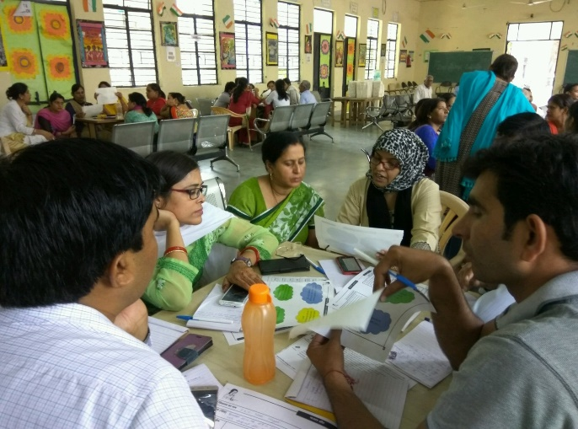4. Orientation of DURCCs- DURCCs were oriented with the final content of training (importantly, to monitor trainings)

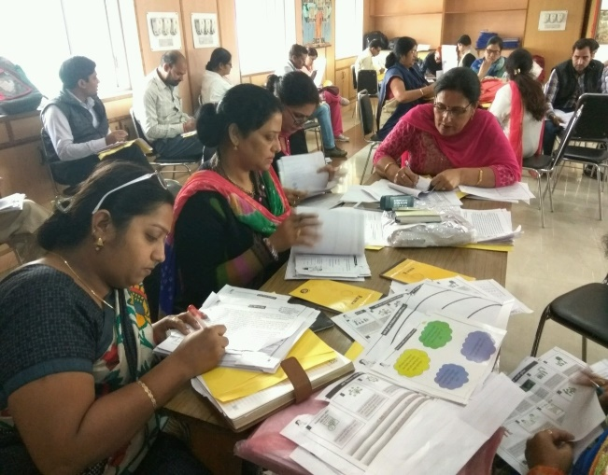

5. Summer-Camp

SMC members took an active part in summer camps held during summer vacations for the students of class VI.

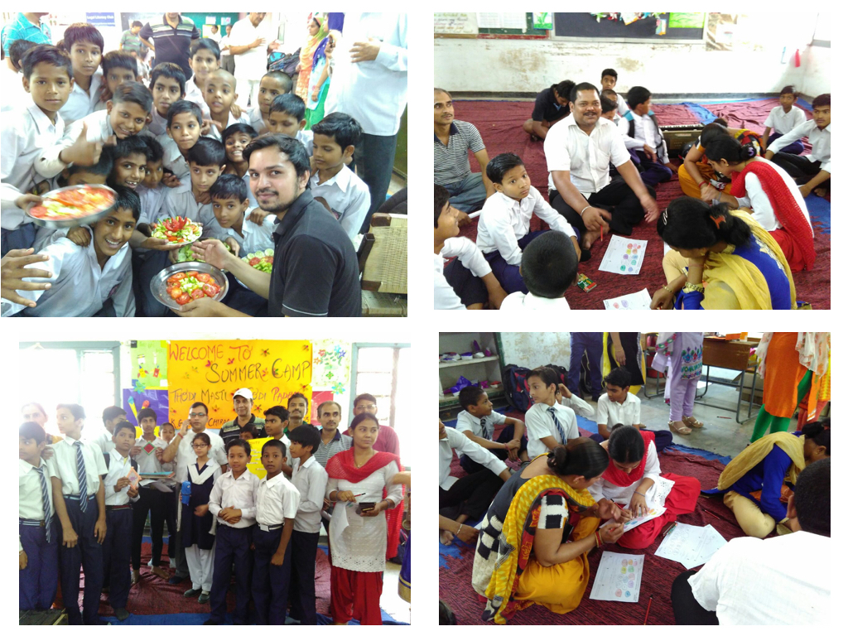

6. Reading Mela

Reading Mela was the part of community awareness program. SMC members were trained by SCERT in collaboration with Saajha on the content and the process of Reading Mela. Approximately 1000 Reading Mela were organised by SMC members across Delhi. The venues of Reading Mela were schools and community parks in which lakhs of students participated.

1. **Material Development**

**a. Total No. of Publications (2016-17)**

|  |  |  |
| --- | --- | --- |
| **S. No.** | **Publications** | **No.** |
| 1. | Printed | 59 |
| 2. | Composition | 9 |
| 3. | Publications under process | 25 |

**(Details attached at annexure-1&2)**

**b. Production of Educational Videos**

This project envisages development of educational video module lessons / programmes, across the spectrum of school education at all levels. Educational videos have already been developed and uploaded on the SCERT website [www.scertdelhi.nic.in](http://www.scertdelhi.nic.in/) for reference:

SCERT, Delhi is in the process of developing 08 educational videos on Physics practical for class XII which are mentioned below:

1. Potentiometer – Comparison of emf
2. Potentiometer – Internal resistance of a cell
3. Wheatstone’s Bridge – Estimation of resistance and Resistivity
4. Focal length of Convex lens – Using u-v and/or I/u and I/v graph
5. Focal length of Convex Mirror – Using u-v and/or I/u and I/v graph
6. Focal length of Concave lens – Using Convex lens
7. Focal length of Convex mirror – Using Convex lens
8. V-I characteristics of a pn-junction diode in Forward and reverse bias.
9. **“ICT in Education” Curriculum**

SCERT, Delhi developed the curriculum of “ICT in Education” for classes VI to X for DoE schools

**Teaching - Learning is organized under these thematic areas**

1. Programming
2. Graphics and animations/internet and ICT Environment
3. Data Representation and Processing
4. Audio Visual communication,
5. Software application

The same was implemented in the schools w.e.f. September, 2016

1. **Curriculum for Nursery and KG classes of DoE schools**

SCERT has developed Curriculum for Nursery and KG Classes as there was no specific Curriculum.

The main aim of pre -school curriculum is to explore the potential of the children and involve them in a host of activities, which help them develop different skills required for formal learning. The suggested pre-school curriculum has aimed at providing a variety of experiences to the children keeping in mind, their age, abilities and social context.

1. **Curriculum for two year Diploma in Early Childhood and Early Primary Education**

SCERT has prepared the two year curriculum for Diploma in Early Childhood and Early Primary Education. The same is being prepared for submission after the final presentation before the experts is done.

1. **Research & Innovation 2016-17**

|  |  |  |  |
| --- | --- | --- | --- |
| S. No. | Name of the Coordinator | Title of the Programme | Status |
| 1. | Dr.Bindu Saxena | “To study the status of Special Training Centre with special reference to Teaching- Learning Process”. | Under Print |
| **Major findings :**   1. Most of the STCs have the facility of pure drinking water (89.41%), proper toilets and sanitation system (87.05%), separate toilet facility for girls and boys (74.11%) , dustbins at right place (82.35%). 2. The STCs are lacking in the facilities such as science lab (18.82%), mathematics lab (16.47%), library (45.88%) and computer lab (18.82%) 3. Above 50% of the STCs have ramps (57.64%) and separate toilets (51.76%) for CWSN. The STCs lack in providing the transport facility (18.82%) and specific aids and appliances (23.52%) to CWSN 4. The teachers have good communication skills (52.94%), effective delivery of the content (64.46%), good interaction (36.47%) and use relevant TLM (71.42%) | | | |

|  |  |  |  |
| --- | --- | --- | --- |
| S. No. | Name of the Coordinator | Title of the Programme | Status |
| 2. | Dr. Bindu Saxena | Status of utilization of Science Laboratories in Sarvodaya Schools of Delhi | Under Print |
| **Major Findings :**   1. 90% of the schools have science labs 2. Sufficient apparatus was found in 73.33% labs 3. The science lab was properly utilized for learning of science concepts 4. Teachers perform science activities to develop science attitude and scientific temperament in the students 5. The science lab requires improvement in the infrastructure such as gas supply, water connection and supply, dual door and safety measures | | | |

|  |  |  |  |
| --- | --- | --- | --- |
| S. No. | Name of the Coordinator | Title of the Programme | Status |
| 3. | Ms. Sapna Yadav  Sanjay Kumar | A study of the effectiveness of educational video of Maths on classroom transactions and learning achievements among students. | Under Print |
|  | Major findings :   1. Analysis shows that the mean post test score of control group is 4.763636364 and that of experimental group post test score is 7.867647059 which clearly show a significant difference in average achievement score and this difference can be credited to significant difference in effectiveness of using educational video program on mathematics on learning achievements among students. 2. Classroom discussion becomes very constructive using EVP and the blended teaching mode. Hence teachers also consider the students as partners in learning. It was observed that most of the learners as well as teachers were attentive during class room transaction using EVP. | | |

**(Details attached at annexure-3)**

1. **YUVA Cell**
2. **YUVA Helpline**

YUVA Helpline is a combined endeavor of SCERT and Directorate of Education where students, teacher’s parents seek guidance and counseling. The helpline is functional from 7:30 AM to 7:00 PM on all working days it is run be specially trained Educational and Vocational Guidance Counselors from Directorate of Education. The toll free no is 10580.

Adolescence is a period in life, which is of maximum confusion the individual is going through so many changes in life and is trying to establish his identity as an independent individual. While coping with these he is also trying to come up to the expectations of others and at times is on the crossroads. Adolescence is a time of attraction towards the opposite sex and infatuation. This at times can lead to taking dire steps that may even lead to crime. At such times, the students can call the helpline and talk to the counselors. The main issues comprise

1. Examination
2. Career information
3. Job opportunities
4. Relationship issues
5. Job opportunities
6. Substance Abuse

The same issues are also of concern for the parents of the adolescents, as each parent wants his child to be a topper and be very successful in life. Counseling forms an important part of the helpline where the individuals be it parent or children are made comfortable by talking to them and making them realize the challenges of life and bring them face to face with reality. The expectations and aspirations should be realistic and according to ones interest, intelligence, aptitude and ability.

**Adolescents and young people can call the YUVA Help line when**

* They are confused and uncertain about their future
* They are unable to concentrate in studies or adopt proper study habits
* They are not able to resolve and manage feelings, emotions, anxiety, and stress.
* They are unsure about themselves, have poor body image and need help to develop self-esteem, self-awareness, and self-confidence.
* They are worried about their relationship with others.
* They need support for pacifying emotional upheavals and tackling low feelings, disappointments and frustrations.

**CALL RECORDS OF YUVA HELP LINE**

**APRIL 2016 TO JANUARY 2017**

|  |  |  |  |  |  |  |  |  |  |  |
| --- | --- | --- | --- | --- | --- | --- | --- | --- | --- | --- |
| **AREAS /ISSUES** | **APRIL**  **2016** | **MAY**  **2016** | **JUNE**  **2016** | **JULY**  **2016** | **AUG**  **2016** | **SEPT**  **2016** | **OCT**  **2016** | **NOV**  **2016** | **DEC**  **2016** | **JAN**  **2017** |
| **ADMISSION** | 137 | 215 | 365 | 220 | 95 | 53 | 31 | 29 | 46 | 59 |
| **SCHOLASTIC** | 54 | 123 | 103 | 104 | 93 | 78 | 51 | 53 | 59 | 34 |
| **CAREER** | 152 | 145 | 155 | 125 | 128 | 52 | 38 | 48 | 62 | 55 |
| **ABOUT HELP LINE** | 79 | 92 | 117 | 135 | 82 | 69 | 49 | 53 | 67 | 33 |
| **JOB** | 20 | 32 | 34 | 33 | 29 | 36 | 28 | 28 | 27 | 42 |
| **RELATIONSHIP** | 04 | 00 | 03 | 03 | 00 | 03 | 00 | 00 | 00 | 00 |
| **EMOTIONAL/PERSONAL** | 61 | 79 | 48 | 56 | 50 | 37 | 43 | 33 | 49 | 27 |
| **FINANCIAL** | 07 | 02 | 15 | 14 | 06 | 01 | 04 | 05 | 02 | 05 |
| **SUBSTANCE ABUSE** | 00 | 00 | 02 | 00 | 00 | 00 | 00 | 05 | 00 | 00 |
| **TOTAL** | **514** | **688** | **842** | **690** | **483** | **329** | **244** | **254** | **312** | **255** |

**CALL ANALYSIS**

In the months of May, June and July, admission related queries were maximum as this is the time for students to take admission in various institutes after the declaration of results. Career related queries are next in the list as callers want to know the career options after X and XII. They need to know the subject choices and how they can proceed in the career field.

Discussion about personal problems was also high. Stress related queries during exams are common and how to overcome these problems along with their own personal issues were discussed at the helpline.

Students wanted to know about job opportunities and financial implications and how to get scholarships and finance for their studies was another concern

1. **Seminar**

A State Level seminar was held on “Changing contours of Secondary Education- Issues & Challenges by YUVA Cell, SCERT on the following themes/sub-themes :

* Emerging trends in school education
* Distance and open learning paradigm.
* Innovation and curriculum development
* Inclusive Education
* Education as a tool for character building and personality development
* Impact of ICT in teaching and learning
* Child rights
* YUVA life skills programmes
* Teacher Education
* Right to Education and policies

1. **Orientation programme on Drug Abuse prevention**

3 days orientation programme on Drug Abuse prevention for counsellors of DoE (guest and regular) was conducted by YUVA Cell, SCERT in collaboration with NISD (National Institute of Social Defence) in Nov 2016 in 2 batches with the aim to orient EVG Counsellors about the growing problem of Substance Abuse in schools and to deal with it. The main issues dealt with were-

* Understanding, Classification and effect of Substance and Psychoactive drugs
* Vulnerability of adolescents for Substance Abuse
* Myths and misconceptions
* Ways to provide support, care and their treatment
* Develop Life Skills to protect themselves from Substance Abuse
* Role of parents and teachers in prevention of Substance Abuse

The lecture method was adopted followed by question- answer and group discussion sessions.

1. **Road Safety Booklet**

In Delhi about thousands of people are killed in road accidents every year. Hence, road safety education is as essential as any other basic skill of survival therefore, YUVA Cell of SCERT, has developed book on "सड़क सुरक्षा जीवन रक्षा".

1. **Legal Education & Para legal Volunteers Training**

Two days training programme was organized on legal Education by YUVA Cell, SCERT in collaboration with Delhi State Legal Services Authority. The awareness programme was attended by B.Ed Trainees, DIET Principal, Faculty and Staff of SCERT

1. **Training on Project Smile**

Project Smile is an assessment project. YUVA cell, SCERT has organized training of all EVGCs and Special Educators (313), of Directorate of Education, Delhi wherein they were trained by experts from IBHAS, NBRC etc. Using tools to assess learning disabilities or other reasons for 31,644 identified non-reader students so that appropriate intervention strategies can be devised to support them in reading and learning.

1. **INCLUSIVE EDUCATION FOR DISABLED AT SECONDARY STAGE (IEDSS) – TRAINING PROGRAMMES UNDER SCERT IN COLLABORATION WITH IEDSS DEPT DIRECTORATE OF EDUCATION**
2. SCERT Training under IEDSS 2016-17
   1. **Training of HOS**
   2. **Training of Vice principals/ Administrators**
   3. **Training of Parents of the CWSN studying in Directorate of Education**
   4. **One day orientation of Newly Recruited SETs**
   5. **6 Days Training of SETs in Cross Disability**
3. **IE-SSA- Programme under IE-SSA IEDSS in 2016-17- Funds received SSA-IE**

|  |  |  |  |  |
| --- | --- | --- | --- | --- |
| **Sr.No** | **Programme Details** | **Dates** | **No. of participants** | **Participants attended** |
| 1 | 5 days Inservice training for general teachers on Curriculum Adaptation | 27 Feb to 3rd March 2017 | 752 | ***168*** |
| 2 | 5 days Inservice training for general teachers on Autism and Multiple disabilities | 6th to 3rd March 2017 | 423 | ***240*** |
| 3 | 5 days Inservice training for general teachers on sign language | 20 to 25th Feb 2017 | 202 | ***125*** |
| 4. | 5 days Inservice training on ICT Blind | 23rd to 28th March | 85 | ***69*** |
| 5 | 5 days Inservice training for RP’s and BRC’s on Curriculam adaptation. | 13-17th Feb 2017 | 27 | ***15*** |

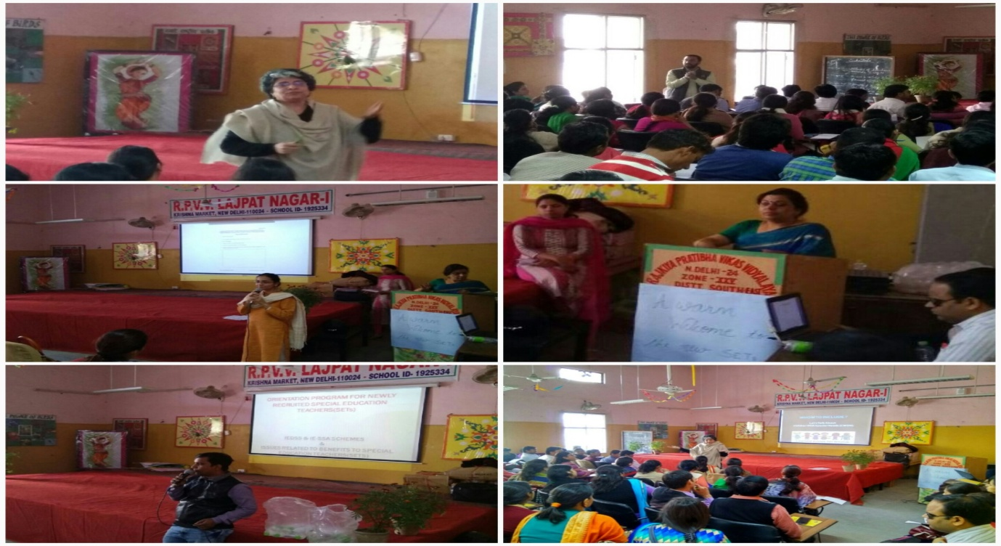

**Glimpses of a training session in progress at RPVV Lajpat Nagar**

1. **Establishment of “Resource Centre for the Hearing Impairment” at DIET MotiBagh**

“Contributes to foster an inclusive society, addressing the diverse needs of all learners”

1. **Major Achievements**

* INSET training Programme for Primary teachers of Distt. South and Central Zone.
* INSET training Programme for Teacher Educators
* Training for Pupil Teachers of DIET MB
* Establishment of Resource Center
* Organized Consortium on **“Inclusive Education concerns and issues, focusing on Hearing Impairment”.**
* Purchase of material related to Training of Teachers on H.I.
* Preparation Videos on inclusive Setup.
* Visit to different H.I instates in Delhi and Outside Delhi.
* Meetings and workshop with different Organisation and NGOs working in the field of H.I.
* Capacity building programs for Stake holders

1. **Our Publications**

* Print Material for teachers/special teachers and teacher educators**-“Making the difference”**
* Audio --Video On ***Inclusive setup ,for Hindi for class III***
* Audio- Video for ***H.I in Social studies class I***
* Audio- Video on ***Sign language for pupil teachersr***
* Audio- Video ***SEP Ek Anokha safar***
* ***Souvenir for the consortium***
* ***Brochure for the resource center***
* ***Copies of different ACTs related to PWD***
* ***RTE ACT with reference to Inclusive Education.***
* ***Collection of Resource books for Teachers/teacher Educators/ Pupil Teachers***
* ***Badlav Ki aur***

1. **Hearing Impairment Resource Center–DIET Moti Bagh have the following features & Materials:**

[**Information about H.I**](http://www.blindchildren.org/textonly/to_infoabout/index.html)

* RTE in reference to Inclusive Setup.
* ACTs and legislatures regarding PWD.
* [Success Stories](http://www.blindchildren.org/textonly/to_infoabout/1_2.html)   
  [Information about H.I](http://www.blindchildren.org/textonly/to_infoabout/1_3.html)
* [In Touch Newsletter](http://www.blindchildren.org/textonly/to_intouch/index.html)
* [Education and Capacity Building](http://www.blindchildren.org/textonly/to_edu_dev/index.html)
* Write Ups/Articles/papers regarding H.I
* [Tips for Classroom Teachers](http://www.blindchildren.org/textonly/to_edu_dev/3_5_4.html)
* [The H.I Child in the Regular Classroom](http://www.blindchildren.org/textonly/to_edu_dev/3_5_5.html)
* Making Whole Language Work
* [Educational Resource](http://www.blindchildren.org/textonly/to_edu_dev/3_5_8.html)
* List of H.I ORGANISATIONS/INSTITUTES/NGOS
* Updating data base on h.i
* Training material for the teachers/special teachers and commnity
* Medical certificate/assistance
* Information about the Assertive Aids/Aids and appliances
* [Books & manuals on H.I and Other Formats](http://www.blindchildren.org/textonly/to_edu_dev/3_6_1.html)
* [Helpful Books](http://www.blindchildren.org/textonly/to_edu_dev/3_6_2.html)
* [Helpful Videos](http://www.blindchildren.org/textonly/to_edu_dev/3_6_3.html)/[Helpful Audios](http://www.blindchildren.org/textonly/to_edu_dev/3_6_3.html)
* PWD ACT
* Bulletins and Brochures for advocacy.
* Reference books for children with special need.

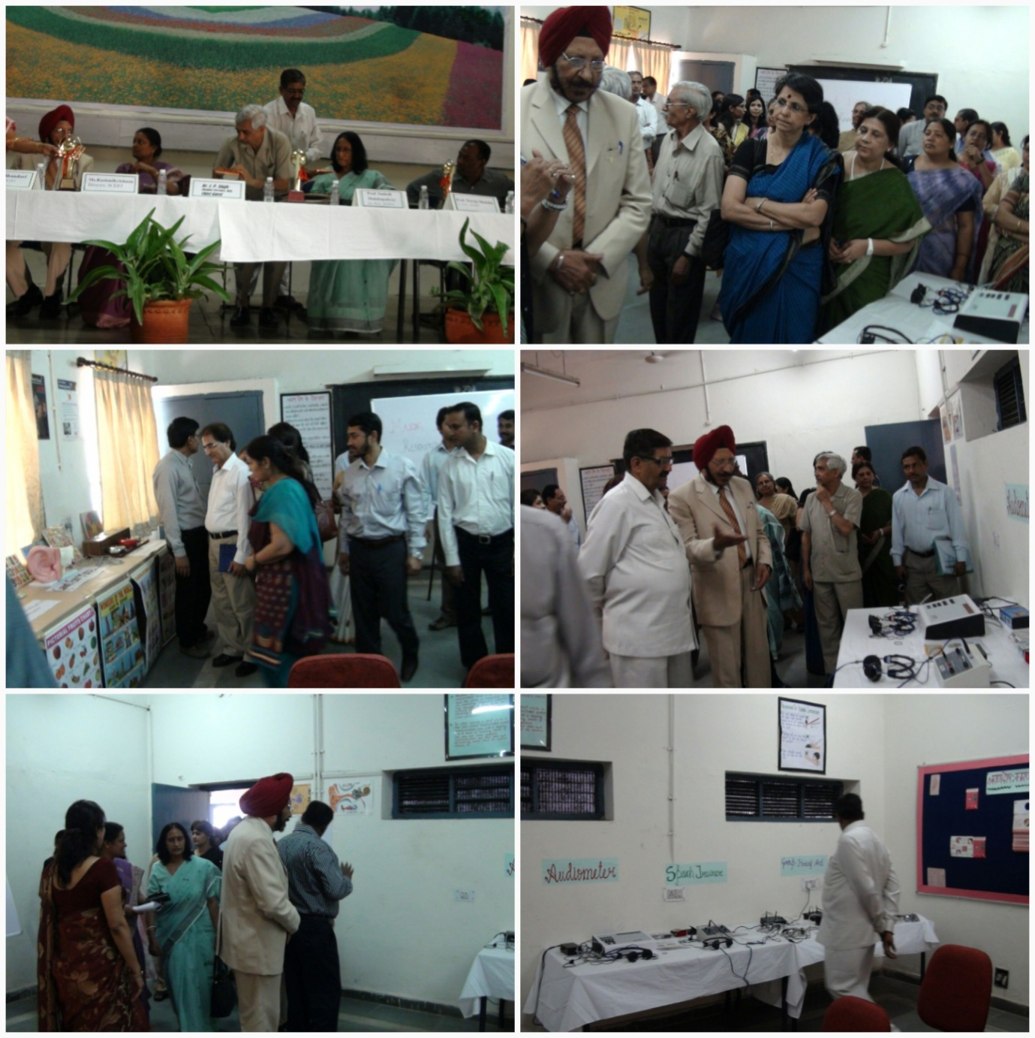

***Annexure-1***

**Material Development 2016-17**

|  |  |  |  |
| --- | --- | --- | --- |
| **S. No.** | **Title** | **Names of the coordinator** | **Status** |
| 1. | Development of EVS Activity Kit for STC | Dr. Bindu Saxena | Material for EVS Activity Kit has been finalized and procurement of material is in process  User Manual has been developed and submitted for printing |
| 2 | Development of 6 modules for PGT- Biology | Dr. Bandita Mohanty  Dr. Bindu Saxena | Submitted for printing |
| 3. | ‘Strengthening of STC & SMC-A Handbook for HoS’ | Dr. Seema Yadav | First two chapters drafted |
|  | Social Science Activity Book for Class VI | Mr. Arun Kumar  Ms. Deepa Vats | All workshops completed and vetting is under process. |
|  | “Suraksha kab kaise aur kiske dwara” | Dr. Rajender Kumar | Organize workshop for lesson writing  Final draft for vetting |
|  | Development of Course design module for training of lecturers History | Dr. Rajender Kumar | completed |
|  | Module For PGT Economics | Dr Seema Srivastva &  Ms Raman | Submitted for Printing |
|  | Module For PGT Commerce | *Dr Seema Srivastva &*  *Ms Raman* | Submitted for Printing |
|  | Module For PGT Punjabi | Ms Raman | Submitted for Printing |
|  | Module For PGT Vocational Teachers (Fashion Designing & Garment Technology) | Dr Naresh Kapoor,  Mr Sharad Sharma &  Ms Raman | Submitted for Printing |
|  | Vocational Teachers (Health and Beauty Studies) | Dr Naresh Kapoor,  Mr Sharad Sharma &  Ms Raman | Submitted for Printing |
|  | Development of Module For Vocational Teachers on Vocational Stream : ‘Fashion Design And Garment Technology’ | Dr. Naresh Kapoor, Sr. Lecturer, SCERT | Submitted for typing, composing and printing. |
|  | Development of curriculum on “**ICT in Education”** curriculum | Ms. Sapna Yadav | Developed & implemented in the schools of DoE. |
|  | **Development** of books **regarding “**ICT in Education**” Curriculum for class VI** | Ms. Sapna Yadav | ET Dept. is in the process of developing books for the students of classes VI in “**ICT in Education”** for effective teaching-learning process. |
|  | Production of Educational Video Programme | Ms. Sapna Yadav | ET Dept. of SCERT is in process of developing videos on 8 topics of Physics practical of class XII.  List of Experiments:   1. Potentiometer – Comparison of emf 2. Potentiometer – Internal resistance of a cell 3. Wheatstone’s Bridge – Estimation of resistance and Resistivity 4. Focal length of Convex lens – Using u-v and/or I/u and I/v graph 5. Focal length of Convex Mirror – Using u-v and/or I/u and I/v graph 6. Focal length of Concave lens – Using Convex lens 7. Focal length of Convex mirror – Using Convex lens 8. V-I characteristics of a pn-junction diode in Forward and reverse bias. |
|  | English Language Teaching Handbook | Ms. Sheelu Mary Alex  Ms. Aisha Islam  Mr. Vikram Kumar  Ms. Aamna Ahmed | 25-30 articles have been received so far.  A workshop is scheduled in the month of March, 2017 where in the articles will be vetted by experts and published by March, 2017 |
|  | Development of Worksheets in English for classroom use to empower and equip teachers of classes VI- VIII, IX – X and XI- XII | Ms. Sheelu Mary Alex  Ms. Aisha Islam  Mr. Vikram Kumar  Ms. Aamna Ahmed | Committees for developing of the worksheets for the different levels have been formed.  Could not be initiated and will be carried forward if unable to start before March 2017 |
|  | Supplementary material for classes 6 to 8 in 5 subjects | Various DIET coordinators | Pragati 1, 2 and 3 has been developed. Pragati 1 and 2 has been printed by DBTB |

***Annexure-2***

**List of Publications 2016-17**

|  |  |
| --- | --- |
| **S. No** | **Name of the Publication** |
| 1. | Dilli Shaala Siddhi School Standard and Evaluation Framework (English) |
| 2. | *Dilli Shaala Siddhi**(Hindi) Sudhaar Hetu Mulyankan School Maanak Avam Mulyankan ki Rooprekha* |
| 3. | Information and Communication Technology in Education Curriculum for class VI-X |
| 4. | Booklet for Capacity Building programme - 8th Oct. 2016, |
| 5. | Material for workshops of Mentor Teachers 26-30 September 2016  (Instruction Sheet, Barah khadi card, Kush Masti Kuch Parhai, Paragraphs, Stories) |
| 6. | *Vidhyalay Prabandhan Samiti Pershikshan Margdarshika(Booklet -1 for* SMC Train the Trainer Workshop in Oct-Nov- 2016*)* |
| 7. | *Parishak Hetu Parshikshan Margdarshika (Booklet -2 for* SMC Train the Trainer Workshop in Oct-Nov- 2016*)* |
| 8. | *Partibhagi hetu Parshikshan Margdarshika (Booklet -3 for* SMC Train the Trainer Workshop in Oct-Nov- 2016*)* |
| 9. | SMC Calendar 2017 (for SMC Train the Trainer Workshop in Oct-Nov- 2016) |
| 10. | Flash Cards No. 1 to 7 (for SMC Train the Trainer Workshop in Oct-Nov- 2016) |
| 11 | Capacity Building of SMC member on Parent Engagement training programme dated 12th & 19 Nov. 2016 |
| 12 | Reading Assessment Tools (Sample -1 -2-3) |
| 13 | Peryog Shaala Sahayako Hetu Sandarshika 2016-17 |
| 14 | Urdu manual for PGT 2016-17 |
| 15 | Senior Secondary Level (Punjabi) Teaching Learning Material 2016 |
| 16 | Pragati Phase-II Hindi Book for Class-VI |
| 17 | Pragati Phase-II Hindi Book for Class-VII |
| 18 | Pragati Phase-II Hindi Book for Class-VIII |
| 19 | Pragati Phase-II English Book for Class-VI |
| 20 | Pragati Phase-II English Book for Class-VII |
| 21 | Pragati Phase-II English Book for Class-VIII |
| 22 | Pragati Phase-II Science Book for Class-VI |
| 23 | Pragati Phase-II Science Book for Class-VII |
| 24 | Pragati Phase-II Science Book for Class-VIII |
| 25 | Pragati Phase-II Mathematics Book for Class-VI |
| 26 | Pragati Phase-II Mathematics Book for Class-VII |
| 27 | Pragati Phase-II Mathematics Book for Class-VIII |
| 28 | Pragati Phase-II Social Science Book for Class-VI |
| 29 | Pragati Phase-II Social Science Book for Class-VII |
| 30 | Pragati Phase-II Social Science Book for Class-VIII |
| 31 | Online Capacity Building programme 5 Dec, 2016 Brochure and Flyers |
| 32 | Delhi Education Transformation Brochure |
| 33 | Strengthening Strategic Leadership for All HoS, DoE by SCERT (10-11 January 2017) |
|  | **List of SCERT Publications Under process** |
| 34 | PGT Economics 6 Modules |
| 35 | PGT Physics 6 Modules |
| 36 | PGT Sanskrit Module |
| 37 | PGT History Module |
| 38 | PGT Political Science 6 Modules |
| 39 | PGT Chemistry 6 Modules |
| 40 | PGT Geography 6 Modules |
| 41 | PGT Physical Education 6 Modules |
| 42 | PGT Hindi Module |
| 43 | PGT Mathematics Module |
| 44 | PGT English 6 Modules |
| 45 | PGT Biology 6 Modules |
| 46 | PGT Commerce Manuals 6 Modules |
| 47 | PGT Home Science Manuals 6 Modules |
| 48 | Fashion Design and Garment Technology |
| 49 | NCERT Health & Physical Education Curriculum for Class-1st |
| 50 | Integrated Social Science Activity Book for Class -6 |
| 51 | Printing of User Manual for Using EVS Activity kit |
| 52 | Handbook STC upper primary Level |
| 53 | Handbook STC primary Level |
| 54 | Worksheet for Class 6-7 |
| 55 | Worksheets for Class 8 (level -4) |
| 56 | Vocational Manual on Health and Beauty Studies |
| 57 | Pragati Phase-III Hindi Book for Class-VI |
| 58 | Pragati Phase-III Hindi Book for Class-VII |
| 59 | Pragati Phase-III Hindi Book for Class-VIII |
| 60 | Pragati Phase-III English Book for Class-VI |
| 61 | Pragati Phase-III English Book for Class-VII |
| 62 | Pragati Phase-III English Book for Class-VIII |
| 63 | Pragati Phase-III Science Book for Class-VI |
| 64 | Pragati Phase-III Science Book for Class-VII |
| 65 | Pragati Phase-III Science Book for Class-VIII |
| 66 | Pragati Phase-III Mathematics Book for Class-VI |
| 67 | Pragati Phase-III Mathematics Book for Class-VII |
| 68 | Pragati Phase-III Mathematics Book for Class-VIII |
| 69 | Pragati Phase-III Social Science Book for Class-VI |
| 70 | Pragati Phase-III Social Science Book for Class-VII |
| 71 | Pragati Phase-III Social Science Book for Class-VIII |
| 72 | "Kahani Bhu Ki" |
| 73 | TGT/PGT Hindi manual - Hindi Gadhya Vidhao Ka Parichay |
| 74 | TGT/PGT Hindi manual - Hindi Sahitya ka Sanshipt Parichay |

***Annexure-3***

**Research & Innovations 2016-17**

|  |  |  |  |
| --- | --- | --- | --- |
| **S. No.** | **Name of the Coordinator** | **Title of the Programme** | **Status** |
| 1. | Dr Bindu Saxena | “To study the status of Special Training Centre with special reference to Teaching- Learning Process”. | Under Print |
| 2. | Dr Bindu Saxena | Status of utilization of Science Laboratories in Sarvodaya Schools of Delhi | Under Print |
| 3. | Ms. Sapna Yadav | A study of the effectiveness of educational video of Maths on classroom transactions and learning achievements among students. | Report is submitted for printing through SRSG |
| 4. | **उच्च माध्यमिक स्तर पर छात्रों द्वारा इतिहास विषय में मानचित्र आधारित अवधारणा में की गइओ साधारण त्रुटियों की पहचान करना** | Dr. Rajender Kumar | Developed the research tools. The tools were finalized to be administered in the classrooms.  Data collection could not be initiated. To be carried forward for the year 2017-18 |