Final Report
“Professional Development Program (Training Packages) for Academic Supervision and Social Mobilization Directorates, Ministry of Education”

Submitted to
“Aga Khan Foundation – AKF”
(Afghanistan Quality Learning Consortium)

Submitted By
Synergy Management Consultants
Kabul, Afghanistan

info@smc.af
+93793288230

Final Report should have the following sections and subsections accordingly.

- Executive Summary (It will be written at the end of the report).
- Acronyms and Abbreviation List (Used in training Packages)
- Acknowledgement (From all the involved stakeholders)
- Background (Could be taken from the AS and SMS need assessment report and competency framework)
- Goals and Objectives / Scope (can be taken from the RFP, inception report)
- Professional Development Program (Training Packages) Development Process (Details of the development process of the training packages)
- Explain Methodology /Approach (
- Limitations and Constraints (Covid-19 and Collapse of government any other can be added)
- Challenges (Can added from experiences like delay in feedback from AKF and working group)
- Discussion and Conclusion (How the whole list of packages developed).
- Recommendations (feasibility and how to implement all the packages).
- List of Annexes
- References if any

Goals and Objectives
The GDAS’s Competency model for Academic Supervisions comprises 4 GDAS Core Competency Cluster, 16 Competencies, 112 Sub-competencies. The Alignment of Training package involves the systematic integration of prescribed GDAS’s sub-competencies that facilitate the training module development. A comprehensive training package involves the systematic development of various competencies and facilitating the development of the knowledge, attitudinal dispositions, and transactional abilities required to be efficient in their work. By the end of this training package, academic supervisors will be able to facilitate effective teaching learning experiences in more organized, learner-centric manner on the below mentioned performance indicators:
Demonstrate the understanding of core learning theories and perspectives.
- Develop perspective required for an efficient and effective academic supervisor.
- Develop familiarity with and adapt to the prescribed sub-competencies required to reflect in knowledge, attitudinal dispositions, and transactional abilities as an academic supervisor.
- Develop instructional design with measurable instructional objectives that take into account learning outcomes using Bloom’s Taxonomy.
- Understand and use of facilitation tools and techniques to engage with stakeholders.

Professional Development Program Development Process
The approach to design training package will be a four steps process

- Identify subtopics for the main topics in consultation with the Technical Working Group.
- Agree with the Technical Working Group (TWG) the outline and subtopics of each training.
- Align GDAS Competency Framework into training design.
- Identify pedagogical approaches and procedures based on the description of the subtopics and objectives.
- Develop a detailed session plan and material (Rubric: Pedagogical Approach to Develop Session is provided below in Figure 1)

Figure 1: Rubric - Pedagogical Approach to Develop Session
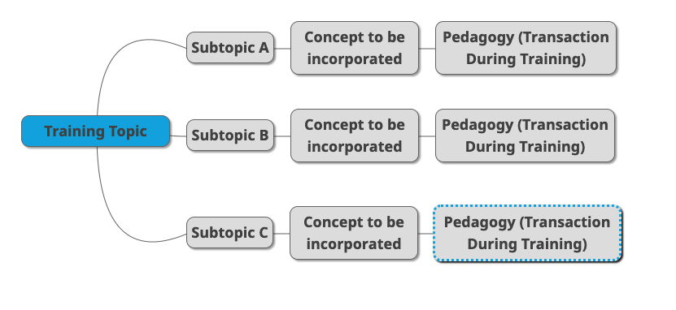
GDAS Competencies will be used to guide the module development discussions and sub-competencies will be embedded in all training modules. The integration of sub-competencies in the training module will be determined by the selection of subtopics & pedagogical procedures. Once subtopics are identified and prioritized, it is important to determine the concepts associated with them. The training methodologies for all concepts will be delivered through various engagement methods.

Training materials for Academic supervisor’s learning contain a collection of high-quality instruction materials which are comprehensive and include engaging resources. Each training Topic will include:

- Module Structure/Framework (including Curriculum)
- PowerPoint Presentation
- Exercises (group work and field based)
- Rubric for observation and Feedback
- Guides to Practical Protocols and Short Readings and references/Additional Resources
Approach for Quality Control (QC)

The SMC team has mobilized a team of experts for the development and quality control management of content developed. Additionally, a content development process has been developed which will ensure iterative review and feedback from a wide range of stakeholders, including the users (see section V for detailed on content development process).The following steps will be taken to ensure high quality products are developed:
- Need Assessment: consulting body will discuss and incorporate the needs of the supervisors in current and future context. (Ref: GDAS Needs Assessment study)
- Objectives: Based on the need assessment, objectives of the training will be set to make the training relevant and useful for the trainees as well as facilitators.
- The training will be designed to address the objectives and follow the rubric set up for pedagogic design and content presentation.
- The draft of the overall unit plans will be internally reviewed by members of the technical development team, after which it will be reviewed by the TWG composed of AQLC and GDAS experts.
- Pilot Training of Trainers (ToT): To ensure the quality and effectiveness of training content, design, and facilitation, the team will pilot a session with the local facilitators of the training. The observation and feedback notes can be incorporated into revised design and into development of subsequent topics.
- Mechanism and Evaluation: Training packages will include mechanisms and evaluation tools to measure the effectiveness of training facilitated, as well as the suitability of the level of participants, ensuring they have understood concepts delivered in the training.

To ensure consistent quality of training materials developed, the content development team will follow the procedures mentioned below.
Proper citation and references to allow for transparency of content and enable further reading as needed.
- Documenting feedback and suggestions to incorporate multiple viewpoints of different stakeholders
- Iteration to avoid redundancy in ideas
- OERs (Creative Commons-Share Alike) if any resources (Like Photographs, Films, Audio and other materials) are used. So materials can be used by all collaborators without any copyright violation.

Explain Methodology /Approach
The SMC team has developed a systematic content development process, with iterative reviews from a wide range of actors. This has been summarized below and also represented below in Figure 2. This process has been approved by the AQLC and GDAS teams.

Step 1: Development of outlines and Translation
- This document will be one to two pages long and will describe the key structure of the training and content
- The outline will be translated to ensure that relevant team members from GDAS can feed into it.
- This outline will be presented in the form of a table. The structure is shown below in Table 2:

Table 2: Training Outline Structure
Training Topic: -
No. of Days Training:
Target Group:
Day | Sub topic | Description | Pedagogy

Step 2: Discussion and agreement with TWG
- TWG members provide feedback on any gaps in areas covered by the outline
- If necessary, TWG group meeting to be held to discuss shape the training content needs to take place
- Approved outline goes into development

Step 3: Draft Content Development by lead technical team
- Lead Consultants with support from national consultant develop the material
- Content to Include
  - Module structure/framework
  - Power point presentation (ideally also including multimedia resources identified from Open Education Resources)
  - Exercises (group work and field based)
  - Rubrics for observation and feedback, and guides to practice protocols
  - Short Readings and references/additional resources

Step 4: Quality Control and Contextual relevance review by support technical team
- Assigned QC team member leads internal quality control mechanisms
- Technical review by QC team

Step 5: Technical Working Group Review and Feedback
- TWG receives material in English
- Written feedback provided in the allocated review timeframe.
- If additional discussion is needed, meeting held with lead consultants

Step 6: Revision based on feedback
- Based on feedback on content, content modifications are done by the development team.
- Support is provided by the national consultant and QC consultant.
- Content is finalized

Step 7: Translation
- Finalized content is shared with the translation team.
- If feedback to content is minimal, translation starts concurrently with Step 6.
- Content is translated to Pashto and Dari
- Translated material undergoes technical review by experts to review technical language.

Step 8: Modified submission with Translation
- Final English, Dari and Pashto Content is shared with AQLC and TWC.

Step 9: Translation Feedback (language only)
- Feedback is received from TWG, and AQLC, if determined necessary.
- Feedback is limited to language only, as content review is already done.

Step 10: Final Translation adjustments and approval by TWG
- Based on language adjustments, a final copy of all material is submitted to TWG and AQLC and recorded as complete.

Additional Steps for selected training/s for pilot

Step A: (After translation Step 7) – Pilot TOT for Kabul AS and DSMS team
- A training will be selected in the pre-activities for piloting
- Module will be developed first and piloting will be initiated first
- Clear assessment form will be developed by content development team
- ToT training will be held and feedback obtained. GDAS team to cascade training to provincial and district level staff. Additional feedback to be received
- Feedback to be shared with lead consultants

Step B: Modified content
- Feedback will not only cover the module itself, but the structure, style, which will direct to an extent the development of other modules
- Adjustments will be made prior to finalization.
Limitations and Constraints
Limitations of these training sessions are that they could not be tried in practice in the field due to time and other constraints. Hence, they are missing the contextual nuances that could have been gained from the training actually being conducted with the real time feedback of academic supervisors.

Challenges
There weren’t many challenges during the design phase of the training. The main challenges came when the draft training had to be reviewed and tested in the field. Due to delay in feedback, and receiving partial feedback, scattered feedback over long periods of time, it led to further delays in the development and revision of the training documents.
Secondly, trial of training after conversion into the local languages was also delayed, leading to further delay in finalization of the training.

Discussion and Conclusion (How the whole list of packages developed).

Recommendations (feasibility and how to implement all the packages).

