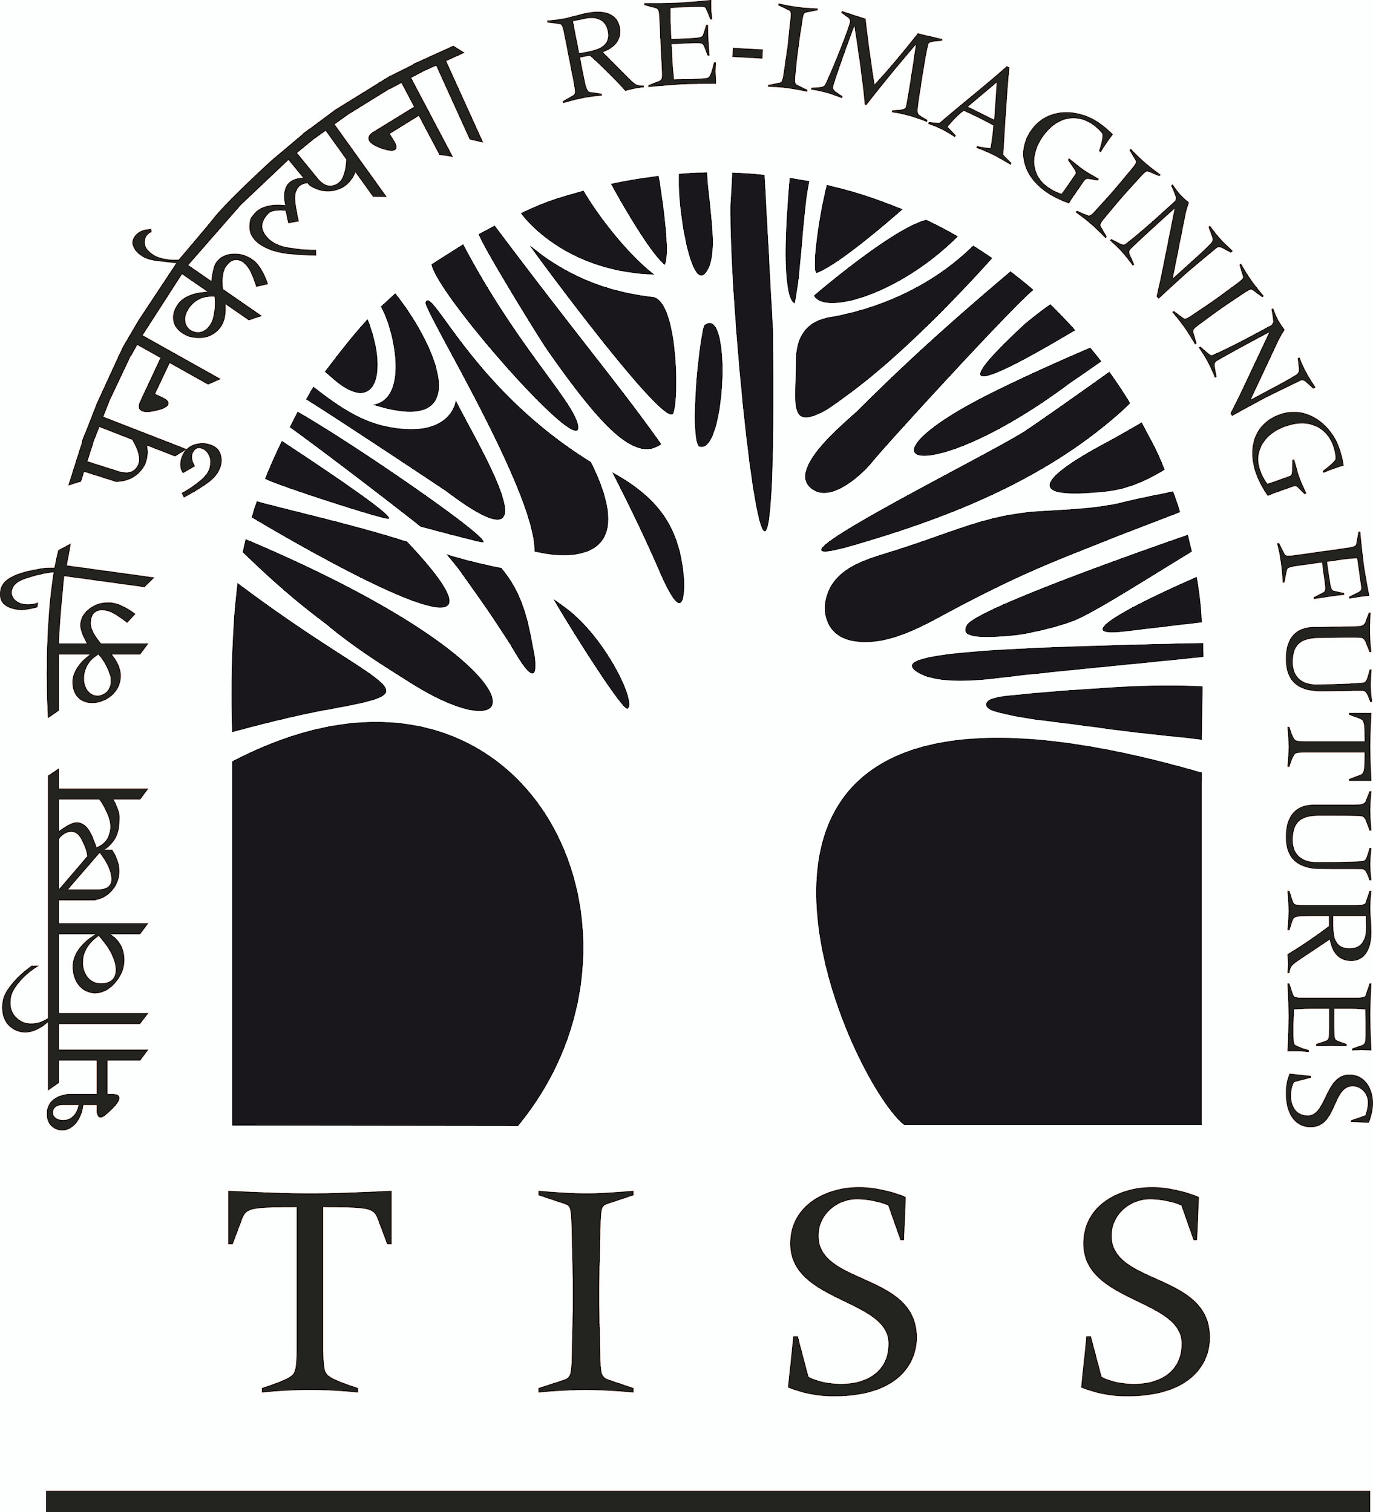

**TATA INSTITUTE OF SOCIAL SCIENCES**

Deonar, Mumbai - 400 088

**‘FACE SHEET’ FOR ETHICAL REVIEW**

| 1. | Title of the Project |  | To be filled by Office | |
| --- | --- | --- | --- | --- |
| **State of Teachers, Teaching, and Teacher Education in India Report - 2023** | Project No. |  |
| Date of Receipt |  |
| Date/s of Review |  |
| Status |  |
| Date of Start |  |
| Date of Close |  |
| Outcome |  |

| **Chairperson** | Prof. Indra Munshi |
| --- | --- |
| **External Expert-Social Sciences** | Prof. T. V. Sekher |
| **Member** | Prof. Manish Jha |
| **Member** | Dr Nilesh Gawde |
| **Member** | Prof. Sasmita Palo |
| **Member** | Dr M. Irshad |
| **Member** | Prof. Zubin Mulla |
| **Member** | Dr Chetna Duggal |
| **Member** | Prof. Bino Paul |
| **External Expert-Social Sciences** | Dr Saman Afroz |
| **External Expert-Child Rights** | Prof Nilima Mehta |
| **External Expert- Legal** | Advocate Mini Mathew |
| **Community Representative (External)** | Mr. Bhaskar Kakad |
| **Member Secretary** | Prof. Surinder Jaswal |

| 2. | Name, affiliation, official postal address, telephone nos., e-mail address of the  Principal Investigator / Co-coordinator.  (*If it is a multicentric study, who would be responsible for implementation of the project)* |
| --- | --- |
|  | Prof. Padma Sarangapani, Professor and Chaiperson, Centre of Excellence in Teacher Education, Tata Institute of Social Sciences, Mumbai. Telephone Number: 9740010510 Email: [psarangapani@tiss.edu](mailto:psarangapani@tiss.edu)  Prof. Mythili Ramchand, Professor, Centre of Excellence in Teacher Education, Tata Institute of Social Sciences, Mumbai. Email: mythili.ramchand@tiss.edu  Dr. Kamlesh Goyal, Senior Research Associate, Centre of Excellence in Teacher Education, Tata Institute of Social Sciences, Mumbai, Telephone Number:--+91-98882 34841 Email: kamlesh.goyal[@tiss.edu](mailto:emon.nandi@tiss.edu)  Aditi Desai, Research Associate, Centre of Excellence in Teacher Education, Tata Institute of Social Sciences, Mumbai, Telephone Number:--+91-9167059041 Email: aditi.deasi[@tiss.edu](mailto:emon.nandi@tiss.edu) |

| 3. | Name and address of the Institution / Organization responsible for conduct / coordination of the project. | 3(a) | Name and address of the Officer responsible for institutional supervision |
| --- | --- | --- | --- |
| Centre of Excellence in Teacher Education, Tata Institute of Social Sciences, V N Purav Marg, Deonar, Mumbai - 400088 | Prof. Padma Sarangapani |

| 4. | Name and address of the Funding / Sponsoring Institution | 4(a) | Name and address of the Officer-in-Charge of the Funding / Sponsoring institution |
| --- | --- | --- | --- |
| Centre of Excellence in Teacher Education, Tata Institute of Social Sciences, Mumbai | Prof. Padma Sarangapani, Centre of Excellence in Teacher Education, Tata Institute of Social Sciences, Mumbai |

5. To be answered / responded by the PI / Co-coordinator

| a. | Does the protocol involve human participants? (If yes, give details) | Yes, the study involves surveys with teachers, headteachers, and education officers. |
| --- | --- | --- |
| i) | Does the protocol involve any kinds of risks related to violation of rights of the participants or the community in general?  *(If yes, give details)* | No. |
| ii) | Have all team members undergone relevant training for understanding the ethical considerations in the project?  *(If no, give details)* | Yes |
| iii) | Are measures regarding maintaining of data confidentiality in place?  *(If no, give details)* | Yes. |
| b. | Does the protocol involve inclusion of vulnerable subjects  *(If yes, special precautions proposed to safeguard their rights and*  *interests shall be documented on separate sheet)* | No. |

It is certified that the statements made herein are true, complete and accurate to the best of my/our knowledge. I am aware that any false, fictitious or fraudulent statements or claims may subject me/us to criminal, civil, or administrative penalties. I/We agree to accept responsibility for the scientific conduct of the project and to provide required progress reports if the permission is granted as a result of this application.

| Signature and assurance of the Principal Investigator / Coordinator responsible for conduct of the study  Prof. Padma Sarangapani |  | (Principal Investigator)  (Signature) | | | |
| --- | --- | --- | --- | --- | --- |
| Date |  | Place | Mumbai |
| (Stamp / Seal) | | | |

| Signature and assurance of the Dean / Chairperson of the School/Independent Centre responsible for conduct of the study | (Signature) | | | |
| --- | --- | --- | --- | --- |
| Date |  | Place |  |
| (Stamp / Seal) | | | |

| Signature and assurance of the Head of the Institution / Authorized person responsible for conduct of the study | (Signature) | | | |
| --- | --- | --- | --- | --- |
| Date |  | Place | Mumbai |
| (Stamp / Seal) | | | |

Signatures of all Co-Investigators

Prof Mythili Ramchand

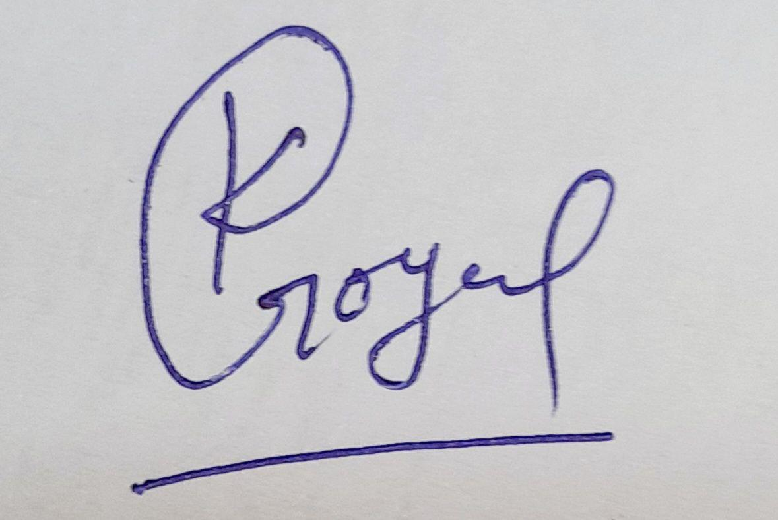

Kamlesh Goyal

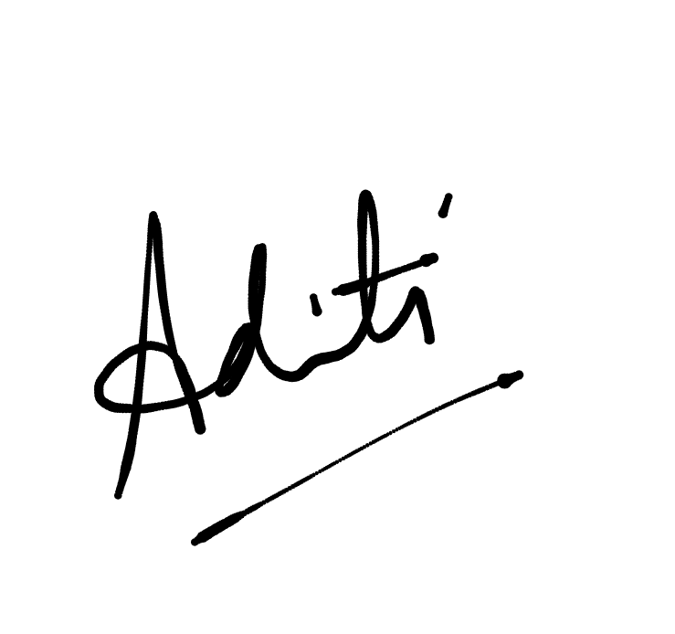

Aditi Desai

| **Title of Project:**  **State of Teachers, Teaching, and Teacher Education in India Report - 2023** |
| --- |

| **Aim & Objective (75 -200 words):**  This report aims to address the question of the demand and supply of teachers, and teacher availability in schools. Through estimating and projecting teacher needs across different subjects, levels and school types and identifying the availability, this study attempts to analyze the issue of teacher shortage and provide suggestions for teacher recruitment and deployment to fill this gap.  **Research Questions**   1. What is the supply of professionally qualified teachers (including the subjects and different levels) and what is its quality? 2. What and where is the demand for qualified teachers? 3. What is the status of supply and demand and deployment in relation to factors such as the size of the state, region (rural/urban), type of management of the school, and for different subject areas (all school subjects including arts, physical education, computer science, work education, and special education), and levels of school (early years, primary and secondary), school management? Are the RtE norms on teacher availability in schools met? 4. What are the demographic characteristics and trends of the teacher labour force? Does it reflect the population demography? What are the trends in feminisation? |
| --- |

| **Brief Background of the Project (250-500 words):**  The State of the Education Report for India 2021, ‘No Teacher, No Class’, identifies over one million teacher vacancies across different states, and over one lakh single-teacher schools. This serves as the starting point for the current report. Teacher shortage remains a huge challenge worldwide, affecting the quality of teaching and learning. Recruitment, deployment and distribution of teachers is complex, and in the case of India, it is also political (Ramachandran, 2021). The supply and demand of teachers pose various challenges such as: recruiting teachers with requisite qualifications across different subjects and levels, estimating the need, deployment of teachers in different types of schools, addressing concerns of equity and justice through the allocation and distribution of teachers in underserved areas, and so on (Organisation for Economic Cooperation and Development [OECD], 2012).  The OECD, 2012 report finds that schools serving the underprivileged are often located in remote areas and hence least preferred by teachers, thus further disadvantageous the already poor and marginalised communities. Given these challenges, how do we ensure that every child in school is taught, and receives equitable and quality education? This report aims to address the question of the demand and supply of teachers, and teacher availability in schools. Through estimating and projecting teacher needs across different subjects, levels and school types and identifying teacher availability, this study attempts to analyse the issue of teacher shortage and provide suggestions for teacher recruitment and deployment to fill this gap.  The report will inform policy and provide suggestions for teacher deployment in selected states and across India. Research and data that highlights the teacher availability across different school management and school types are few in the Indian context. This report intends to fill this gap and focus on teacher supply and demand. |
| --- |

| **Methodology (250-500 words):**  The report will analyse the demand and supply of teachers, and teacher availability in schools across the country, on the basis of both primary and secondary data.  **Secondary data**  In terms of secondary data, Data related to the supply of teachers (in the context of science, maths, languages, performing arts, physical education, special education, computer science, head teachers etc.) will be extracted from multiple sources such as annual reports of the Ministry of Education (MoE), NCTE, Central Board of Secondary Education (CBSE) and other data sources such as UDISE, AISHE, PLFS, PAB Minutes, Press Information Bureau (PIB) etc. As far as possible, this secondary data will be disaggregated by type of management (government/private/others).  The data regarding the demand for qualified teachers will be accessed from a number of sources, particularly vacancy advertisements of Central and State governments and large-scale private school managements (socio-religious organizations and philanthropic, CSR-funded schools etc). The policy documents pertaining to the recruitment and deployment of different state governments will also be analysed. The guidelines published by NCTE on teacher recruitment, NITI AAYOG, and data from CTET and state TETs on pass percentage will serve as important sources of information. The secondary literature and research reports will be reviewed for this purpose.  **Primary data**  The primary data collection would be done with teachers, head teachers, teacher educators, student-teachers, and department functionaries at the district and state levels to understand the availability of teachers, recruitment and deployment policies in the chosen states. Different school management and Teacher Education Institutions (TEIs) are the sites of study. For this purpose, **ten states - Assam, Chhattisgarh, Bihar, Delhi, Karnataka, Maharashtra, Meghalaya, Punjab, Telangana, and Odisha** are proposed for in-depth analysis. Twenty-nine districts have been selected in total in these ten states (3 each in a state). The primary data collection would involve surveys in schools and TEIs and in-depth interviews with district officials and teacher unions. |
| --- |

| **References:**  Belur, R. (2021, Oct 21). Now, engineering graduates can teach at Karnataka govt schools. *Deccan*  *Herald.*  https://www.deccanherald.com/state/now-engineering-graduates-can-teach-at-  karnataka-govt-schools-1044861.html (accessed on 19 November 2022)  Does India have enough special teachers? Supreme Court asks (2021, Oct, 21).  https://www.indiatoday.in/education-today/news/story/does-india-have-enough-special-teachers-supreme-court-asks-1870970-2021-10-29 (accessed on 19 November 2022)  MHRD (2017). Samagra Shiksha: Framework for Implementation (Draft). https://samagra.  education.gov.in/docs/Framework_IISE%20_F.pdf (accessed on 13 October 2022).  MHRD (2020). National Education Policy. MHRD: New Delhi  OECD (2012). Preparing teachers and developing school leaders for the 21st century – Lessons from  around the world. OECD  Ramachandran, V., Béteille,T., Linden, T., Dey, S., Goyal, S. and Chatterjee, P.G. (2018). Getting the  right teachers into the right schools: managing India’s teacher workforce. World Bank Study.  Ramachandran, V. (2021). Shortage of subject teachers: a festering wound in the Indian school  system. https://research.acer.edu.au/teacher_india/40 (accessed on 13 November 2022)  Sarangapani, P., Thirumalai, B., Ramanathan, A., Kumar, R., and Ramchand. M. (2021). State of the  Education Report for India 2021, No Teacher, No Class. New Delhi, UNESCO Regional Office.  https://unesdoc.unesco.org/ark:/48223/pf0000379115/PDF/379115eng.pdf.multi |
| --- |