A Policy Implementation Analysis Report

UNICEF-TISS collaboration

Shala Granthalaya chi Ghosti: The Story of School Libraries in Maharashtra, India

Name of Authors & Team
Citation: Ramanathan, A., Kamble, S., Mitra, S. Chalwadi, R. Jayaram, A. (2023). Shala Granthalaya chi Ghosti: The Story of School Libraries in Maharashtra. CETE, TISS and UNICEF.

Authoring Team
Anusha Ramanathan, Assistant Professor
Sheetal Kamble, Postdoctoral Fellow
Shreyasi Mitra, Research Associate
Ravi Chalwadi, Research Assistant
Arpitha Jayaram K, Research Manager

Research Team
Anusha Ramanathan
Sheetal Kamble
Dinesh Chand
Ravi Chalwadi
Shreyasi Mitra
Nishevita Jayendran

Student Interns Team for Data Collection, Compilation and Analysis
Aishwarya Anilkumar Jadhav
Agasti Chaskar
Ameya Sanjay Jadhav
Bhavna Shahare
Dipalee Kamble
Kajal Gupta
Kushali Arote
Madhuri Bhale
Maitrayee Pan
Prapti Shamkuwar
Riya Wasnik
Saurabh Bhusari
Soumya Chahande

Graphic Design
Ramesh Khade

Acknowledgement

We would like to express our sincere gratitude to the team at UNICEF, Ms Reshma Agarwal and Ms Maithili Gupte, who have been the stalwarts behind this research study from conception to execution to now its reception. They have facilitated the process and given many insights through every step of the way.
We would especially thank Ms. Saroj Jagtap at Samagra Shiksha who coordinated all our visits and facilitated the Google Survey form to be circulated through WhatsApp groups and circulars. She not only gave inputs but also held late-night debriefs with this research team on the status of data collection and the way forward. Without her support, this research could not have had the reach it did.

We further thank the team at SCERT, Pune who met us and were gracious enough to spare us time for interviews and follow-up calls.

Research in the field of libraries and the use of libraries needs the voices of practitioners to inform the study and the design of the tools. We were lucky enough to have on our advisory panel Ms Parul Bajaj from Parag, Tata Trusts; Ms. Purvi Shah, Pratham Books, StoryWeaver; Mr Saktirbata Sen, Room to Read and Ms. Sujata Noronha, Bookworm Goa all representing library spaces and Ms. Shveta Lall, Language and Learning Foundation coming in as the advisory expert for language and literacy development. Their inputs have helped refine our tools for the research and we wish we could have done more of the open-ended questions such as ‘What books do you read, ‘describe your vision of a library’ in the survey as well. These questions in the interviews revealed a lot of insights and Saktibrata Sen’s idea of looking at community habits and attitudes regarding libraries deserves research themselves. The feeble forays we made as offshoots to our research visits tell us this question deserves historical research to understand the changes over time from oral cultures of storytelling to script-based consumption of stories and the impact on literacy and not just script-literacy, but also communicative, critical and cultural literacies.
Thanks are also owed to Prof Padma Sarangapani, our Centre’s Chair for supporting us through and through and Ms Gayathri Moily for her constant support through the many financial aspects we had to maneuver. Mr Tushar Vaity who oriented student-interns through travels and claims and Mr Vijay Jathore for handling the personnel.
Last, but not least, we cannot forget the 13 student interns we were privileged to work with: Aaishwarya Anilkumar Jadhav, Agasti Chaskar, Ameya Sanjay Jadhav, Bhavna Shahare, Dipalee Kamble, Kajal Gupta, Kushali Arote, Madhuri Bhale; Maitrayee Pan, Prapti Shamkuwar, Riya Wasnik, Saurabh Bhusari and Soumya Chahande They were on the field for weeks and went beyond their brief in their quest to trace how libraries/books were used in schools and the processes of the policy implementation. They grappled with frustration many times and have anecdotes that can (and should) fill a book. This research is based on the work they did. We are proud of them all and thankful to each one of them.
Content Table

- Acknowledgement
- Abbreviations
- Executive Summary

- Introduction
1.1 About the study
1.2 Research Objective
1.3 Research Design and Methodology
- Background
2.1 Literature review on the importance of libraries and the nature of libraries

- Reflections from the Teachers and Other Stakeholders on School Libraries

- Insights from Research: Current State of School Libraries in Maharashtra
4.1 Segregation of Districts for Survey
4.2 Pilot Study - Nashik District
4.3 Survey Findings
4.3.1 Existence of Library and Infrastructure
4.3.2 Access to Library
4.3.3 Collection of Books and Resources
4.3.4 Utilization of Funds
- Stakeholders
5.1 Role of Stakeholders
5.2 Library and Community
5.3 NGO Participation

- Caselets and Best Practices

- Conclusion and Recommendations

- References

- Annexure

Abbreviations

ASER Annual Status of Education Report
BEO Block Education Officer
BRC Block Resource Centre
BRP Block Resource Person
CRC Cluster Resource Centre
CRP Cluster Resource Person
DEO District Education Officer
DIET District Institute for Education and Training
FGD Focus Group Discussion
MPSP Maharashtra Prathamik Shikshan Parishad
NCF National Curriculum Framework
NEP National Education Policy
NIPUN National Initiative for Proficiency in Reading with Understanding and Numeracy
PRIs Panchayat Raj Institutions
SCERT State Council of Educational Research and Training
SMC School Management Committee
UDISE Unified District Information System for Education
ZPHS Zilla Parishad High School

Executive Summary

Shala Granthalaya chi Ghosti (The Story of School Libraries in Maharashtra) is a study to assess the status of school libraries in government elementary schools in Maharashtra.

The National Educational Policy (NEP) 2020 values libraries in keeping with the Samagra Shiksha guidelines to include the provision of library grants to all government schools. The study aims to contribute as a policy analysis report highlighting the school library budget in Maharashtra and promoting reading habits among school children. With the support from Samagra Shiksha, it was possible to reach out to the stakeholders and study the use of the school library budget. This study allowed us to visit a ZP school in Maharashtra and gather recommendations from teachers/HMs /BRC /CRC /SMC /DIET faculty and DEO/BEO to sustain the school library.

The current analysis will serve as a valuable reference to inform and enhance current and future programs and school library budget policy changes. Recommendations will also be considered to create more significant support for teachers and children to promote reading habits among children and allow for inclusivity.

Main Findings:
The following are the findings of the school library study
- Not all children can easily access books due to limited library and reading corner spaces in the school. Children with special needs have almost no access to books or libraries.
- There is no dedicated period for the school library. Hence it gets difficult to track for teachers the time children spend in libraries and their progress.
- School libraries are not available during vacation. So it is difficult to engage children in reading. Only a few villages have community libraries to reach out to children. But, the books available there are not age-appropriate for children.

Recommendations:
- The fund of Rs. 5000/- is not enough to run a library in schools with more than 200 students and the durability of the books is also quite short. Therefore, adequate funds are required for the maintenance of the library space and the books and toys and such,
- There must be an increase in awareness of existing schemes and funding among all stakeholders: from DEOs to SMC Members.
- There is a dire need for training teachers and to research the use of the library space more effectively in low-resource contexts such as government schools.
- The School Management Committee should be activated with an increased focus on Library usage and ensure community engagement in library activities.
- A separate space for libraries is a requirement. Separate rooms are essential to creating a reading environment for children because the reading corner has limitations.
- The school should have a library period so that the maximum number of students can benefit from it. Timetabling library use would increase the use of the library by a corner shelf or a room full of books
- The teachers and HMs should be provided with the agency to select the kind of books required for their children. The teachers should not only be a part of the book selection committee but should also be upskilled to be able to create/relevel/translate storybooks for the school library.
- Library books should be age-appropriate, diverse, engaging, and valuable. Texts should be codified, and physical facilities should be provided. Resources should be open for all to read, and records should be kept. There should be regular management of books. Multilingual books should be available in the school library, according to the languages spoken by the school children.
- Schools should be enabled to curate and create digital materials for CWSN students to build more inclusive libraries.
- Access to libraries should be provided beyond school hours and home lending should be allowed alongside creating a robust and digitized system of tracking the use of books and per-student reading engagement.
- The dependency on external agents (NGOs) to activate and maintain school libraries should be reduced to ensure sustainability.

- Introduction

1.1 About the Study

The Shala Granthalaya chi Ghosti (The Story of School Libraries in Maharashtra) is a study aimed at understanding the state of school libraries in elementary schools in Maharashtra. The study was conducted in the Zilla Parishad (ZP) schools of Maharashtra, looking at the functioning of the school libraries, their usage, best practices in some of these schools, problems associated with the effective functioning of the libraries, issues with the availability of the quality of the books and the age appropriateness of these books.

This is a study that responds to UNICEF’s call for proposals to assess the status of school libraries in government elementary schools in Maharashtra. In the case of Maharashtra, the UDISE data showcases heartening statistics such as the fact that 99% of schools report that they have libraries. However, even though Samagra Shiksha Abhiyaan accords primary schools (grades 1-5), an annual library grant of Rs. 5000/- and upper-primary schools (grades 6-8), Rs. 13,000/-49% of schools have 100 books and only 6% report having more than 300 books. Furthermore, only 48% of head teachers (a number similar to the schools with 100 books) report satisfaction with the library resources they have.

With the increase in the focus on foundational literacy and numeracy under the National Education Policy(NEP) 2020 and the records of learning loss and poor reading levels, the importance of libraries that can be spaces for joyful learning and developing literacies cannot be emphasized enough. The NEP highlights the need to strengthen libraries and emphasizes providing access to ‘enjoyable’ and relevant books for children to ensure a culture of reading in schools. Furthermore, the National Achievement Survey (NAS) results pre-Covid indicated that schools with an active library tended to achieve better learning outcomes. The discrepancy between States that rank high on NAS as opposed to those that rank low is an almost 30 per cent differential in libraries with 91% of schools in high-ranking states having a library as opposed to a 62% in low-ranking ones.

To better support schools in promoting the use of libraries, it is critical to understand the current status of libraries and library usage, along with the existing models of library settings in schools across Maharashtra.

There is little research available on libraries and library use across India even without a specific state focus. While many institutions are working in the space of libraries and how to enhance their use, the reports of the use of libraries are restricted to the sites of the non-state actors’ interventions for the most part. Furthermore, the UDISE data reporting has not been corroborated through research at any juncture. With the increased focus on Foundational Literacy and Numeracy, the thrust on home language instruction and the need for more play-based, joyful learning in the education system the need to study if spaces such as libraries are active in schools and enable students to observe themselves in the stories, see worlds beyond their experiences and develop their ability to imagine vistas and experiences unexplored. This study is unique for being one of the few to study the library spaces in schools and looks at the effectiveness of the implementation of a much-lauded policy scheme of Padhe Bharat Badhe Bharat (India Reads, India Develops). It has become imperative to see how libraries in government schools that are imagined as spaces for holistic development and bringing the community together with marginalized children especially having a safe space to read books and exponentially increase their opportunities are actualised in reality.

1.2 Research Objective
The overall objective is to recommend the state, practices, and policy-level changes for ensuring the effective use of libraries to promote literacy and reading in government schools in Maharashtra. Specifically, the study aimed to
- Compile the various policies and documents such as National Education Policy 2020, Revised guidelines of the Samagra Shiksha for Library Grant and promoting reading in schools, of NIPUN Bharat Programme ( National Initiative for Proficiency in Reading with Understanding and Numeracy Bharat Programme), and ASER report (The ASER, is an annual, citizen-led household survey), and provisions on libraries issued by the Government of India and in the state chronologically.
- Assess the status of libraries vis-à-vis the above policies and provisions at the school level.
- Understand the status of school libraries in Maharashtra, from the perspective of book availability, the types of books, their quality and appropriateness for children of all age groups, the functioning of the libraries, and usage among students;
- Study the type of training given to teachers to promote the use of libraries for students in school;
- Identify the gaps in current policies/ implementation and expectations from children and schools;
- Document good practices and innovations in the context of libraries and library use in the state.

1.3 Research Design and Methodology
For this study, qualitative and quantitative methods for data collection were used.
- Secondary research to establish the importance of libraries as physical spaces to improve literacies ranging from foundational to critical to cultural
- Present an analysis of various policies and frameworks related to libraries, especially in the context of Maharashtra.
- Survey to understand
  - The nuances of the libraries that exist in government elementary schools in Maharashtra concerning availability, quality, access, and use of library resources,
  - Teacher preparedness in identifying, selecting, and facilitating the use of resources,
  - Stakeholders’ perceptions regarding the use of libraries.
- Gather first-hand information concerning the availability of, access to, and use of resources in the library.
- Identify gaps between policy and practice and similarities and differences in stakeholder perceptions.
- Identify and document best practices adopted by government school libraries.
This research used a mixed study methodology that included secondary data analysis, in-depth literature review, desk review of relevant and credible data sets, interviews with key stakeholders, FGDs, and field visits as follows:
- Desk research included compilation and analysis of available research studies by universities/ reputed NGOs/ other agencies on the status of libraries in the last five years. Data from reliable data sets such as the UDISE and reports published by the state on utilizing library funds were also considered.
- Field Survey: Data collection for the study used both qualitative and quantitative methodologies of data collection, including focus group discussions, interviews, and field surveys with relevant stakeholders.

The primary respondents of the study were district officials (DIET and EO office), block and cluster officials, school HMs, teachers, children, and other relevant stakeholders working in the schools(including community representatives). To the extent possible, we have ensured respondents' diversity in age, gender, and social groups and geographies.
The study was conducted in selected government (education department) elementary (grades 1-8) schools that have received books in the last five years and funds for infrastructure to set up school libraries. The same included different types of schools based on the enrollment size of the 36 districts in the state.
The image below shows the themes under which the survey was conducted.
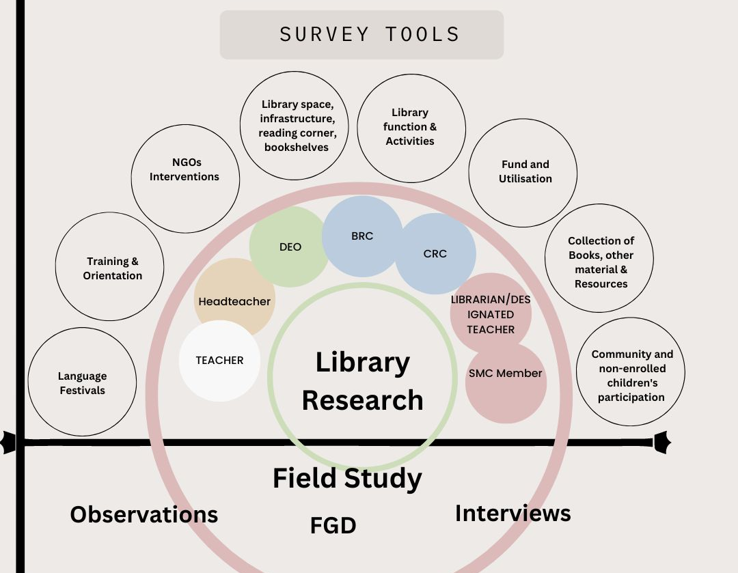
Fig 1: Survey Tools
The first data collection phase used rapid survey tools to cover all 36 districts of Maharashtra—the survey form required facilitation at the SCERT and DEO levels to be sent out as formal orders.
The second phase of data collection included field visits. The field visits cover 17 districts. This selection was based on purposive sampling to representatively cover rural, urban, and tribal sites guided by suggestions solicited from the stakeholders, the trends indicated by the rapid survey, and the suggestions by UNICEF. The primary respondents were school HMs, teachers, students, and those working in the schools in the library space, including community leaders and NGO members. The tools used were interviews and focus group discussions primarily. There was also the observation of a session of students using library resources. In each district, attempts were made to visit 02 representative schools. There were also crucial informant interviews conducted with district officials, SCERT officials, and the leadership of other private bodies or NGOs working in the library space in government elementary schools in Maharashtra.

- Background

Library Space and Significance of the Role of Teachers:

Singh (2003) lamented the lack of a library to support a reading culture for the 'neo-literates' in India. Schools are often the only place students can access learning materials besides textbooks in low-resource contexts. Unlike textbooks that offer students little agency in the selection process, libraries afford them a space to explore and exercise their agency in choosing materials that cater to their interests. Thus, the space is transformative enabling skills such as critical literacy.

The needle has recently moved in India concerning policies highlighting the need for libraries and encouraging schools to invest in them. Be it the National Curriculum Framework of 2005, the Right of Children to Free and Compulsory Education Act of 2009, or the National Education Policy of 2020, the thrust on libraries as a core learning space has been highlighted repeatedly.

With the increase in the focus on foundational literacy and numeracy under the NEP 2020 and the records of learning loss and poor reading levels, the importance of libraries that can be spaces for joyful learning and developing literacies cannot be emphasized enough. The NEP highlights the need to strengthen libraries and emphasizes providing access to 'enjoyable' and relevant books for children to ensure a school reading culture. To better support schools in promoting the use of libraries, it is critical to understand the current status of libraries and library usage, along with the existing models of library settings in schools across Maharashtra.

School libraries play an active and leading role in the educational process, where they help pupils to continue their education effectively so they can learn by themselves. School libraries bear the slogan "Learn how to teach yourself and search for information" (Aljahran, 2007)
School libraries aim to encourage teachers and students to use the available materials in the education process. The objectives achieved through school libraries in school education may be increasingly different from those being achieved through textbooks. The library should have the necessary materials and teachers to teach the children how to use the materials, thus instilling in the students a natural interest in acquiring knowledge.
Textbooks are teaching tools but have many limitations. Textbooks do not create enjoyable learning for children and do not connect with children's experiences. Hence the idea of story books has a positive effect on children and contributes to learning. Books not only develop the habit of reading in children but also increase their vocabulary. Through assisted learning, children begin to think and express their own opinions while learning.
According to author Sara Srygley (1967), the school library should also reflect the purposes of the school, its concepts of how learning is achieved, and the needs and interests of the children and teachers served.
In a program characterized chiefly by a teacher or text-transmitted knowledge, the library becomes a supplementary program, often used by children who independently explore its resources unrelated to basic instruction. It is, therefore, a place for a child’s development. Children can choose a book that matches their interests. Sometimes children visit the library because they like the place. Providing books to read can help connect children and influence other children to read books and use the library.
Therefore, libraries should be sensitive to individual differences among children, the potential of modern communication media, and the psychological value of visual media on children while catering to the needs of children. (Srygley and Krentzman, 67)

School library researchers representing countries worldwide have repeatedly demonstrated the role that school libraries and school librarians have on students' reading comprehension and motivation. Various articles about reading and promoting reading in school libraries were published from 2010 to 2016. School library researchers worldwide agree that additional research is needed to determine how school library programs affect student achievement.
That is why the Right of Child to Free Compulsory Education Act 2009 has made libraries compulsory in every school. The library reference criteria are as follows:
Nature of School Library
The collection of library materials has specific objectives in mind. School administrators and principals should take a definite stance on whether the school should have a single central library or classroom library. A single central library is for a small number of children or for a single child. Classroom libraries can be used by students who finish their class work or as a lone service for the class to supplement the books they read from the main library. One important thing one should remember while accepting the role of a librarian is that the success of a school library depends on how much the students and teachers have access to library books.
Classroom Libraries
It is an ideal library system to have a central library and trained librarians in every school. However, considering the space constraints of today's schools, providing a central library to all the schools is impossible. Class libraries are indispensable in schools that cannot afford to start a central library. Class libraries greatly help student development if they are appropriately run in a planned manner. Class libraries are an essential practice in school libraries. In this practice, students who serve as classroom librarians gain hands-on experience in librarianship and develop leadership qualities. Other students get to observe the work of the library closely. Library books are different from textbooks. These books encouraged children to read independently. Children develop their vocabulary and try to express their thoughts in class.

Exchange of books
Providing students with books to read at home is an important educational function of the library. As students need more time to read books and reference books during school hours, arrangements should be made to take books home. There is a great need for this service to develop an interest in reading among students and increase it. This situation defines the role of the School Management Committee to involve parents and community members in reading and functional literacy.

Magazines and Newspapers
Students cannot read magazines and newspapers during school hours despite their desire due to lack of time. It is educationally crucial for school students to read tangible periodicals and newspapers. So that the students are provided with this good reading material, special provisions should be made so that they can read it during mid-term break or after school. Teachers and children need more time to access the school library. Dedicated reading periods help keep children, and teachers engaged in school library activities and increase children's reading ability. Magazines and newspapers update children's knowledge.

Reading Rope Activity
These activities from primary schools are very successful nowadays. In this, a rope is tied to the classroom's front wall. Books are hung on ropes keeping in mind the students' age, interests, and curriculum. Students take books and read according to their available time. Books are replaced after a certain period. In this way, the library provides an impetus for the overall development of the students. This is the best way for schools to attract children to reading.
A recent example of the importance of libraries can be demonstrated through the example of Karnataka. The state initiated a new social movement by revitalizing and recalibrating the 5600-strong network of rural libraries. The government of Karnataka has started a community library in the village. They appointed trained librarians in the village to assist children. Children who are not enrolled in school have access to this library. It is not only a unique model of a community library but also it engages the community to inculcate the habit of reading in children.
Historically, decentralized governance through Panchayat Raj Institutions (PRIs) has empowered rural communities. In Karnataka, panchayats were vital in renovating library buildings with child-friendly murals and parks. The funds raised by the Panchayats were utilized appropriately. The state government has sanctioned 339 new libraries this year, 2022. (Nakray and Keerty, 2022)
- Reflections on School Libraries
The study involved multiple interviews with Teachers, HMs, CRCs, BRCs, and DEOs. During these interactions, the teachers and other stakeholders shared their understandings and reflections on the importance of reading for children, the purpose of libraries and their impact and so on. This section has some of the reflections shared.
One of the teachers while speaking about reading said ”Reading not only gives happiness to children but also gives them the freedom to choose books, they are an important tool for empowering the human brain, and libraries play an important role in accomplishing this.'' Another teacher emphasized the importance of reading, “A library is the centre of knowledge for children. Books help develop children's joy of reading and their habit of reading. It increases children's vocabulary. Children discuss this at home and school. Parents also develop an interest in reading’’.
Our data indicates that the teachers are aware of the necessity of libraries. While talking about libraries one of the teachers said “Library is an ocean of knowledge, one who enters this ocean, will know the vast wealth of books and reading.... the rich experiences of life can only be realized through reading”, Another teacher said “the idea of a library is not only books but the availability of books to teachers and children. However, they have limited reading materials for elementary school. We cannot ensure accessibility and availability''.
One other teacher reflected on learning skills and enjoyable learning processes.” Classroom libraries engage children more in reading, and joyful reading helps children lead active reading and writing processes”. To this, another teacher adds “'The 6th to 8th-grade children are more interested in their future, and in this process, the library plays an important role in providing magazines and newspapers and other resources for children‘'. Another teacher shared their idea of a library “A library is essential for every school. Because all students need books for supplementary reading.”. They also said, “The library is a repository of knowledge. This repository starts from the school. Children get the taste of reading from books, so every school should have a well-equipped library”.
As they spoke of the importance of a library teachers also added some thoughts about the current state of school libraries. One of the teachers commented,'' If there is no classroom for children, how can we expect a library and a reading corner in the school? ‘’ Most of the teachers shared their experiences and revealed the actual condition of the school library "There are many old and torn books in the library. There are no shelves to store books. There is no separate room. No librarian’’. Another teacher said “There should be a suitable and separate room for the library. A variety of books should be available. There should be a separate full-time employee for management. Library funds should be provided annually, and library-related training should also be provided.” Adding to this another teacher said “Library funds should be provided for the school according to the number of students and should be provided regularly. Thus, all students will have access to books. There should also be a separate staff for the library.” One of the HMs said Zilla Parishad schools said “We do not get any separate grants for libraries to buy books. Books are provided without considering the preferences of the students and the locality”. An overall opinion towards the funding was that it should be received annually to procure better books and resources for children. Teachers also suggested that, "This topic must be included in the SMC meeting so that the parents can get information and will help us and children". Therefore, the library continues to teach and develop an interest in reading among the children and the community as well.

When asked the thoughts of BEO and DEO regarding the school library this is what was said “In the age of information technology, the interest in reading books is decreasing. Some books in the library should be in the form of pictures to inculcate the love of reading in the minds of primary school students at an early age. There should be regular funding for the library to sustain the school library”
The following statements were made by a teacher on how a library should be. He said, “Elementary school has classes from 1st to 4th. A book (library) creates a definite interaction between children and teachers. It is essential to have books that should be at par with the child’s cognitive level. The library fund should be given to every school every year, or every school should get a set of books regularly like last year. The book is the guru. Various competition activities should be conducted to make children interested in reading.
At least one library should be available in every village. A separate room should be available for it. The government should provide room construction funds to start the library. An independent librarian should be appointed. They should be paid monthly and should be trained once a year. Daily newspapers should be made available in the library. New agricultural magazines and books on horticulture, vegetables, and flowers should also be published, and the library should be public. Interested readers should be published according to the children’s interests and age group. The furniture required for it should be provided. By reading, a person can do all the tasks of life easily.”
These interviews provided a greater understanding and insight towards the current state of the school libraries in various districts across Maharashtra through the first-hand experience of teachers, HMs and education officials. These also helped in understanding their beliefs and opinions towards a holistic library program. If reformations were to be brought in, teachers might become the ground-level implementers and their beliefs towards an effective library program will impact during implementation of any new reformations. The following section provides in detail the insights found through primary data of survey and secondary data where the status is looked at from various perspectives.
- Research Findings
The research encompassed multiple approaches as mentioned above in the design. This section particularly speaks about the survey conducted among teachers, head teachers and the educational functionaries and the various survey findings.
3.1 Segregation of Districts for Survey
In Phase 1, the survey tool was sent to all 36 districts through the State mechanism. Regional online meetings were conducted to orient the participants to the tools and aid doubt-solving. These meetings also acted as an FGD to solicit more detailed examples that the survey might not have been able to capture.
For phase 2, the selection of the districts for data collection was based on four primary criteria:
- Regional Representation
- Geographical aspects (sharing borders with other states, water scarcity)
- Demographics - (Tribal, Religious minorities), the economic landscape (rural/urban/migrant, BPL), and linguistic representation and disability
- Aspirational districts
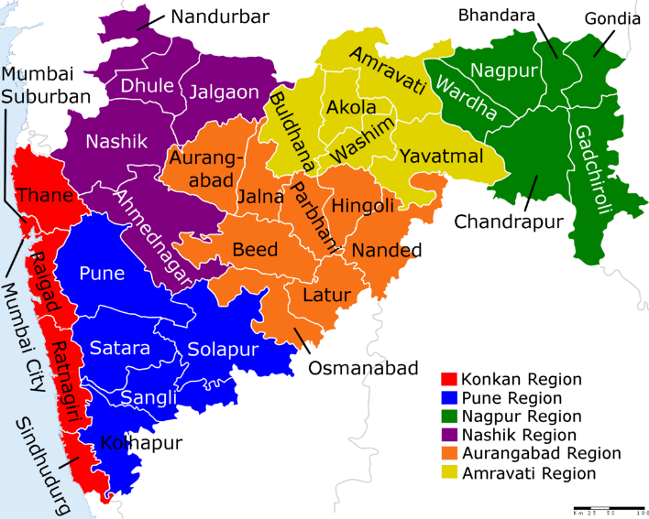
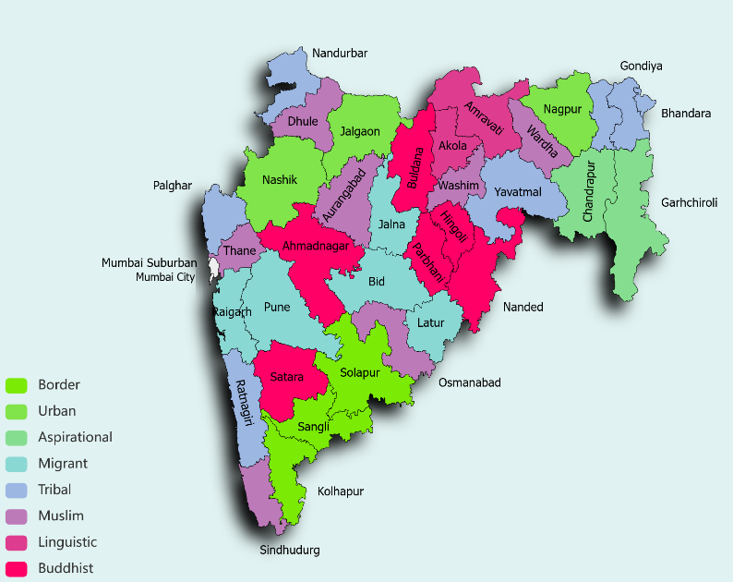
Fig. 2: Maharashtra Districts Fig. 3: TISS Profiling of Districts

The table below highlights the salient aspects of the districts based on a desk review undertaken.
Region | Districts | Criteria
Western Maharashtra | - Satara  - Sangli  - Solapur  - Kolhapur  - Pune | - Buddhist Population | Rural | History  - Border | Conflict  - Border | Conflict | Disability  - Urban-Rural | Border | Conflict | Linguistic  - Urban | Migrant | Disability
Marathwada | - Aurangabad  - Beed  - Nanded  - Hingoli  - Jalna  - Osmanabad  - Parbhani  - Latur | - Urban-Rural | Muslim | Linguistic | DisabilityRural | Muslim | Migrant population  - Rural | Migrant | Buddhist population  - Buddhist population  - Tribal  - Muslim  - Rural Aspirational | Muslim  - Buddhist
Konkan | - Ratnagiri  - Sindhudurg  - Thane  - Raigad  - Palghar  - Mumbai City  - Mumbai-Suburban | - Tribal | Sex Ratio 1122 | Disability  - Muslim population | Sex Ratio 1036  - Urban-Rural | Muslim | Tribal | Migrant | Disability  - Migrant  - Tribal  - Urban | Migrant | Linguistic |  - Clubbed with Mumbai-City | Disability
Vidharbha | - Gadchiroli  - Chandrapur  - Gondia  - Yavatmal  - Nagpur | - Border | Naxalism | Rural | Aspirational |  - Tribal  - Tribal | Rural  - Urban-Rural | High density of schools  - Rural
North Maharashtra | - Nandurbar  - Nashik  - Jalgaon  - Dhule  - Ahmednagar | - Tribal | Aspirational District | Disability  - Urban | Buddhist Populations  - Muslim Population  - Buddhist Population  - Buddhist | Conflict | High Dropout
Vardha | - Buldhana  - Washim  - Akola  - Amravati  - Wardha | - Buddhist Population  - Muslim Population  - Linguistic  - Urban-Rural | Linguistic  - Tribal  - Muslim | Disability
Table 1: Region-wise District Profile of Maharashtra
The below-mentioned districts were selected for the qualitative data collection. Amongst them, 16 districts were selected for the qualitative analysis:
- Western Maharashtra: Satara, Kolhapur, and Pune
- Marathwada: Aurangabad, Beed, and Osmanbad
- Kokan: Ratnagiri, Palghar, and Mumbai
- Vidharbha: Gadchiroli and Gondia
- North Maharashtra: Nadurbar, Ahmednagar, and Nashik for the pilot study
- Vardha: Akola And Amravati

3.2 Pilot Study - Nashik District
Initially before the survey and field visits were conducted in all the districts, Nashik district was selected for the pilot study. Meetings with DIET professors, BEOs, teachers, and HMs were conducted in this pilot study. During the pilot study, online survey tools were filled with the help of DIET faculty and the Samagra Shiksha coordinator of the Nashik district. Along with such meetings with educational functionaries, school visits and interactions with non-state bodies like Room to Read were conducted. These interactions added to our secondary data in understanding the state of the libraries in the district of Nashik.
There were meetings conducted with the BRCs, CRCs and DEOs and later with the DIET faculty and these interactions emphasized the need for more library literacy and underlined the importance of undertaking this study. School visits were organized, but schools with better library infrastructure were those with some non-state actor intervention, mostly organizations like Room to Read and Pratham books in a few schools.
The schools visited in Nashik where there were no interventions from the non-state players like Room to Read had no library room, the books were locked away and had not been issued to students with teachers themselves having little knowledge of the books available, their condition or opinions on their quality. No reading activities were conducted in the two schools visited with no ongoing intervention for libraries. In the schools where there was an intervention we could see a separate library room, with books which were age appropriate with a balanced number of books in different languages, arranged in a way that children from different reading levels could choose from it as well.
Fig.4: Images from Nashik meeting and different Libraries from select schools in the district
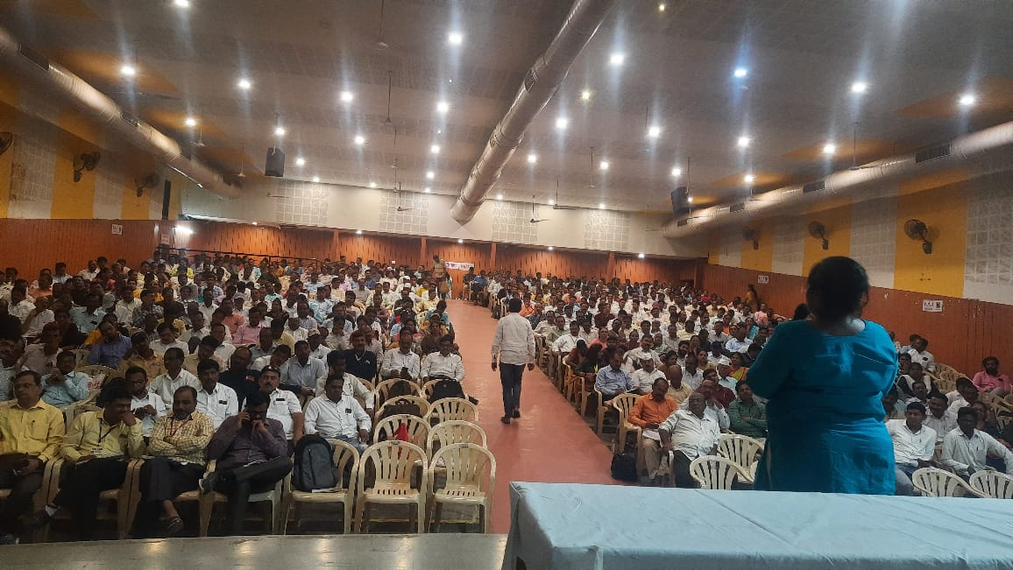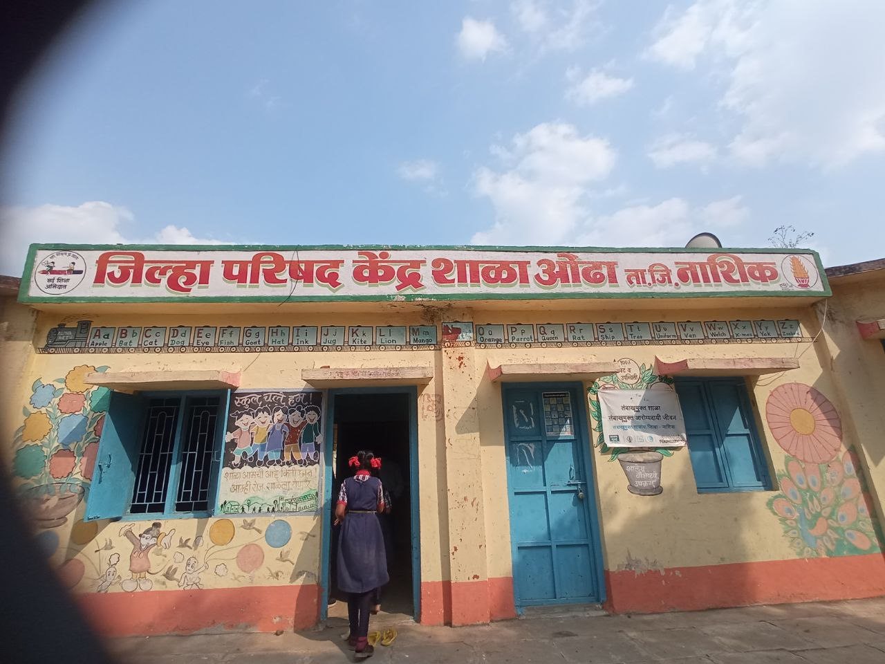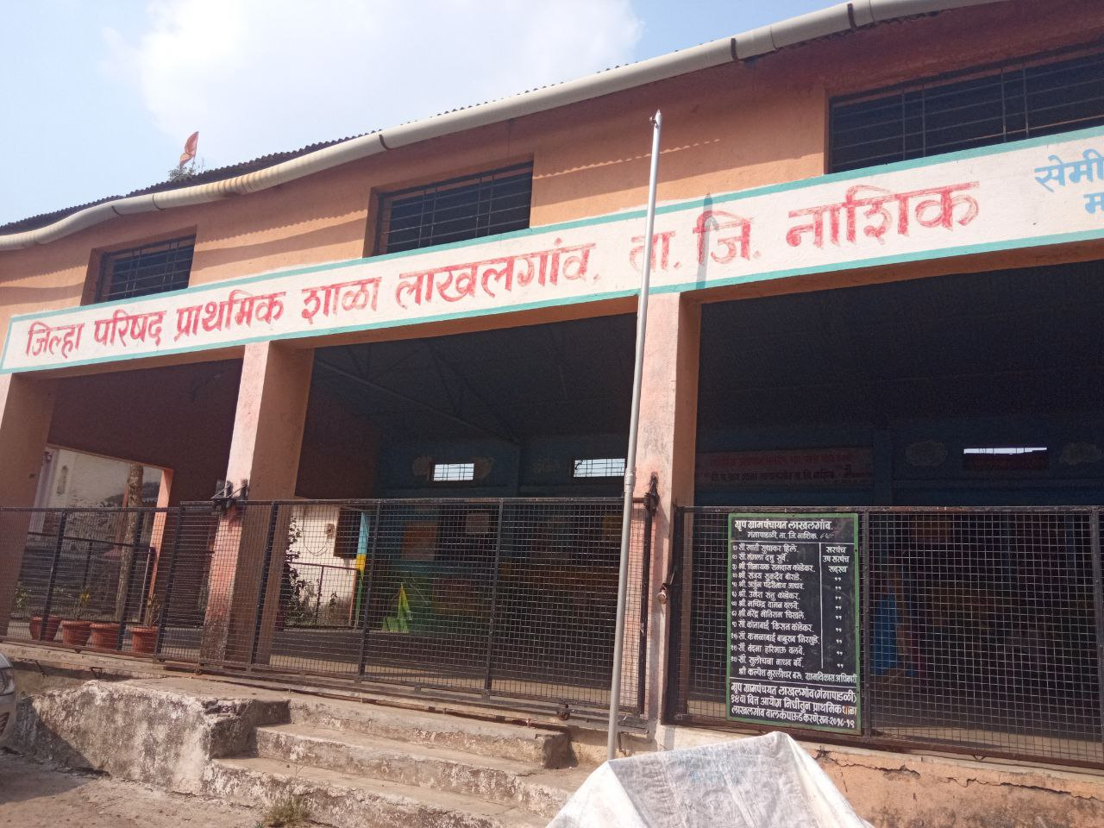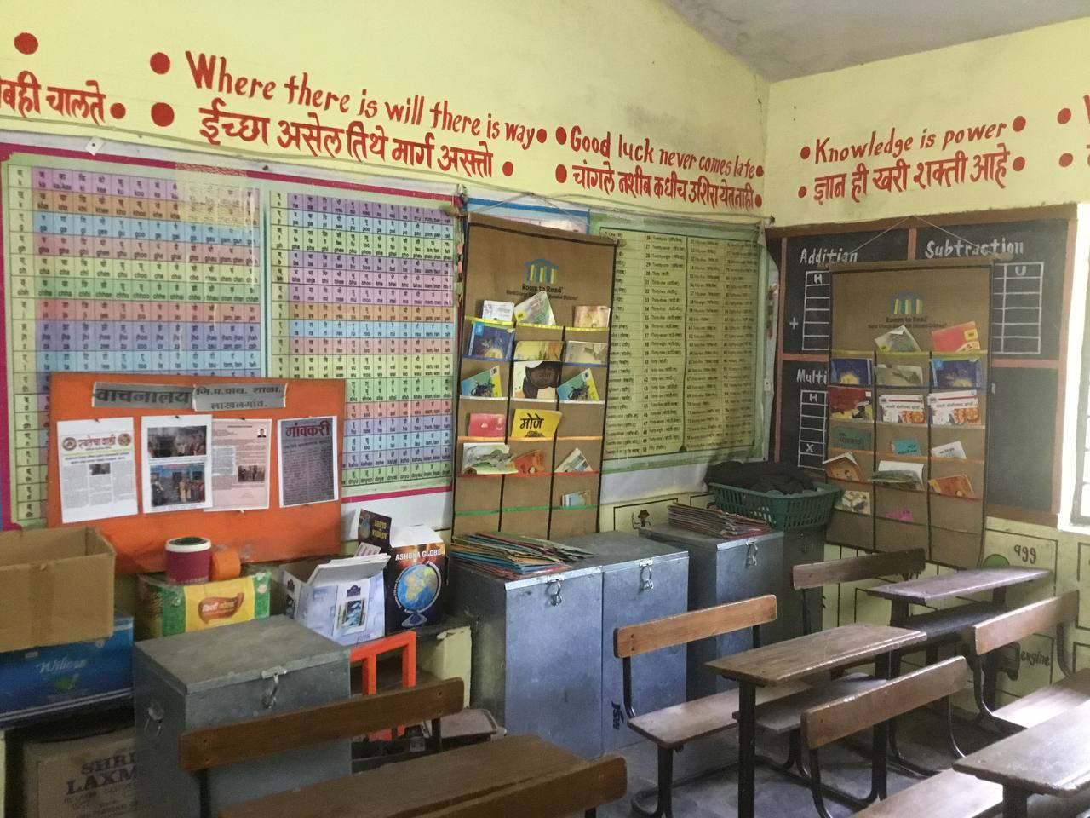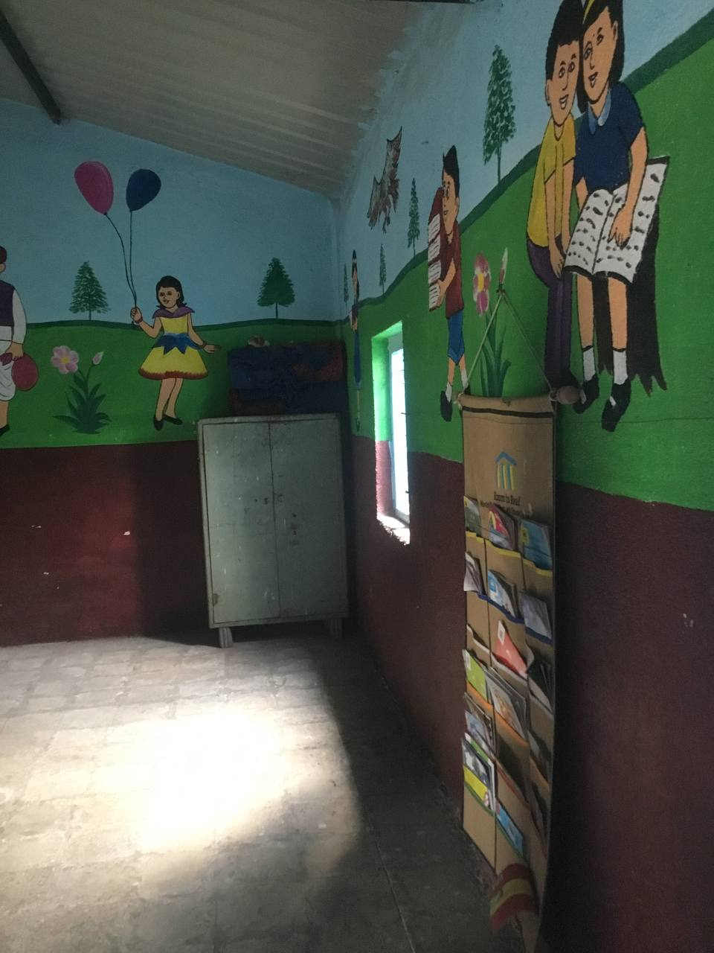
3.3 Survey Findings
The survey was conducted in 36 districts in Maharashtra and gathered responses from 9,917 participants. The table below provides the breakdown of the profiles of the survey respondents.
Teachers | Head Teachers | BRC | CRC | BEO | DEO | SMC | Total
3,980 | 5,308 | 253 | 302 | 31 | 13 | 30 | 9,917
Table 2: No. of responses received from various profiles of the respondents
Out of the 9917 respondents, 69% of the teacher participants were male, and 31% were female. Four teacher participants opted for ‘Other’ as their gender. The gender ratio of the survey participants was broadly consistent across the 36 districts of Maharashtra.
Ahmednagar and Raigad districts contributed the highest number of participants to the online survey, with a percentage share of 14.8% and 9.3%, respectively, followed by Nashik at 7.5% of the total. Districts such as Dhule, Pune, and Washim have the lowest number of participants, with a percentage share of (0.1%), (0.2%) and (0.7%).
The online survey covers 36 districts. Nevertheless, most teachers, HM, and BRC/CRC members were involved in teacher training, annual functions, and other school activities. They needed help to fill out the online survey form. Across the districts, teachers say they need to become more familiar with technology. Therefore they needed more time to fill up the survey tools. Lack of mobile network and computer availability made them more helpless to submit Google survey forms.
The survey yielded multiple insights on the school libraries in districts. The following sections consist of the insights derived from the survey.
3.3.1 Existence of Library and its Infrastructure
The vital role of a school library in a school highlights space and time. A library can be an enriching space for children and encourage them to read and think. It's a space where they gain new knowledge and skills. Such a space should be accessible to children without the restriction of time. It encourages children to engage with books and the community and allows parents to see their children's progress.
School infrastructure is needed to create a reading environment in the school. NEP 2020 (para 5.9) suggests a conducive and secure infrastructure for children to learn. Effective learning environments and comfortable spaces motivate teachers to teach and help children learn in their schools. Understanding the status of libraries is the central focus of this study; the diagram below informs the availability of space for a library.
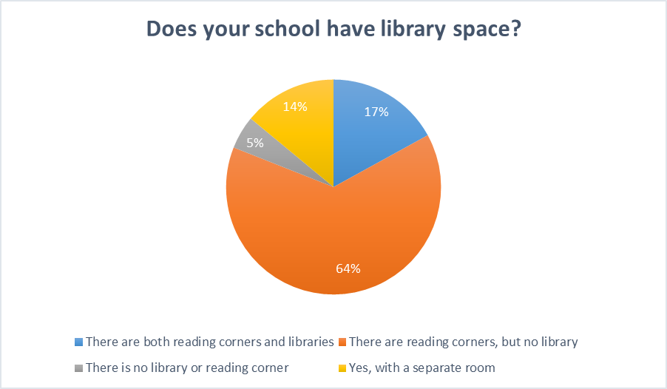
Figure 5: The status of the school library and reading corner, as answered by the teachers:

64% of the total participants have said that there are reading corners in their schools but no library, 17% said there are both reading corners and libraries are present in their schools, 14% responded saying there is a library in a separate room in their schools, and 5% have responded mentioning that they neither have a library nor a reading corner. This data shows that there are a huge number of schools in all districts combined where reading corners have been created with the intention of creating certain spaces to encourage reading but infrastructure-wise there are no separate library rooms for children.

NEP 2020( para 6.2) defines a reading corner as "A reading corner is distinct from a library in that it is part of the classroom where books are easily accessible to children’’. The reading corner allows children to read independently and engage in group activities. It provides mobility to children in the classroom with a selection of books from an attractively displayed range. According to teachers and HMs in all the districts of Maharashtra, they were able to have reading corners. However, after the pandemic, some schools' conditions deteriorated, wherein sometimes, first to fifth standards have no classrooms. Thus, having reading corners is out of the question in these schools.
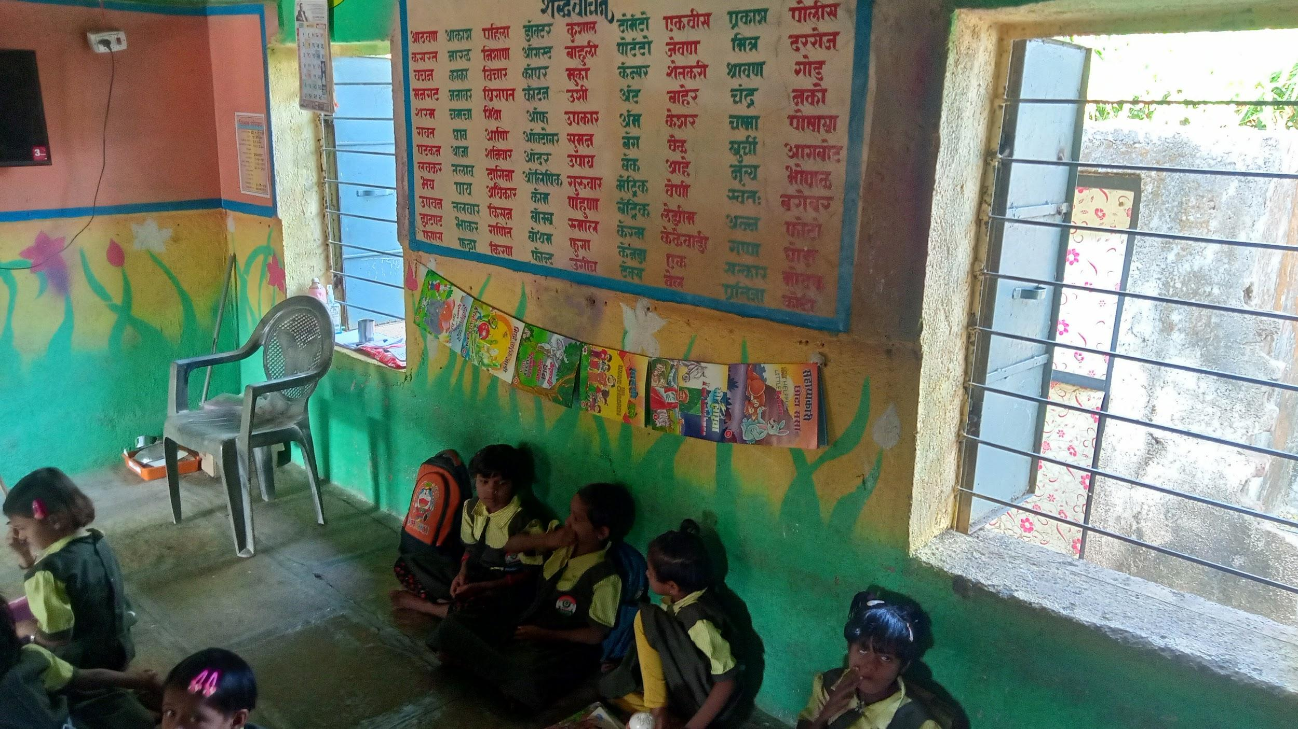
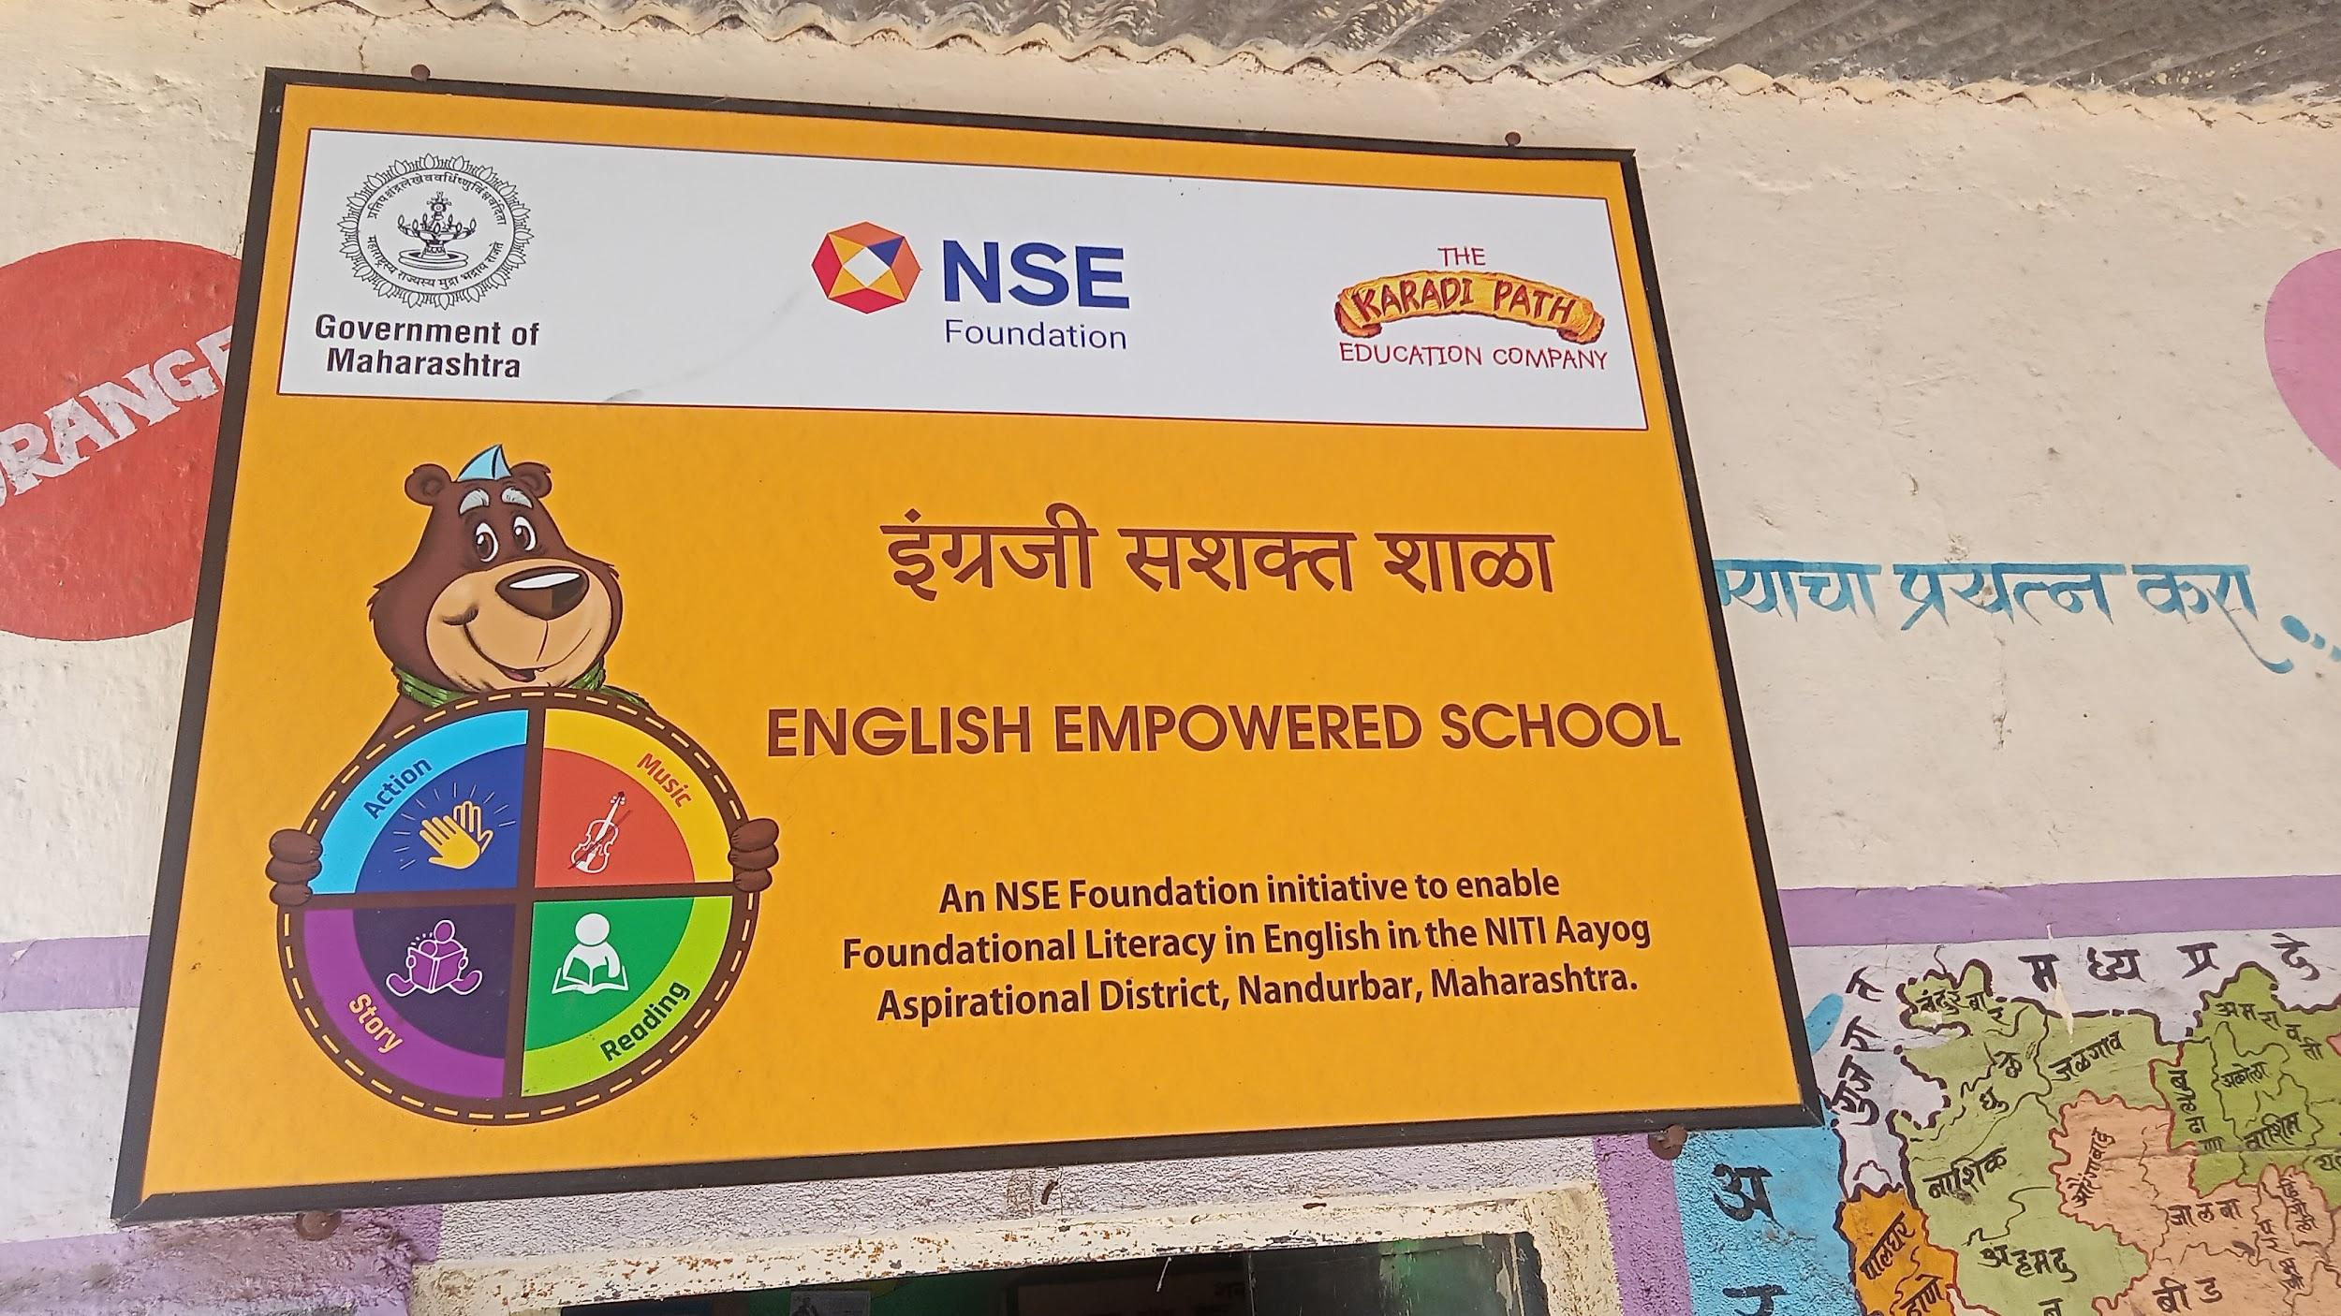
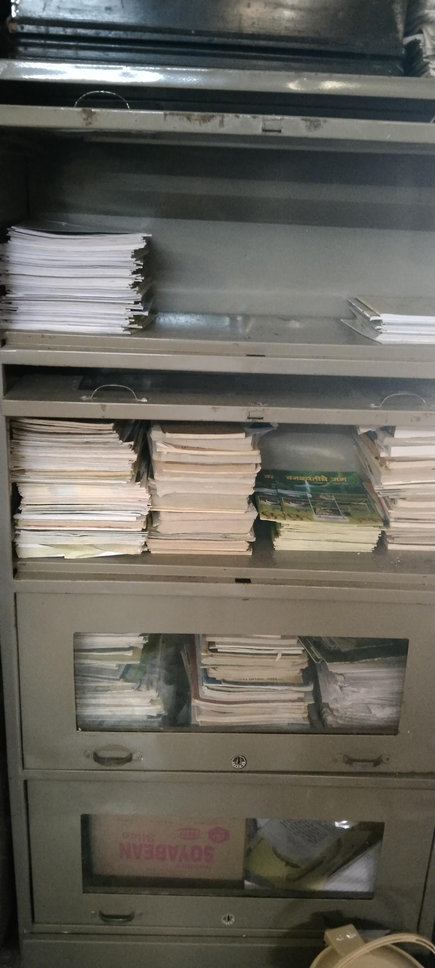

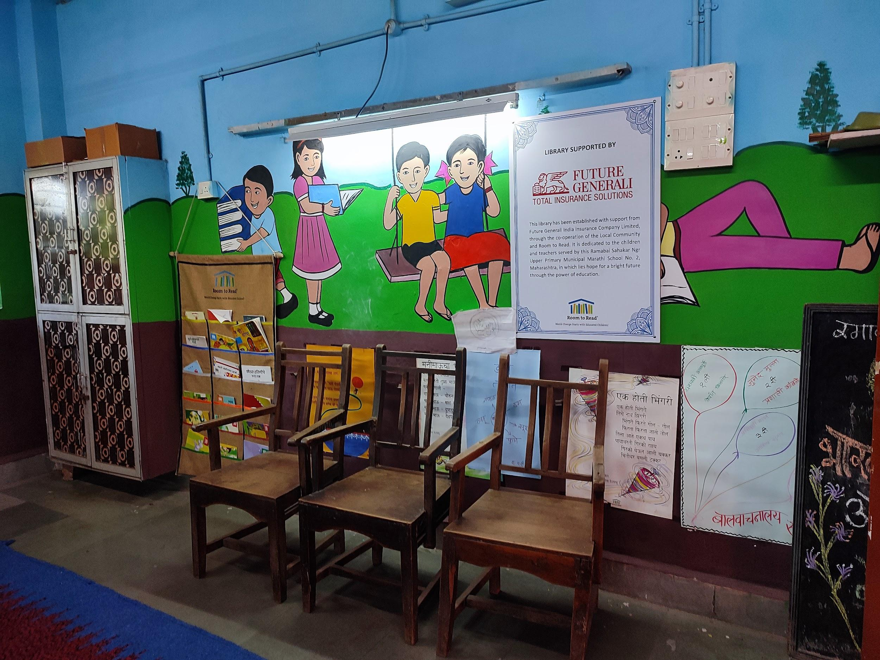

Fig. 6: Comparison: Schools without NGO Intervention where books are under lock and key (image on left) and a separate, welcoming room and well-maintained registers in schools with ongoing NGO interventions (images on right).

3.3.2 Access to Library
Access to the library can be looked at in two different ways. First, access to the library space for the children who are attending the school to see when they are able to access the library space and secondly access to the library space for children who are unregistered/ who have not enrolled to schools. The data below presents both perspectives of access to space for children who are part of the school and out of the school system.
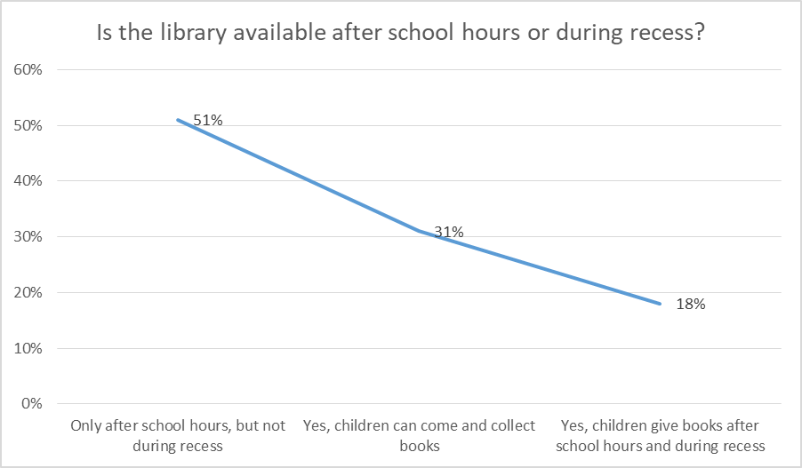
Figure 7. It represents the availability of the library after school hours or during recess
A total of 3981 teachers responded, out of which, a majority 51% said that the library is available only after school hours, but not during recess nor during vacations; About 31% of teachers said that children can come and collect books after school hours and during school breaks. The remaining 18% responded to the question saying that children are given books after school hours and during recess and vacation time.
Due to fear of books being damaged, the teachers often do not allow children to take the books home. This should be different, as it would deter them from visiting the library. During vacations or after vacation school hours, the school library should be kept open to students.

The Right to Education Act aims to provide free and compulsory education to every child in the country. Therefore, children from unregistered schools also have the right to access the library. The table below explains library access for non-registered school children.
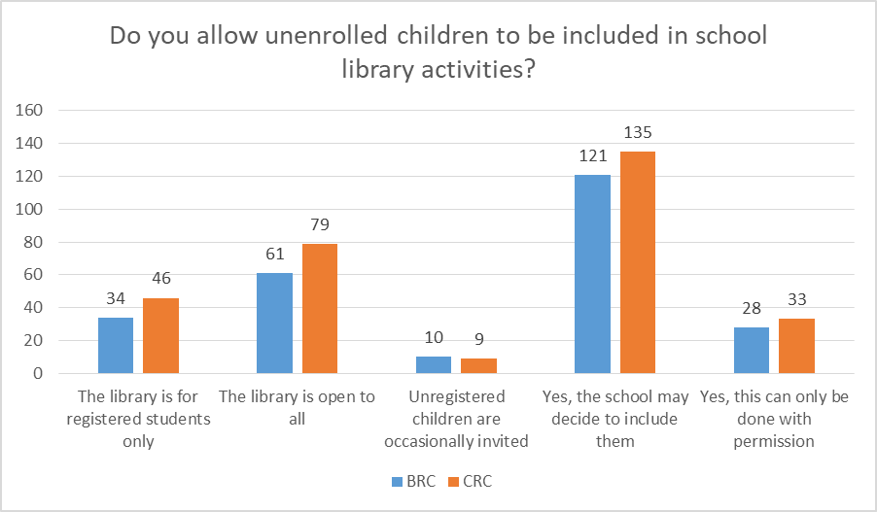
Fig 8: Library access to Out-of-school children
The total number of responses received is 556 from the BRCs and CRCs. As it is clear in the above graph, the majority of them said the school may decide to include unenrolled children in school library activities or not, and the respondents said there should be a library in the village to cater to the out-of-school children. This provides access to all age groups irrespective of their registration at any school. School libraries tend to be limited to the school children only.
3.3.3 Collection of Books and Other Resources
The collection of a variety of books and resources in a library encapsulates the quality of the library and the effective engagement of children through such libraries. Hence it is crucial to identify, procure and store such books for the library. The books were procured under the Library Grant received from the State government. The schools procured a variety of books including story books, magazines, comics and reference books.
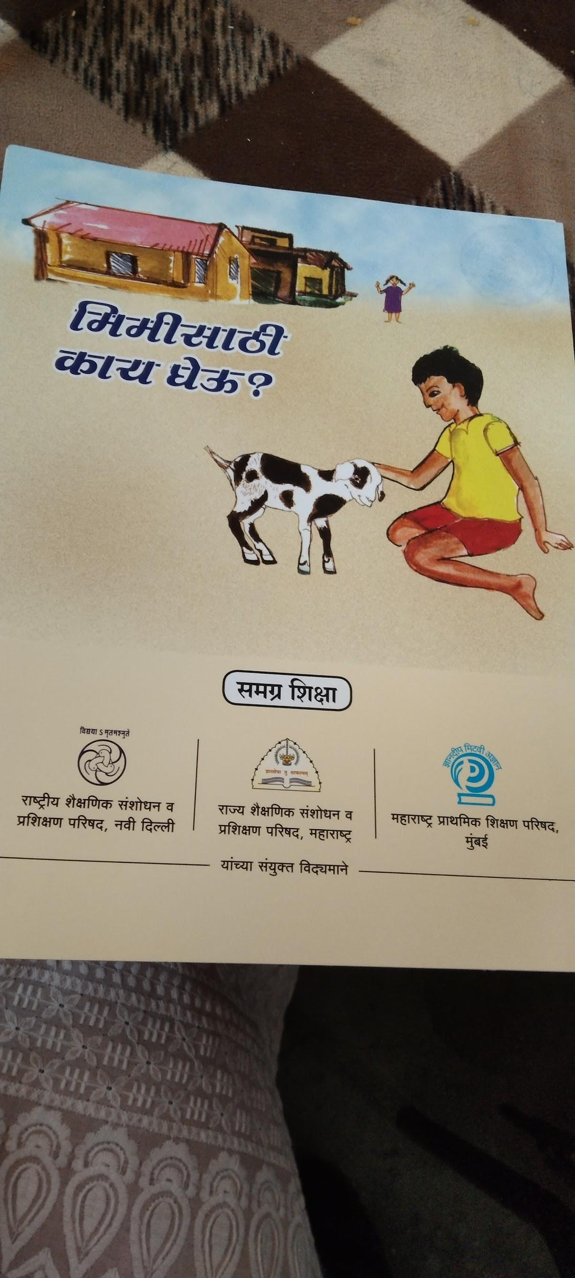
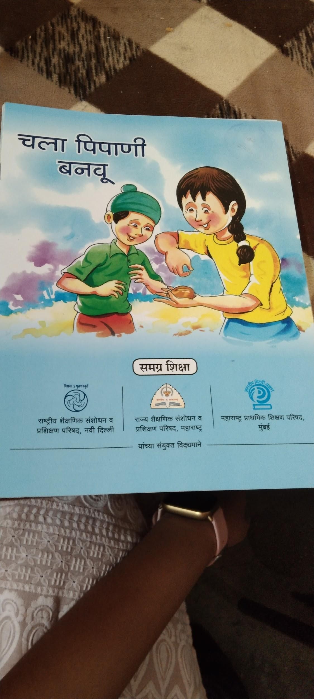

Under the Library Grant scheme of the Samagra Shiksha, the state government started providing books directly to the schools utilizing the grants directly at the state level. The onus of utilizing the funds fell on the State government itself. Since the books are printed and provided at a state level, the schools are denied their agency to procure the kind of books that they deem fit for their children with local dialects being used and such. The benefit of this large-scale supply of books to schools resulted in every school reporting their possession of 100 books and the presence of a library (in whatever form) on U-DISE. However, this process standardizes the languages and the types of books provided. Books are not contextual to children and the struggle to be inclusive still remains with limited to no resources for Children with Special Needs. During the Covid period i.e., 2020 to 2022 academic year books were not provided due to the shutdown of schools and in the academic year 2022-23, schools are yet to receive the books under this scheme.
The infographic below illustrates different language books available in the library from all the respondents to the survey. What must be noted is that children in most parts of Maharashtra do speak languages other than standard Marathi and these languages and the variations of Marathi language are not adequately represented. The books range from non-fiction to fiction, but for the primary grades, the bulk of books are story books with visuals, which is heartening.
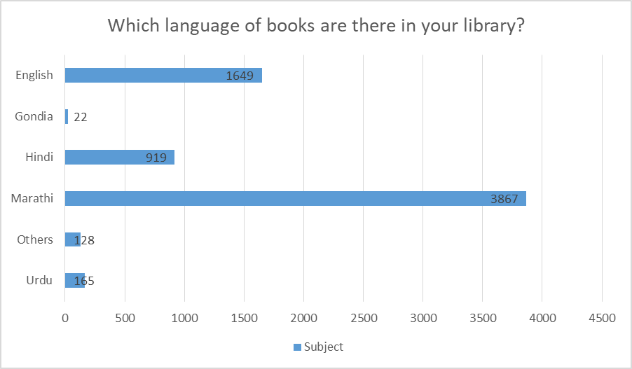
Fig 8: Language of Books Available in Schools

The above table indicates the language of books available in the library. As one can see, most of the books are in Marathi. The number of books available in Marathi is 3867, 1649 in English, and 919 in Hindi.

During the school visits, a visit to the Panchgani "Pustakanche Gaon" a community library was undertaken to understand the community and children's participation. However, there are no age-wise books in the library as there is no proper record of children's reading and learning.
NEP 2020 (para 4.14) reflects that all efforts should be made to produce high-quality bilingual textbooks and teaching-learning materials for science and mathematics so that students can think and speak both in their mother tongue/native language and English. Therefore, books in different languages should be available according to the needs of the schools. There are Urdu medium schools in Aurangabad and Osmanabad. Amravati, Akola, and Gadcharoli are aspirational districts in Maharashtra and have many tribal children at school. Apart from Marathi and some local languages, books should be available according to the needs of children to improve their reading ability.

In most Zilla Parishad schools, library books are provided by the government. However, these municipal schools run eight different mediums of instruction and only a few mediums are considered while sending these books. Most books are in Marathi, Hindi, and English, so it is necessary to include books of other mediums in the library.

Books that can be purchased under the library grant of Samagra Shiksha include 1) Storybooks, 2) Reputed children's magazines and comics 3) Reference books for secondary and senior students. 3) Other books considered essential for a child's holistic development include mental health and Wellness, sports, Art, music, and design thinking. Visits to the 17 districts revealed that most schools have storybooks and Kishor magazines. Most of the books collected are through donations and they are not age-appropriate. Priority needs to be given to Children with Special Needs (CWSN) as well while procuring books/ resources. Some children would need audio-visual resources and that needs to be included as well. Hence a requirement to procure/ provide a wide variety of books to the schools is imperative..

3.3.4 Utilization of Funds for Libraries

Funding for school libraries is also a critical aspect of this study. Understanding the state of the library requires a focus on ends and uses. Samgra Shiksha provides guidelines for library grants and promotes reading in ZP schools. The grant ensures that infrastructure, book-related resources and human resources are included with all stakeholders. The analysis below provides us with a picture of the funding timelines, the sufficiency of the funds, and awareness regarding the utilization of these funds.

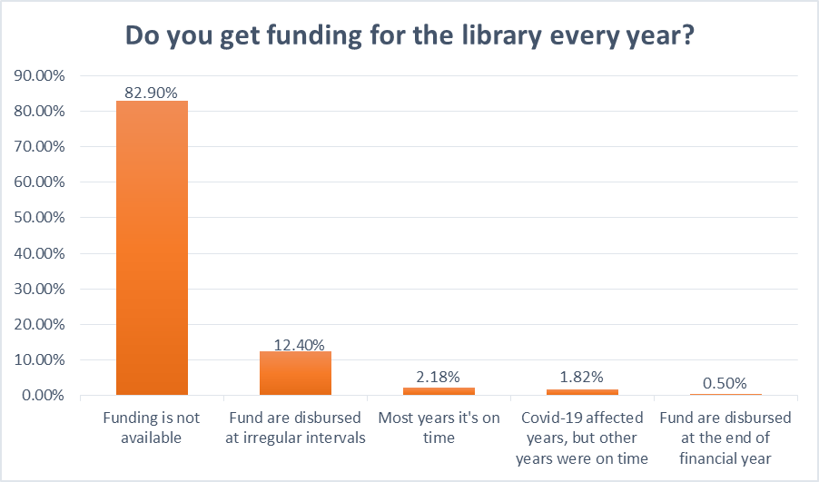
Fig 9: Regularity of funds for the library as reported by HMs

The HMs were the primary respondents to this particular question. Of the 5309 responses from HMs across districts approximately 83% reported that funds are not available every year. 1.82% said that the funding was affected during the COVID-19 period, while 0.50% of HM said that funds are disbursed at the end of the financial year.

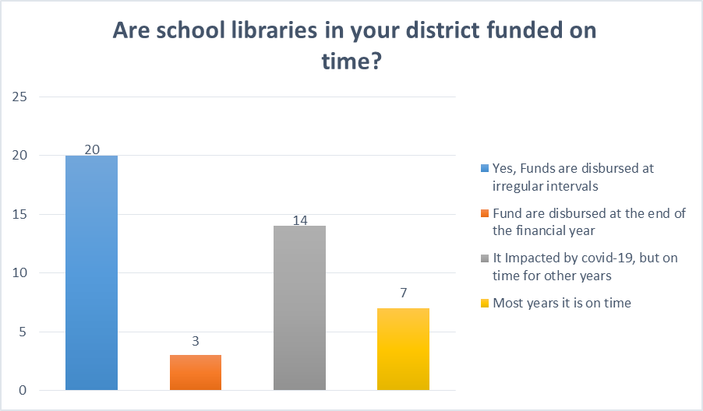
Fig 10: Library funds utilized by the district as reported by DEO/ BEOs

Regarding funds, the responses of BEOs and DEOs are significant as well. Out of 44 BEOs and DEOs, only seven affirmed that they got the funds on time. 3 BEOs and DEOs said the funds are disbursed at the end of the financial year. 20 of them informed us that the funds are disbursed at irregular intervals. 14 BO and DEO said it was affected by COVID-19 but had been on time pre-pandemic.

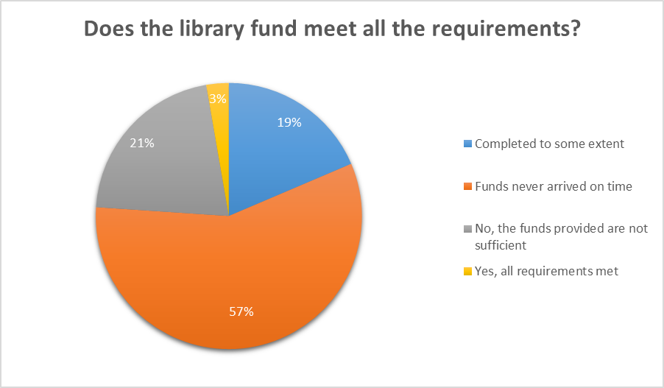
Fig 11 Meeting all the requirements from the library funds as reported by HMs

Funding for the libraries needs to be looked at not just in terms of availability but also whether it is sufficient to run an effective library in the school that can cater to both the children and the community. Hence another aspect of the question of the sufficiency of library funds was asked. Out of 5309 HMs, 57% of HMs reiterated that the funds never arrived on time. 21% said that the funds provided needed to be increased. There were very few responses in favour of current funds adequately meeting all requirements (only 3%).

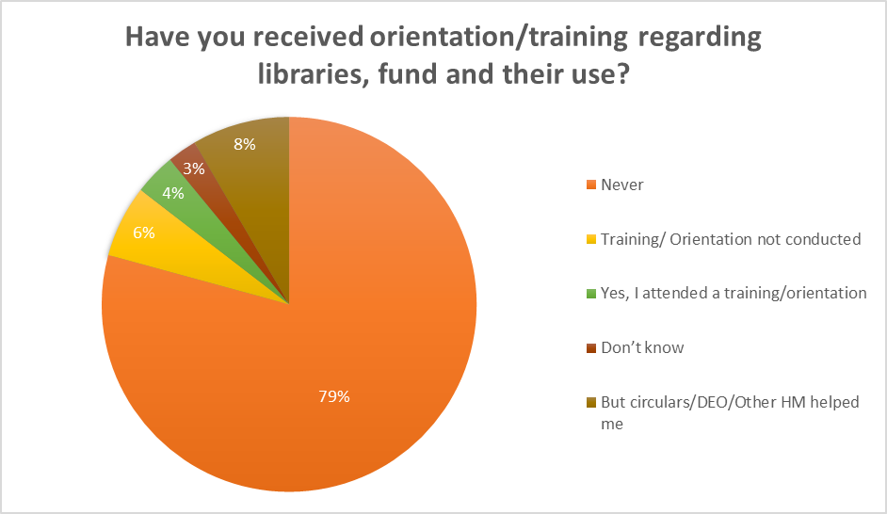
Fig 12: The graph below shows the responses to the same question by the HMs and teachers:

Out of the 5309 respondents, the data shows that 4207 HMs/teachers i.e., 79% have never received orientation or training on library funds and their usage. Moreover, very few of them responded that they had attended the training. Only a few HMs and DEOs had helped them in the program.

Moreover, our visit to the 17 districts in Maharashtra revealed that all the stakeholders we had considered, namely the HMs, teachers, and BRC/CRCs, needed to be made aware of the funds related to the library. This reiterates the overwhelming need for large-scale awareness of the Samagra Scheme for Library Use.
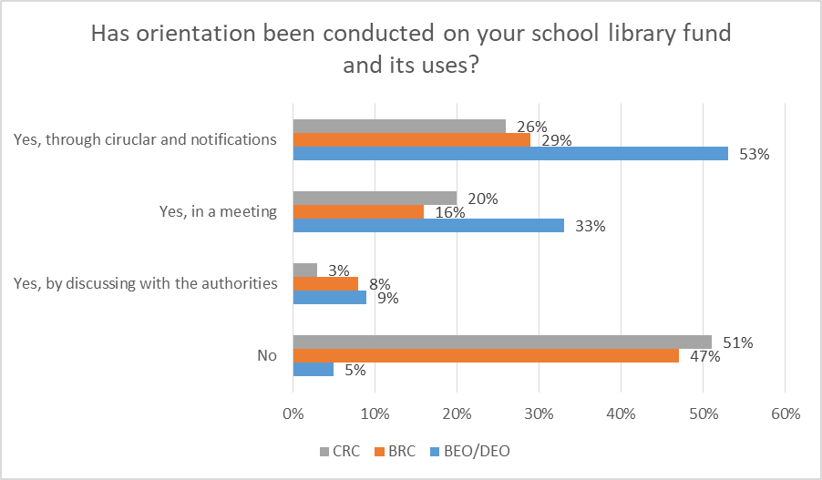
Fig 13. The story of lack of funds - Perception of the stakeholders

The above graph displays the answers of CRC, BRC, and BEO/DEO on whether any orientation had been conducted in the schools related to library funds and their uses. The total number of responses from block resource persons was 254, out of which 119 respondents said that they had yet to receive any training or orientation regarding the utilization of funds. 74 respondents affirmed that orientation was conducted through circulars and notifications.

Budget allocations from the State

While considering the efficacy of a scheme, it is not only important to understand how the funds are apportioned and who has agency to utilize them, but also to what extent the funds are utilized and trace possible reasons for under or overutilization and posit possible solutions.

Some essential details of the 5-year budget to understand budget allocation and utilization of primary school library funds in Maharashtra are outlined below. This overview provides an idea of how the school library's needs can be met.
- The Year 2018-19 finance 20.40 fewer expenses 15.50
- The Year 2019-20 financed 183.93 more than 441.33
- The Year 2020-21 finance 383.02 fully utilized 383.02
- The year 2021-22 finance 649.08 0 utilization because of the pandemic
- In the year 2022-23, finance 649.76 less utilized 126.068

FY 2020-21 38 3.03 lakhs fully utilized for the school library. Nevertheless, in the current year, 2022-23, 646.76 are yet to be utilized for the school library.
During the field visits, a BRC said that when the library fund comes, it should be accompanied by proper guidelines. Also, if you want to buy library books, there should be proper instructions.

Based on the above analysis, providing funds in a timely manner helps the officials, the teachers and HMs to utilize these funds in an effective manner by procuring books to maintain the space. The uncertainty of the availability of funds may lead to teachers/HMs becoming oblivious towards libraries. Based on the data it also seems that the majority of the school teachers and HMs are less aware of how to effectively use the funds provided for the library, this state of unawareness might lead to using these funds for something else which might take priority. Apart from these, training on what constitutes a holistic library also goes a long way in setting up an enriching space for children. It is important for the state to provide proper funds in a timely manner for schools to maintain a decent library.

- Role of Stakeholders
Government educational functionaries are significant stakeholders. For the study functionaries from the district level to the school level were considered for the survey. 1)DEO/BEO, 2)BRC/CRC, 3)HMs/Teachers, 4)SMC 5) Library-appointed teachers were the ones who participated in the survey. A District Education Officer is an educational professional appointed by the government. They are responsible for inspecting the functioning of state-run educational institutions in a district by appointing, promoting, developing attendance, and implementing major programs. BRC/CRC are resource persons who are responsible for training teachers and HM, monitoring the classes and providing feedback. The data collected through these functionaries are presented in previous sections.
4.1 School Management Committee
The School Management Committee (SMC), established under the Right to Education Act 2009, plays an essential role in India's education system. SMC consists of representatives from the community and they play a crucial role in determining accountability in government school libraries. The SMC as a whole focuses on the holistic development of schools.

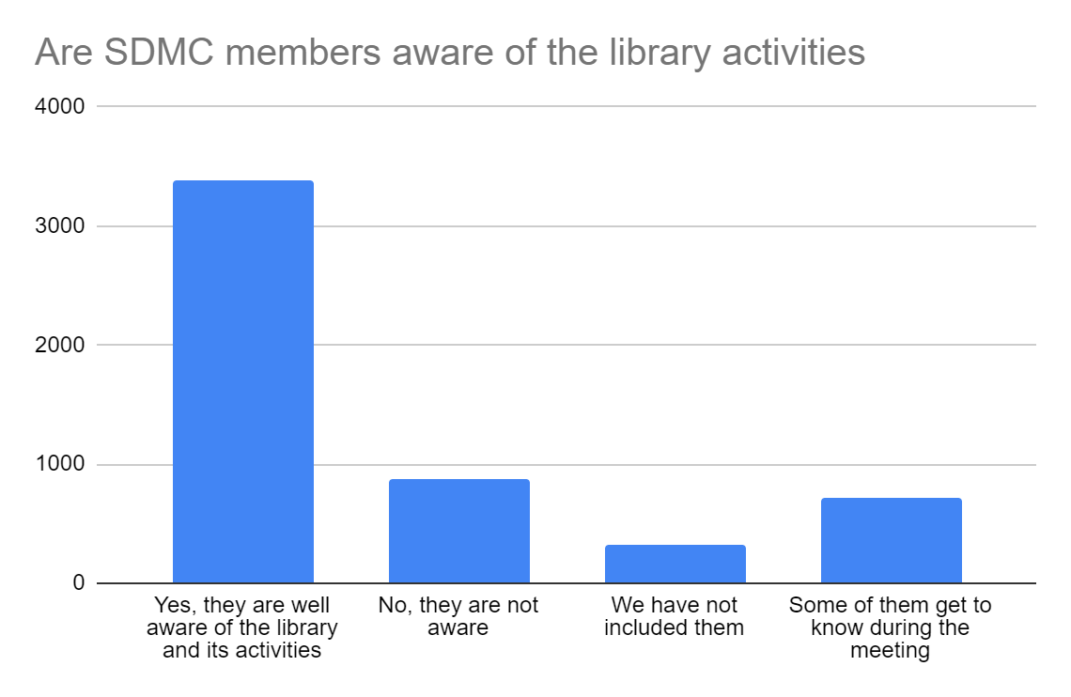
The table above shows the awareness of SMC members about the library activities and about 3387 teachers responded that the SMC is aware of library activities, and 878 responded by saying the SMC is not at all aware of the library activities. There were a few teachers who responded that they had not included them and some responded that during the meeting some parents get to know. SMC plays a significant role in the school library and reading activities. SMC members are connected to the school as well as to the community and village so that they can approach the children quickly. The parents and community are not involved in the library activities of the school. Most teachers said SMC members needed to know about the library meetings and activities. However, Aurangabad, Osmanabad, Palghar, and Nashik are some districts with a village library and a community library, SMC Initiated Library, open to all. Therefore, children can easily access the library during vacation. Some teachers cited the unique role of SMC in creating awareness among members about library activities.
4.2 Non-Governmental Organizations
Early-stage NGO intervention helps in planning library-related activities with school children. Room to Read and Pratham are two organizations working in Maharashtra primary schools in setting up and maintaining library spaces in schools. Sometimes training is provided to teachers to engage children through books. They have books available for reading and suitable models for implementing library activities. Room to Read is working in 15 taluks of Maharashtra. There are 240 clusters in the area.
The school has a central-level library called a module library, a separate room in the school, and they have to renovate that room at the central level by painting and arranging it. They use this place as a library with about 1500 to 1800 books for reading. They even organize district-wise training programs for teachers. One has to note that these interventions are for a limited period and the onus falls on the schools to maintain the libraries once the NGOs have left.
The figures below show the NGO interventions in the schools'
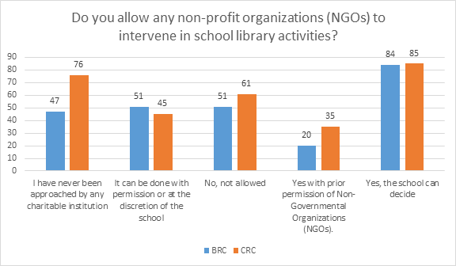
Fig 15. Non-Profit Organization and School Library Activities:
The total number of responses received from BRC & CRC is 555, out of which the majority of them said the school could decide where they allow any non-profit organizations to intervene in school library activities; hence one of the respondents said the school should have a library and a separate room for the library. NGOs and philanthropists should visit the school library. Books related to current affairs and competitive exams should be present.

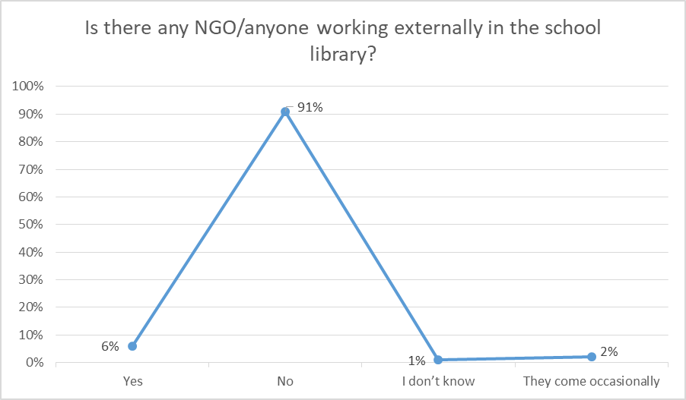
Figure 16. External Organization and School Library
Figures 15 and 16 show NGO interventions in school libraries in Aurangabad, Nashik, and Beed district. 3981 responses were received, as one can see; most teachers, 91%, said there is no external intervention in their school, 6% of schools saw an intervention, 2% said the representative came occasionally, and only 2% said, they do not know of any such interventions.

- Best Practices and Caselets
5.1 Best Practices
The visits provided an insight into some of the practices that schools with limited resources have creatively to inculcate reading habits among children. The following section provides 5 such examples of best practices that were recorded during the visits.

- Hanging Books: One of the initiatives taken in the school in Palghar is that the books are hung on the window. This way books are accessible to children throughout the day. They read books during lunch breaks and whenever they get time. Children from 5th to 8th grade take responsibility for these books. At the end of the school day the books are kept back in the same place.
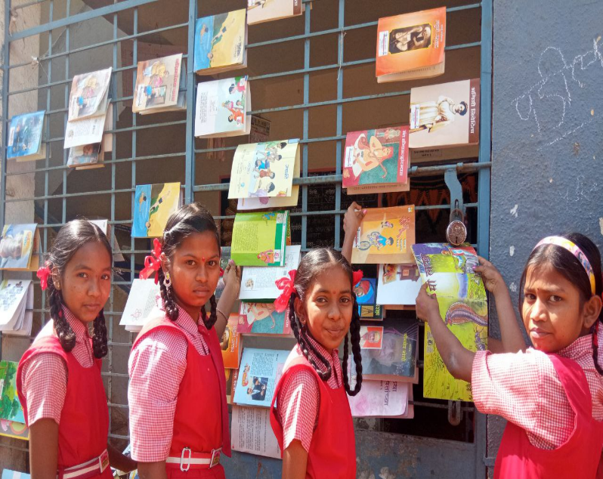
- Book Clinic at the school library
“As we fall sick, we need medicine, just as a book needs a clinic’’: A teacher in Palghar has started an activity called “Book Clinic”. This is an activity related to the school library. Students do not bring school bags on Saturdays. Instead, they come and read books in the library. Due to constant use, some books get torn and damaged. In this activity, the teacher says children are taught how to put tape on a torn book, put on a cover, and glue the book. This activity increases the enthusiasm of children. They learn how to repair books and understand how to take care of books.
- Reading Circle for Community Books
In Ratnagiri, the teacher has started an APJ Abdul Kalam Reading Circle called Firta Vachan Katta(फिरता वाचन कट्टा). It consists of a mobile cart that has around 400 books which many people have donated. In this district, people live in Wadi settlements, with less contact with others. In such a situation, this Reading Practice comes in handy. People come to the cart to read. Books are given to people in the community through "Book Messengers" (''पुस्तक दूत ‘’), who are primarily children. Therefore, children's interaction with their parents also increases. Some of the interior villages have no access to newspapers. People are not familiar with any medium of reading. Therefore, this reading circle helps the community people to familiarize themselves with books.
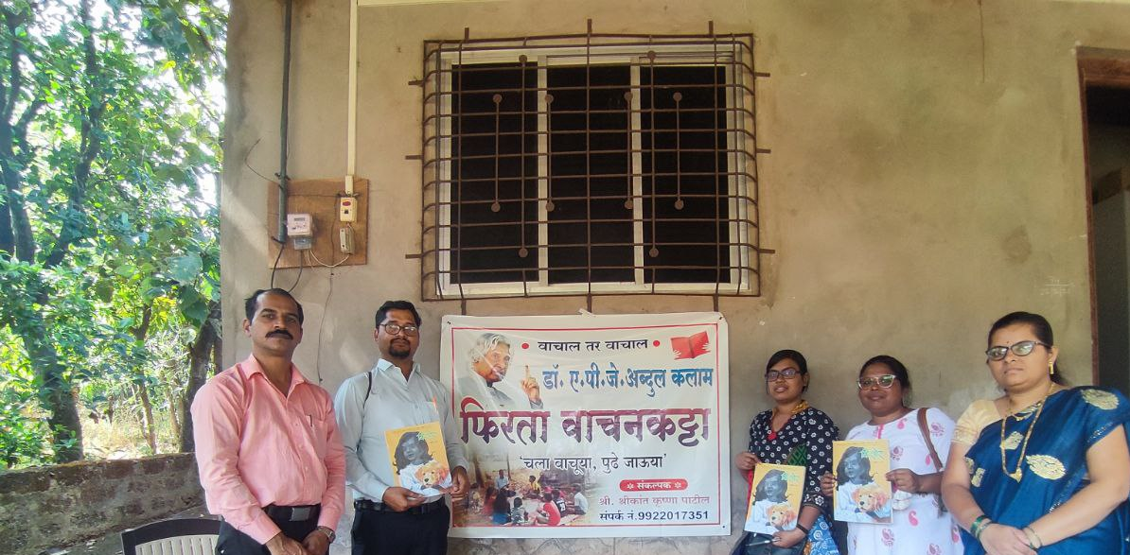

- Book Writing
Writing a book is a unique activity conducted at the Palghar school. Through this activity, the teacher makes the children (aged 5 to 8 years) identify books within ten days. Within these ten days, children have to note the names of the books, book covers, authors, book references, book prices, publisher names, etc. The teacher gives specific themes for the children to write a 10-page book. For example, children wrote books on monsoons, schools, agriculture, etc. Some children have caricatured the cover of their “Pustak”. The teacher also shares his experience of writing the book with the children.
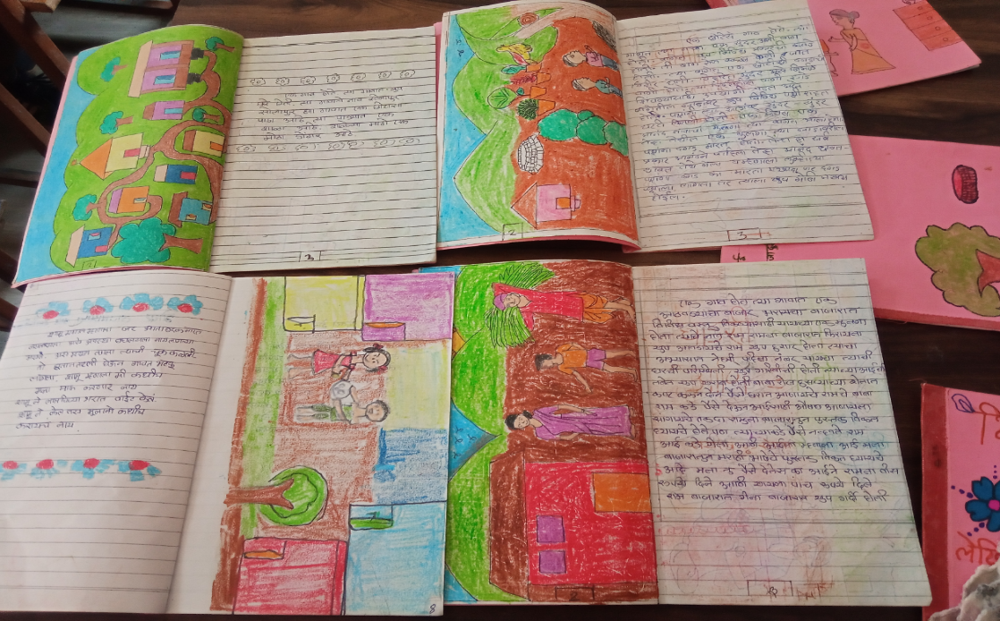
- Limited resource-based library

This is a picture of a ZP school library developed by a self-motivated teacher with limited resources. Earlier, there were reading corners for children of 1st to 5th grade. But there is no place for children to sit in school. In such a school, a teacher in Aurangabad has created a library in the available space. This library has been designed so that children can easily access books.
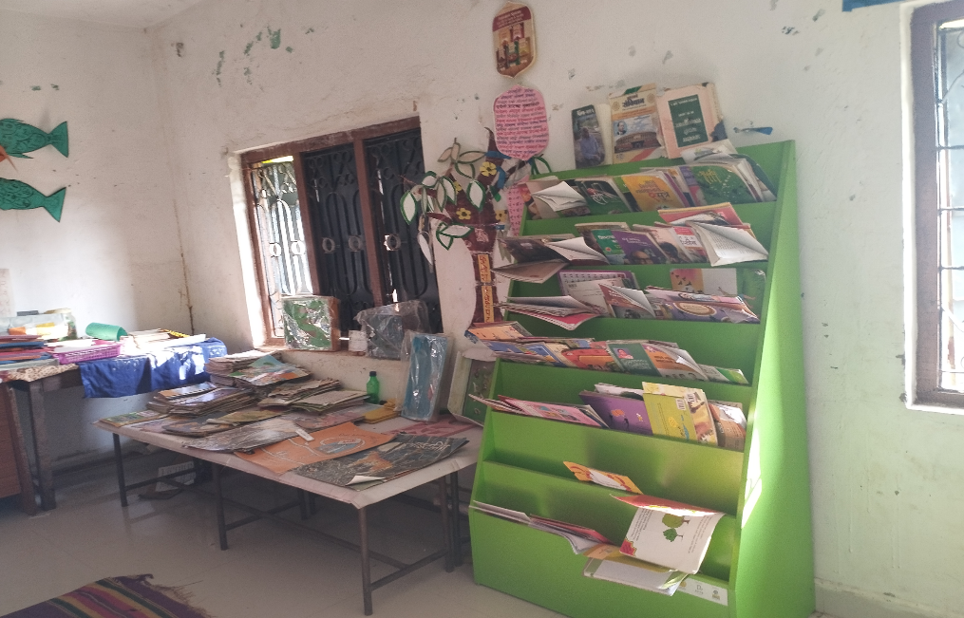

The above 5 Best Practices also highlight the self-motivation of the teachers because their love of books is expressed through the ideas they have implemented at their school and in their community.

5.2 Case Studies
Caselet of Head Teacher:

Name of the Teacher: Sunita Arvind Kathole
Name of the district: Buldhana

This case aimed to understand the teacher's perception of the school library, how reading helps her grow as a person, and the teacher's experience with children through her narrative and her own experiences. The concept of the library was explained by the teacher, wherein she not only explained the meaning of the school library but also tried to connect it to her personal experience of having a reading culture.
She is a self-motivated teacher with first-hand experience in school libraries and books. The library is an essential part of her life. She also shared articles and readings highlighting how teachers can motivate children to engage in school library activities.
According to her, a library is generally a place where all kinds of printed and handwritten materials are kept together. Looking back to history, she stated how Nalanda University had a dynamic library in ancient India and how manuscripts were preserved during medieval times. Even the Kings-maharajas used to have separate libraries for themselves. Referring to Ranganathan, she emphasized that libraries are public institutions that foster democratic values. She also said that the library movement complemented public education in the nineteenth century. Maharaja Sayajirao Gaikwad spread and propagated universal education through this movement in Baroda states.
According to the teacher, “A book is a teacher. If the library is well equipped, the children's knowledge level will increase, and the children's curiosity will increase’’.
For her, the essential purpose of a library is to store knowledge and information. In recent times, the concept of libraries has changed. It has become like an institution for information exchange because the reader comes to ask for database information without asking for a book.

“A library is like the salt in an academic meal. Like a dish is complete with salt, education is only comprehensive with libraries. A respondent Teacher
“A library is the soul of a school. It creates space for learning for teachers as well as students.’’
Schools and colleges have libraries where the students get used to reading with context. Getting many books in one place is convenient for the writing to be scholarly. Separate libraries are also available for corporate and industry sectors, employees, managers, executives, and engineers.
“A library is a storage of books for increasing children’s knowledge. Therefore, it is necessary to arrange the books in the library to attract the children to read books.”
However, according to her, “The library has no space limit. It should be available in the community so that the children not only enter the library but are constantly connected with reading.’’
Therefore, she believes, “In connecting children to libraries of all kinds, reading materials and teachers are valuable allies. Teachers and children can work together to encourage book discussions and recommend titles to help children become enthusiastic, thoughtful, and non-discriminating readers.’’

This spirit of reading culture is highlighted through the following caselet of children from the Navghar ZP School at Palghar.
Caselet of Children

Name of school: Navghar ZP school
Class: III and IV
District Name: Palghar

Children's expressive writing demonstrates what they learn at school and how they relate their experiences to everyday life. Case studies and narratives create discussion around children's exploration and learning habits through reading.
We visited Navghar School, Palghar. We had expected children from classes 5 to 8 to discuss their reading experiences. However, children from classes 3 and 4 were more vocal. We collected their stories and learning experiences in the school library.
Most children love to read story books. The names of the books are “Chor Police, Bhau Bahin, Mavshi Che Hat Moje, Pipani, Phale Kha, and Takat Vadhava.”
etc, (चोर पोलीस, मावशीचे हात मोजे, भाऊ बहीण, तीन आंधळे आणि एक डोळस, फळे खा, ताकत वाढवा इत्यादी)
When we asked the children what they had learned from these stories, they answered that they had learned moral values from these books.
For example, having read the book चोर पोलीस (Chor Police), they learned the moral value that "Stealing is bad".
When they write essays, they read school library books. One of the children said they realized they could write an essay when they read.
We are sharing an example here.
"I wanted to write an essay on mothers. For this essay, I read the book of Sham's mother(श्यामची आई).“
One of the children wrote a short poem for his mother. It was a poem written on the occasion of
his mother's birthday.
“आई तू इतकी सुंदर आहेस कि गुलाब हि लाजवेल .फुलांच्या बागेत तुझे सौदर्य दिसेल .

(Mother, you are so beautiful that even a rose would blush. Your beauty will be seen in the garden of flowers.) Children informed us that they enjoyed reading storybooks, but sometimes they could not understand the content. When we discussed this issue with teachers, they said children love reading story books. Although they try to relate to their experience, the storybook has limitations.

- Conclusion and Recommendations
6.1 Conclusion
Speaking and reading skills are basic skills developed through library books. The process of reading and writing not only helps to understand the meaning of words but also develops vocabulary. Therefore, it is necessary to create a reading environment for children.
Due to Poor infrastructure, limited books for reading, insufficient funds to run library activities,non-availability of reading materials for children with special care, and lack of dedicated librarian teachers to help children in the library, all these constraints make children miss the ‘joy of reading’.
All school observations and stakeholder interviews help to understand the significant contribution of school library operations to this study. The role of the self-motivated teacher and the lack of funding for the library narrated the stories of the s school libraries.

Policy Briefing
A rationale identified by this research is the funding and resource gap in primary school libraries. All qualitative and quantitative studies highlight limited funding. All stakeholders are of the consensus that funding is irregular and HM, teachers, and SMC are not aware of the strategic provision of school library funding. DEO and BEO are the final authority to disburse funds to the school. All official circular details of the school are with DEO and BEO, still, fund details are not communicated to HM and teachers. The already available book resources, infrastructural and human resources are not suitable to sustain the library. That is why teachers are limited in creating an inclusive environment in the school library.
Increasing expenditures on education
Among the BRICS countries, the following is the expenditure in the percentage of GDP.
- Brazil – 4.5% in the year 2019
- Russian Federation – 3.7% in the year 2020
- India – 4.5% in the year 2020
- China – 3.6% in the year 2020
- South Africa – 6.6% in the year 2021
It is evident that even among its economic equals, India still lags in expenditure on education. These aspiring global powerhouses must create world-class human resources and citizens with an affinity towards reading as a culture. This can be inculcated only during primary school with a comprehensive library encouraging students to explore their potential.

The NITI Aayog Report 2018, ‘Strategy for New India @75’, recommended that the central and state governments increase their expenditure to at least 6% by 2022. The same was also recommended in the NEP.

- Efficient, transparent expenditures: The funding from the central and state governments to the students needs to be trackable to the last rupee and individual student. Currently, the information available in the public domain is only about fund transfers up to district-level departments. The government circulars and notifications about this are not readily available to ordinary citizens who wish to know about public expenditures at the Taluka and village levels. Besides creating transparency, this will also enable the citizens to analyze expenditures and suggest cost-efficient ways to improve overall public finance in India.
- Establishing systems of social audit and monitoring and evaluation: The existing ‘Parents Teachers Association’ and other such bodies should be informed and capacitated about various funding being provided by the government for improving the schools. PTA can evaluate the quality of libraries physically and suggest improvements. This feedback should be communicated directly to the Block Development Officers

6.2 Recommendations

Recommendation 1

The fund of Rs. 5000/- is not enough to run a library in schools with more than 200 students and the durability of the books is also quite short. Therefore, adequate funds are required for the maintenance of the library space and the books and toys and such,

Almost all DIET faculty and BEOs strongly opine that INR 5000 per year is not enough to run the library and that books are not distributed regularly in the library.
“Every school has a small amount of books in the library but not many. Because we do not get funds and processes from the government for the purchase of books, there are very few books available in the library.”
- A CRC

Recommendation 2

There must be an increase in awareness of existing schemes and funding among all stakeholders: from DEOs to SMC Members.

“Books on Hindi and English are a must for children. So that children can get information about that subject.”
- An SMC Member
“Readers, reading materials and staff are the three components of a library. The basic purpose of a library is to store knowledge and information. These tools can be taken from the library for use and returned for a limited period. In modern times, the concept of libraries has changed and it has become an information exchange institution. Because the reader comes to ask for database information without asking for a book.”
- An HM

“Should include useful books for competitive exams”
- A CRC

“If there is awareness among the students, teachers and parents, the library can be of great use to the students, their cognitive power can increase, their confidence can increase.”
- A CRC

“There should be a separate room in the school and books of children's interest should be made available and they should be allowed to use the books. For that a teacher should be appointed with a proper schedule for work.”
- A BRC
“There should be an independent library, and sufficient additional books should be made available for reading.”
- A Block Officer

Recommendation 3
There is a dire need for training of teachers and to research the use of the library space more effectively in low-resource contexts such as government schools.

The teachers (96%) do not know much about the scheme, its purpose, and how the funds can be used. More importantly, they (77%) have not grasped the essence of the schemes aimed at instilling the joy of reading.
Teachers (65%) have shared that school library management training will help them in running the library. Some (35%) feel that DIET professors are willing to conduct half-day workshops or training for teachers on library management.

DIET Faculty believe a training program should be conducted for school teachers. This training program must include the following:

- To develop a separate module for school library management
- Forming guidelines for School Libraries through research
- With increased focus on FLN and it being the core of literacy, DIETs can contribute to the education of the school library community by planning their research.
- Guidelines should be developed to assess children and help understand children's learning through school libraries.
- Conducting separate training for teachers on School Library Management on community learning

Training will also aid another demand from the teachers that they be part of selection committees for books given to the library. Where books are not available some teachers (about 10% of respondents) opined that they could also write and translate books that suited the children in their schools.

Recommendation 4
The School Management Committee should be activated with an increased focus on library usage and ensure community engagement in library activities.

“It is necessary to follow up at the government level for schools to house quality books. For that, various activities have to be implemented, to increase the reading culture in rural areas. It is also necessary to create awareness among the people of the community”
- An HM
Furthermore, library provisions nor its use feature in the SMC meetings held in schools. This was reported by almost all HMs and SMCs when interviewed during visits.

Recommendation 5
A separate space for libraries is a requirement. Samagra Shiksha has guidelines for library arrangement. The focus should be on reading areas, display shelves, and the school's openness. Separate rooms are essential to creating a reading environment for children because the reading corner has limitations. Reading corner has limited space and not all children have easy access to books.

The teachers (100%) agree that books should be available so children can use the library effectively and visit it anytime. However, library access in reality does not align with the teachers’ beliefs.

Recommendation 6

The school should have a library period so that the maximum number of students can benefit from it.

Almost 80% of teachers surveyed and interviewed expressed that library management felt like 'extra work'.
“But it is very important to ensure the spaces. Hence it is necessary to track the children's records. To regularize the reading activities need a dedicated library period.”
- Teacher

Recommendation 7
The teachers and HMs should be enabled to exercise agency to select the kind of books required for their children. The teachers should not only be a part of the book selection committee but should also be upskilled to be able to create/relevel/translate storybooks for the school library.

A library can be found in every school with help from some NGOs and other people
- HM

This is also echoed in what teachers had to say about the need for books in the library. The schools with more than 250 students and with grades up to 8th or 10th state that they need an Atlas and books on science, math, general knowledge, etc. Lack of training among teachers and lack of sensitivity to the need for “reading for joy” is reflected in repeated comments from teachers and headmasters across districts. The comments mainly state the need for the purchase of books catering to the subject discipline. The need for guidebooks is especially alarming given the goals that NEP 2020 posits holistic development with a focus on critical thinking.

Recommendation 8
Library books should be age-appropriate, diverse, engaging, and valuable. Texts should be codified, and physical facilities should be provided. Resources should be open for all to read, and records should be kept. There should be regular management of books. Multilingual books should be available in the school library, according to the languages spoken by the school children

Teachers (almost 65%) report that age-appropriate books are not available in school libraries.
“Children's interest in reading has decreased and it is difficult to get them into the habit of reading. Age-appropriate books help children become familiar with words and phrases.”
- A Teacher

Recommendation 9
- Schools should be enabled to curate and create digital materials for CWSN students to build more inclusive libraries.

There was a significant number of opinions from teachers and BRC/CRCs regarding CWSN children.
According to one CRC Samagra Shiksha and SCERT provide large print books for visually impaired children. But children belonging to other categories of CWSN cannot access the library, due to a lack of audio-visual material and tactile reading material.

Recommendation 10

Access to libraries should be provided beyond school hours and home lending should be allowed alongside creating a robust and digitized system of tracking the use of books and per-student reading engagement.

Respondents across all segments (average 64%) opined that a library needs to be available outside school hours Around 20% of them felt that the school library should be made available to the larger community as well through systems such as “24-hour open library self-run by villagers” and “mobile library, especially during vacations”.

Recommendation 11
Dependency on external agents (NGOs) to activate and maintain school libraries should be reduced to ensure sustainability.

While almost 80% of the respondents felt a strong need for NGOs to work in the space of school libraries, many of these, almost 9% of this sample, also implied the library to be a separate space with a separate librarian, often provided by the NGO or appointed by the Government on a part-time basis, or someone from the village who was preferably well-educated. This however undermines the sustainability of the library as an inherent part of the school ecosystem and defeats NEP 2020 and Samagra Shiksha Guidelines for Library.

- References
Articles:
- Banerjee, Dwarika. N. (1996). The Story of Libraries in India. The MIT Press on behalf of American Academy of Arts & Sciences, 125 (4), PP 353-361.
- Batra, Poonam. ( Oct. 1-7, 2005,). Voice and Agency of Teachers: Missing Link in National Curriculum Framework 2005. Economic and Political Weekly, 40 (40), PP 4347-4356.
- Das, Amit Kumar. (2021). Elementary education and library system in India: the symbiotic model based on Bloom's Taxonomy. Library in Philosophy and Practice
- Khorakiwala, Rahela Dr., Pawar, Sakshi, & Dixit, Pratik (2022). Putting the Public Back in Public Libraries: Restructuring the Governance of Public Libraries in Maharashtra.
- Soulen, Rita. Reinsel, and Lara. Tedrow. (2021). Students’ frequency of access to school library materials in transformative times. Journal of Librarianship and Information Sciences, 54 (4), PP 622-639.
- Srygley, Sara. Krentzman. (MAY, 1967). The Role and Function of the Elementary School Library. Elementary English, 44 (5), PP 472-474.
Web Documents:
- “India Gets Reading at Home” Campaign. (2021, September 21). Room to Read. Retrieved October 20, 2022. https://www.roomtoread.org/the-latest/india-gets-reading-at-home-campaign/
- In How ‘Open Libraries’ in schools are helping children express themselves better!.https://cafindia.org/program-impact/stories/item/85-how-open-libraries-in-schools-are-helping-children-express-themselves-better
- Kadidal, Akhil.. (2020, Sep. 27) Karnataka govt planning to transform Panchayat libraries into Learning center Https://www.deccanherald.com/state/karnataka-govt-planning-to-transform-panchayat-libraries-into-learning-centers-893830.html

- Shaikh, Asif.. (2018, Aug. 6 ). In शाळासिध्दी लेखमाला - http://asiflshaikh.blogspot.com/2018/08/5.html
- Tikadar, Agrima. (2022, February 8). NDLI wins World Summit Award 2021 for initiatives during the COVID-19 pandemic. Edugraph. https://www.telegraphindia.com/edugraph/news/ndli-wins-world-summit-award-2021-for-initiatives-during-covid-19-pandemic/cid/1851067
- TNN.. (2022, Jan. 4 ). In Maharashtra education department launches 100-day drive to restore reading habits in pupils. https://timesofindia.indiatimes.com/education/news/maharashtra-education-department-launches-100-day-drive-to-restore-reading-habit-in-pupils/articleshow/88685062.cms

Annexure
Survey Tools
The primary respondents of the study will be district officials (DIET and EO office), block and cluster officials, school HMs, teachers, children, and other relevant stakeholders working in the schools (including community representatives). This survey is part of a study in 36 districts in the state along with an depth study in 10-15 selected elementary (grades 1-8) schools that have received books in the last 5 years and/ or funds for infrastructure to set up school libraries.

Consent Form -
Filing this Survey tool is considered your consent for your participation in the study. We, the Tata Institute of Social Sciences and UNICEF will ensure the anonymization of data.

Common Details:
The form will collect Email ID (and send a copy response automatically)
Description - Purpose of Study and guarantee data anonymization

- Name (First Name Last Name):
- Sex:
- Email ID - Official on which communication is desired:
- Mobile Number: (10 digits):
- Highest Qualification:
- District: Single Select - 36 districts
- Designation: Single Select (Will lead to section questions based on role)
  - DEO
  - BRC
  - CRC
  - Headmaster (or officiating)
    - Grade of school: (1-4) (1-5) (1-8)
    - Place of school: Village / urban / semi-urban / town
    - Special educator/ librarian/ Teacher and librarian
  - Librarian (appointed for this work)
  - Teacher
    - Grade of school: (1-4) (1-5) (1-8)
    - Place of school: Village / urban / semi-urban / town
    - Special educator/ librarian/ Teacher and librarian
  - Teacher nominated as a librarian (Additional Charge)
  - SMC Member

01 - Survey Tool for DEO- UNICEF Maharashtra Library Study - 2022

- Have you had orientation regarding the Library, funding and its utilization?
  - Yes, through circulars and notices
  - Yes, in meetings
  - Yes, through discussions with authorities
  - No.
- Does your district receive funds allocated for school libraries on time?
  - Most years it is on time.
  - Funds are disbursed at irregular intervals
  - Covid-19 years were affected, but other years were on time
  - Funds are given towards the end of the financial year.
- Have you had to return funds allocated for the library back to Samagra Siksha?
  - Always (all 05 years of funds received)
  - Most times (3-4 times in the past 5 years)
  - Sometimes (1-2 times in the past 5 years)
  - Never
- How important is the library in school education for children?
  - Extremely important
  - Very important
  - Somewhat important
  - Not important
- What element do you think is required to make the library more inclusive and learner-friendly? Explain (not more than 100 words).
- What types of monitoring mechanisms are best practices for school libraries?
- Organizing library activities regularly
- Maintaining the records of books
- Celebrating language festivals
- Conducting regular meetings with the headmaster to read library work
- How often do you discuss with the headmaster / CRC/BRC regarding library activities?
- Monthly meeting
- Quarterly meeting
- Yearly Meeting
- Never
- How many schools among elementary ZP schools have a dedicated (room for a) library?
  - ______ of total _____ schools
- How many schools in your district have a dedicated librarian?
  - No of librarian
- Have teachers in your district go through the capacity-building program in your district for library management?
  - Yes, organized by the state
  - Yes, organized by an NGO / University / Association,
  - Some of them through their own initiative
  - No
- Any suggestions/comments on school libraries in your district? (Optional)

02 - Survey Tool for BRC/CRC- UNICEF Maharashtra Library Study - 2022

- How many schools have libraries or reading corners in your districts/supervised schools?
  - ______of total___________Schools
- How many schools in your district/supervised schools have a dedicated librarian?
  - No of librarian________________
- Have you had orientation on Library funds and their utilization?
  - Yes, through circulars and notices
  - Yes, in meetings
  - Yes, through discussions with authorities
  - No.
- Do your districts/supervised schools receive funds allocated for school libraries on time?
  - Most years it is on time.
  - Funds are disbursed at irregular intervals
  - COVID-19 years were affected, but other years were on time
  - Funds are given towards the end of the financial year.
- How often do you visit the school library?
- Weekly
- Fortnightly
- Monthly
- Anytime
- How often do you conduct meetings with the headmaster/headmistress regarding library activities?
- Monthly meeting
- Quarterly meeting
- Yearly meeting
- Never
- What do you discuss about the school library in meetings headmaster/headmistress ?(multiple select)
  - Funding for the school library
  - Infrastructure needs
  - Procurement of books
  - Use of the library (timings and access)
  - Timetabling of the library period for each class
  - Inclusion of special needs children
  - None of the above
  - Never discussed anything
- Have you prepared written guidelines or library activity plans for librarians/designated teachers? (Multiple choose)
- Yes for issuing books
- Yes for conducting activities
- Yes for timetabling
- Yes for the separate period for the library
- No, there are no guidelines
- No, the Samagra Shiksha policy document has been forwarded
- No such instructions were given by the authorities
- None of above
- Have you conducted technical/capacity-building training for a teacher/librarian/nominated teacher in the last five years?
- Yes (Every year )
- No ( not conducted)
- Sometimes (once or twice in the last five years)
- Never
- Do you allow any school to have NGO intervention in school library activities?
  - Yes, the school can decide
  - Yes through prior permission from the NGO
  - It can be done either by permission or by the school's decision
  - No, it is not allowed
  - I was never approached by any NGO
- Do you allow schools to incorporate non-enrolled children in library activities?
- Yes, the school can decide to include them
- Yes, it can be done only with permission
- The library is open to everyone
- The library is only for enrolled students
- Invite non-enrolled children occasionally
- Why do you think the library is important for schoolchildren? (multiple choice)
- Yes, it is important for their study and knowledge-building
- It is somewhat important for children’s fun
- This is the place for children to interact with each other and the teacher
- It is important to improve the language
- It helps children to develop reading habits
- It makes children prepare for exams
- Does not make any impact
- Not useful
- Do you conduct awareness activities for the school library?
- Yes, I conduct meetings with the community, SMC and school regularly
- Yes, the school conducts meetings, and I attend
- Sometimes, the school conducts meetings and I attend
- The school conducts meetings, but I do not attend
- No, I am not involved in library-related activities.

03-Survey Tool for Headmaster/Headmistress
- Does your school have a library?
  - Yes, with a separate room
  - There are reading corners, but no library
  - No library or reading corner
  - There are both reading corners and library
- Have you gone through the orientation/training regarding the library, funds and their utilization?
- Yes, I attended one training/orientation
- No, never received any training
- Training/Orientation was not conducted, but Circulars/DEO/other HMs helped me
- Not aware
- Do you receive funding for the library, every year?
  - Most years, it is on time
  - Funds are disbursed at irregular intervals
  - Covid-19 years were affected, but other years were on time
  - Funds are given towards the end of the financial year
- Does the library funding fulfil the requirements?
  - Yes, meet all the needs
  - Somewhat fulfil
  - No, the given fund is not enough
  - The fund has never come on time
- How do you spend the library funds?
  - In purchasing books
  - In library activities
  - Funds are not utilized
  - Expensed on other activities
- Do you discuss the school library concerns in staff meetings? (multiple select)
  - Funding for the school library
  - Infrastructure needs
  - Procurement of books
  - Use of the library (timings and access)
  - Timetabling of the library period for each class
  - Inclusion of special needs children
  - None of the above
  - Never discussed anything
- Have you allowed or approached/been approached by any NGO/anyone outside the school to organize library activities in the school?
  - Yes
  - Never
  - Sometimes
  - Not required
- Have your teachers undergone any training related to the library?
  - Yes, All.
  - Yes, but only the librarian/designated teacher.
  - None of them could go for such training
  - I am not aware of such training having been conducted.
- Do you face challenges regarding libraries? (Multiple options)
- Related to book availability
- Related to infrastructure
- Related to staff/ human resources
- Related to the children (timetable, returning books)
  - Yes, always there are challenges
  - Sometimes, challenges come
  - No, there are no challenges
- Does the library have any specific rules for the students?
- Yes
- No
- Do the children request to issue books or teacher or librarian provide them with books?
  - Children can issue books
  - Teachers provide books on demand
  - Teachers help differently-abled children only
  - The teacher gives books to the children
  - There is no system for issuing
- Is the library accessible to the students after school hours or during vacation periods?
  - Yes children can come and collect books
  - Only after school hours but not on vacation
  - Yes, children issue books after school hours and during vacation
- Can non-enrolled children issue books from the library?
  - Yes, they can issue
  - No, they cannot issue books
  - They can issue with the help of SMC members
  - Non-enrolled children are not allowed at all
- Do you have exclusive staff to manage, organize and assist in accessing books in the library?
  - Yes, we have a separate Librarian
  - No, we do not have staff
  - The librarian is a designated teacher
  - There is no staff, we all manage on a turn basis
- Do SMC members know about the library and library activities?
- Yes, they know well about the library and activities
  - No, they are not aware
  - Some of them know those who come for a meeting
  - We have not included them
- Do you discuss library matters with the SMC members? (Multiple Choices)
  - Yes, we discussed it with them
  - No, we do not discuss Funding for the school library
  - Infrastructure needs
  - Procurement of books
  - Use of the library (timings and access)
  - Timetabling of the library period for each class
  - Inclusion of special needs children
  - None of the above
  - Never discussed anything
- Do you think libraries are important for schoolchildren? (Multiple)
- Yes, it is important for their study and knowledge-building
- It is somewhat important for children’s fun
- This is the place for children to interact with the teacher
- It is important to improve the language
- It helps children to develop reading habits
- It makes children prepare for exams
- Not useful
- It interferes with regular classroom teaching-learning

04-Survey Tools for Teacher- TISS-UNICEF Maharashtra Library Study - 2022

- Which class/es do you teach?
  - Std 1
  - Std 2
  - Std 3
  - Std 4
  - Std 5
  - Std 6
  - Std 7
  - Std 8
  - Std 9
  - Std 10
- What do you teach?
  - All subjects for my grade
  - Specific subject/s across grades
- Which subject is your primary specialization?
  - Marathi
  - English
  - Hindi
  - Other Languages
  - EVS / Social Science
  - Mathematics
  - Science
- Have you gone through the orientation/training regarding the library?
- Yes, I attended one training/orientation
- No, never received any training
- Training/Orientation was not conducted, but Circulars/DEO/other HMs helped me
- Not aware
- Does your school have a library/reading corner space?
  - Yes, with a separate room
  - There are reading corners in classrooms, but no library
  - No library or reading corner
  - There is both reading corner and a library
- What language books are there in your library? (multiple select)
- Marathi
- Hindi
- English
- Urdu
- Gondi
- Other
- How many language books are there in your library?
- One Language
- Two Languages
- Three to five languages
- Six to Eight languages
- Nine and above languages
- What types of resources are there in your library? (Multiple Questions)
- Storybook
- Comic book
- Math reference book
- Sciences reference books
- Journal and Periodicals
- News Paper
- Dictionaries
- Encyclopedias
- Atlases-Maps
- Text Books
- Audio Cassettes
- Films
- Digital resources
- Computer
- Games & Toys
- Other
- Do the books have a sticker or front cover with the following? (Multiple choice)
  - Bulbul
  - Mynah
  - Koel
  - Samagra Shiksha and Year of Purchase
  - None of the above
- How do you provide access to the library books to the children in your library? (Multiple select)
- Bring books to the classroom
- Take children to the library/reading corner
- Issue books to each child to take home
- Children have the agency to issue books on their own
- Help the differently-abled children to issue and access materials
- Assign a peer buddy for every child for buddy reading
- How do you organize the library activity in your school library/reading corner? (Multiple)
- Read aloud
- Shared reading
- Paired reading
- Independent reading
- Conduct fun activities
- Playing video or audio programme
- Showing maps or atlas
- How many times do you organize library-related activities in your class? (Multiple)
- Daily
- Weekly
- Fortnightly
- Monthly
- Occasionally
- Never Organized
- Do you have an official library period for your class?
  - Yes
  - No
- Is there an NGO/anyone from outside working with the school library?
- Yes
- No
- They come occasionally
- I am not aware
- Is the library accessible after school hours or during vacation?
- Yes children can come and collect books
- Only after school hours, but not during vacation
- Yes, children issue books after school hours and in vacation
- Do you have any responsibility to look after the library during or after school hours?
- Help in organizing books
- Support in conducting activities
- Help occasionally when the Headmaster/Headmistress asks
- For organizing meetings with SMC or community
- None of the above
- Why do you think the library is important for schoolchildren? (multiple choice)
- Yes, it is important for their study and knowledge-building
- It is somewhat important for children’s fun
- This is the place for children to interact with each other and the teacher
- It is important to improve the language
- It helps children to develop reading habits
- It helps children to prepare for exams
- Does not make any impact
- Not useful
- Do you involve in the following activities?
- Repairing books
- Replacing materials
- Recovering the cost of a lost resource
- Connecting with publishers
- Coordinating with SMC & parents
- Reporting on portal
- None of the above

05-Survey Tools for Designated Teacher/Librarian- UNICEF Maharashtra Library Study - 2022
- Which class/es do you teach?
  - Std 1
  - Std 2
  - Std 3
  - Std 4
  - Std 5
  - Std 6
  - Std 7
  - Std 8
  - Std 9
  - Std 10
  - Not applicable
- What do you teach?
  - All subjects for my grade
  - Specific subject/s across grades
  - Not applicable
- Which subject is your primary specialisation?
  - Marathi
  - English
  - Hindi
  - Other Languages
  - EVS / Social Science
  - Mathematics
  - Science
  - Library Science
- Does your school have a library space?
  - Yes, with a separate room
  - There are reading corners, but no library
  - No library or reading corner
  - There are both reading corners and library
- Have you gone through the technical training to run the library?
- Yes, I got the training once
- No, Never received any training
- Training never conducted
- Not aware
- Where do you keep the books within the library or reading corner?
- Open bookshelves
- Wooden door Cupboard
- Glassdoor Cupboard
- Boxes
- Any other place
- How many books does your school library/reading corner have?
  - No of Books_________
- Do you have an official library period for your class?
  - Yes
  - No
- What language books are there in your library? (multiple select)
- Marathi
- Hindi
- English
- Urdu
- Gondi
- Other
- How many language books are there in your library
- One Language
- Two Languages
- Three to five languages
- Six to Eight languages
- Nine and above languages
- What types of resources are there in your library? (Multiple Questions)
- Storybook
- Comic book
- Math reference book
- Sciences reference books
- Journal and Periodicals
- News Paper
- Dictionaries
- Encyclopedias
- Atlases-Maps
- Text Books
- Audio Cassettes
- Films
- Digital resources
- Computer
- Games & Toys
- Other
- How do you get your books in your library?
- Purchase from Government Published
- Purchase from private publishers
- Received from Donation
- Funding by NGOs under Projects
- Do the books have a sticker or front cover with the following? (Multiple choice)
  - Bulbul
  - Mynah
  - Koel
  - Samagra Shiksha and Year of Purchase
  - None of the above
- Do you organize the library activity in your school library/reading corner? (Multiple)
- Read aloud
- Shared reading
- Paired reading
- Independent reading
- Conduct fun activities
- Playing video or audio programme
- Showing maps or atlas
- How many times do you organize the library activities in your school library/reading corner? (Multiple)
- Daily
- Weekly
- Fortnightly
- Monthly
- Occasionally
- Never Organized
- Is there an NGO/anyone from outside working with the school library?
- Yes
- No
- They come occasionally
- Not allowed
- Is the library accessible after school hours or during vacation?
- Yes children can come and collect books
- Only after school hours but not on vacation
- Yes, children issue books after school hours and during vacation
- Who looks at the library after school Hours?
- Teacher/librarian/designated teacher
- Headmaster/Headmistress
- SMC members
- Other / peon or security person
- Why do you think the library is important for schoolchildren? (multiple choice)
- Yes, it is important for their study and knowledge-building
- It is somewhat important for children’s fun
- This is the place for children to interact with the teacher
- It is important to improve the language
- It helps children to develop reading habits
- It makes children prepare for exams
- Does not make any impact
- Not useful
- Do you involve in the follow-up activities?
- Repairing
- Replacing
- Lost Resources
- Connecting with publishers
- Coordinating with SMC & parents
- Reporting in portal
- None of the above

06-Survey Tools for SMC-TISS-UNICEF Maharashtra Library Study - 2022

- What is the frequency of SMC meetings conducted in a year in your school?
  - Once a month
  - Twice in a semester
  - One in a semester
  - Once a year
  - Never
- Does your school have a library?
  - Yes
  - No
  - There are reading corners, but no library
  - I am not aware
- Does the school discuss the school library concerns in the SMC meetings? (multiple select)
  - Funding for the school library
  - Infrastructure needs
  - Procurement of books
  - Use of the library (timings and access)
  - Timetabling of the library period for each class
  - Inclusion of special needs children
  - None of the above
  - Not aware if any of this is discussed
- Have you as an SMC member (multiple select)
  - Visited the school library/reading corner
  - Observed library activities
  - Given inputs on books/resource selection and display
  - Checked the use of the library through the register, library cards, etc.
  - Not done
- Has the librarian or designated teacher conducted activities with children focused on reading books in the library or reading corner?
  - Yes (they often do activities)
  - Sometimes (once or twice in year)
  - Never (never heard about the activities)
  - Not applicable (my school does not have a library or a reading corner)
  - Not Aware
- Do you play any role in connecting parents and children with the library?
  - Yes (Discuss most of the time with the parents)
  - Sometimes (discuss with parents when there is a meeting)
  - No (Never discussed with parents)
- Have you observed any NGO/anyone outside the school organizing library activities in the school?
  - Yes
  - Never
  - Sometimes
  - Not Aware
- Is there a library for all community members in your locality?
  - Yes, a very good and often used one
  - Yes, but am not aware of its use
  - No
  - Not aware
- Do you think libraries are important for schoolchildren? (Multiple)
- Yes, it is important for their study and knowledge-building
- It is somewhat important for children’s fun
- This is the place for children to interact with the teacher
- It is important to improve the language
- It helps children to develop reading habits
- It makes children prepare for exams
- Not useful
- It interferes with regular classroom teaching-learning

Singh, S. (2003). Library and literacy movement for national development. New Delhi: Concept Publishing.
This is the world library research report https://scholarcommons.sc.edu/cgi/viewcontent.cgi?article=1172&context=libsci_facpubGavigan, Karen. W (2018). School Library School Library Research and Research from Around the World: Where World: Where It's Been and Where It's Headed. University of South Carolina Scholar Commons, 45 (5), PP 31-39.
The Right of Children to Free and Compulsory Education Act, 2009, explains the role of libraries in school education. The school referred to in clauses (iii) and (iv) of clause (n) of section 2 shall ensure that children admitted by clause (c) of sub-section (1) of section 12 shall not be discriminated from the rest of the children in any manner about entitlements and facilities such as textbooks, uniforms, library and Information, Communication and Technology (ICT) facilities, extra-curricular and sports.
htttps://www.deccanherald.com/state/karnataka-govt-planning-to-transform-panchayat-libraries-into-learning-
https://www.unicef.org/education/inclusive-education https://udiseplus.gov.in/#/home
https://www.drishtiias.com/daily-news-analysis/aspirational-district-programme NITI Aayog has defined aspirational districts on the essential aspects of 1)Health and Nutrition, 2)Education, 3)Agriculture and Irrigation 4)Financial Inclusion and Skill Development.
UDISE 2020-21
Revised Guidelines for Promoting Libraries, MoE, 2020
NAS Report 2021
Samagra Shiksha Website: https://samagra.education.gov.in/library.html#:~:text=Provision%20for%20separate%20annual%20library,of%20books%20under%20Samagra%20Shiksha.
Government expenditure on education, total (% of GDP) | Data (worldbank.org)
Strategy_for_New_India_0.pdf (niti.gov.in), page 113.

