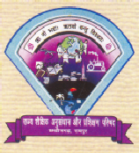
Telephone 0771-2443596 Fax-0771-2443496 Website: www.scert.cg.gov.in Email: scertcg@gmail.com

jkT; 'kSf{kd vuqla/kku ,oa izf’k{k.k ifj"kn~] NŸkhlx<+]
'kadj uxj] jk;iqj

State Council of Educational Research & Training, Chhattisgarh
Shankar Nagar, Raipur (C.G.)

No./SCERT/CSS/T.E./2012/_________ Raipur, Dated: 08/03/2013

To,

Sri Vikram Sahay
Director (EE-I)
Room No. 429 C Wing, Shastri Bhawan
New Delhi 110-115

Subject: Expenditure report of Centrally Sponsored Scheme for the FY-2012-13.

Ref: Your Letter No. F.44-17/2012-EE.9 dated 11th December , 2012

In this regard we are submitting the Expenditure report of Centrally Sponsored Scheme for the financial year 2012-13. We received a grant of Rs. 667.22 Lakhs and we spent a total of Rs. 943.26 Lakhs as on 31st December 2012.
You are requested to release the 2nd installment of approved grant for Chhattisgarh.

Encl.: As above.
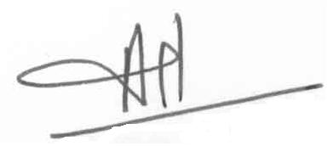 Anil Rai
Director, SCERT
Chhattisgarh, Raipur

En.No. /SCERT/CSS/T.E./2012/_________ Raipur, Dated: 08/03/2013

Copy To:

- Secretary, Govt. of C.G., School Education Department for necessary action.

Anil Rai
Director, SCERT
Chhattisgarh, Raipur

